Home learning w/b: 30-3-20 Year: Nursery
Message from Mrs Clark and Mrs Hammerson
Hello Nursery!
We hope that you are enjoying spending time with your families and have been finding time to complete some of your challenges. We look forward to seeing what you have been up to when we return to school. With Easter approaching, and the recent warmer weather, we thought we would send you some suggestions of things that you could do at home to keep you busy over the next couple of weeks.
Remember to send in any examples of work or pictures of fun activities to eynursery@lea-pri.herts.sch.uk so we can celebrate your achievements.
Personal Social and Emotional Development  Play pairs with your family. You will need at least 5 pairs of eggs. Turn over two eggs and find ones that match, wait for your turn and then count how many eggs you have collected at the end.  You could use this template and colour your eggs in first.  https://www.firstpalette.com/printable/easter-eggs.html  Alternatively make your own eggs from paper or card that you have available. | Literacy  Phonics - letter e  Learn the song and the Jolly Phonics action  https://www.youtube.com/watch?v=Out8AklQHmY  How many things can you think of beginning with e?  Can you guess the word your grown up sounds out to you?  Words for adults to sound out saying each sound separately:  h-e-n p-e-n p-e-g t-e-n  Note to parents…. If you are unsure of how to say the individual sounds correctly, revisit the link on the school website:  https://lea-pri.herts.sch.uk/curriculum/phonics/  You could also log on to Education City and play ‘Elephant Escape’. See link below to practise the ‘e’ sound  Reading  Can you recognise any sounds that we have learnt already in the books you are sharing (s a t p)?  Writing  Whilst you are drawing, painting, making marks or writing your name, remember to hold your pencil correctly.  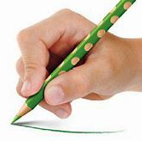  Physical Development  You could make some Easter biscuits. Practise mixing, sifting, kneading and rolling. You may want to try this recipe.  https://www.bbc.co.uk/food/recipes/easter_biscuits_37686
Communication and Language
Listen to lots of stories and talk about the characters. See the online story links below. Can you join in with the repeated parts?

Talk about some of the symbols of Easter or baby animals (see Understanding the World below).
Maths
Education City – Play Eggs for Breakfast. See the link below.
If you haven’t made any play dough yet – have a go! You can use anything to make marks in the dough (sticks, forks, lego etc.) and use things like lids and cups as well as cookie cutters to cut out shapes. You can help with the measuring and then count the shapes you make too. Play dough is also great for your finger muscles.
https://www.bestrecipes.com.au/recipes/playdough-recipe/oyycpq9f
Expressive Arts and Design
If you haven’t already, it might be nice to draw, paint or collage a ‘rainbow of hope’. We would love to see these.

Get creative….. What can you make from an egg box?
Understanding the World  Learn about how Easter is celebrated.  https://www.bbc.co.uk/cbeebies/watch/lets-celebrate-easter?collection=lets-celebrate-celebrations  Find out about animals that lay eggs. Could you draw an animal that lays an egg or sort your toys into animals that lay eggs and ones that don’t.  Can you learn the names of springtime baby animals, e.g. horse/foal, sheep/lamb? | Other Learning  Cosmic Kids Yoga - See links below  Bunny bounce warm up  https://youtu.be/9gV85rd3yTc  Mr Hoppity the hare story  https://www.youtube.com/watch?v=BN7M-uQSOYE
Daily basic skills
Write or trace your name, starting at the correct place. You could use chalk, paints, water or glitter - get creative! You could also place objects on the letters in your name, this will help strengthen your finger muscles as you pick up small objects and help you to remember the order of the letters.
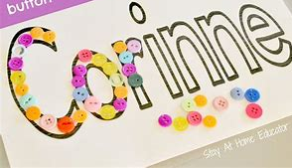
You could also use buttons to make pictures.
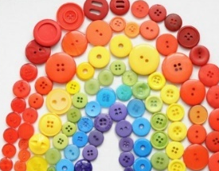
Don’t worry if you don’t have any buttons, start collecting bottle lids, use small counters instead or cut out pictures from magazines!

Online Learning
- Education city- use individual log ins to access set work
https://www.educationcity.com/
- Stories to share
https://www.worldbookday.com/big-little-book-corner
- Nursery rhymes
https://www.bbc.co.uk/teach/school-radio/nursery-rhymes-a-to-z-index/z4ddgwx
- Easter counting
https://www.bbc.co.uk/cbeebies/puzzles/peter-rabbit-counting

