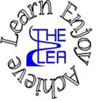
Home learning w/b: 30-3-20 Year: Reception
Message from Mrs Gallagher
Hello Reception!
I hope you are all keeping safe, are enjoying this time with your family and are doing some fun activities together! I would love to see any work or pictures that you have done so please remember to send these to reception@lea-pri.herts.sch.uk so I can celebrate your achievements.
As you may have been very busy following the previous ideas for activities, I have now provided more to help your child to continue to challenge themselves!
Personal Social and Emotional Development  Play turn taking games together – any board games or make your own snakes and ladders board to use.  Talk about safety and how we stay safe – make a safety poster based on what you discussed. | Literacy  Phonics  These activities will depend on your child’s ability as to which sounds you focus on. However, recapping ones that they know will just consolidate learning.  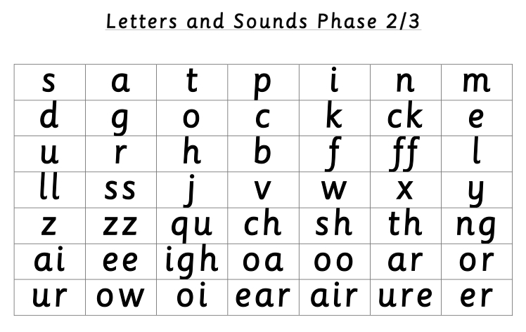  Focus on a different sound a day – have a go at writing as many words with this sound in. Can you beat your amount each day?  How many things around the house can you find with this sound in? Can you draw a picture with things that just have todays sound in?  You could also make your own phonics game based on the ‘buried treasure’ game from www.phonicsplay.com  Make your own treasure chest and a bin (or use one you have at home!), write real and ‘nonsense’ words (jip, fom, erp, shuf, earp etc.) on paper and segment and blend each word to decide if it should go in the treasure chest or bin! Parents – please make sure you are using digraphs and trigraphs, depending on child’s ability – and encourage them to see the two/three letters making one sound.  Note to parents - if you are unsure of how to say the individual sounds correctly, revisit the link on the school website:  https://lea-pri.herts.sch.uk/curriculum/phonics/  Reading  Read a book daily – share a book together, look for sound of the day you have been focusing on, find a tricky word, and discuss what is happening and what might happen next.  Writing  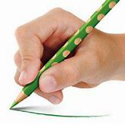  Whilst you are drawing, painting or writing your name, remember to hold your pencil correctly.  Parents – please make sure that you provide lines for your child to write on as this is how we have learnt to form our letters correctly.  Have a go at writing a letter to a friend or family member, write your favourite part of a story or what might happen next in the story or write some words with the sound you are doing that day.  Physical Development  Continue practising your letter formation – https://www.letterjoin.co.uk  Cutting activities – focus on holding scissors correctly and cut along lines.
Communication and Language
Listen to stories either online https://www.worldbookday.com/big-little-book-corner
https://www.bbc.co.uk/iplayer/episodes/b00jdlm2/cbeebies-bedtime-stories
Or with a family member – can you repeat the phrases? Can you guess the rhyme in rhyming stories? Talk about what happened in the story – beginning, middle and end.

Talk about some of the symbols of Easter or animals that have come out of hibernation (see Understanding the World below).
Maths
Have a go at some Easter baking – measure out the ingredients together. There are a few recipes on here:
https://bbcgoodfood.com/recipes/collection/easter-kids

Make Easter patterns – you can use the coloured mini eggs (if you can get hold of them) or have a go at drawing some different coloured eggs to make a pattern with.

We have been learning to add and subtract – use different objects – pasta, lids, pencils, toys etc. – draw a number line or use fingers.
You could also try this game:
http://ictgames.com/funkyMummy/index.html
Expressive Arts and Design
Make an Easter card for someone in your family – draw some things to do with Easter such as, bunnies, chicks, eggs etc. Are there any different resources you could use to decorate with instead of pens or pencils?

Have a go at making something out of junk modelling – can you make something related to Easter?
Understanding the World  Learn about how Easter is celebrated.  https://www.bbc.co.uk/cbeebies/watch/lets-celebrate-easter?collection=lets-celebrate-celebrations  Use the link to learn about the story of Easter and complete the activities – order the story, think and discuss etc.  https://hwb.wales.gov.uk/cms/hwbcontent/Shared%20Documents/vtc/ngfl/re/b-dag/ngfl-container/re-unit2-en.html  Find out about different animals that come out of hibernation in Spring – research them and look at the similarities and differences between these animal – what do you notice? | Online Learning  Cosmic Kids Yoga – physical development  https://www.cosmickids.com/category/watch/  Education city- use individual log ins to access set work  https://www.educationcity.com/  Try the activity – Counting Carnival (+ and -).  Try the activity – Pet Shop (putting words in a sentence in the correct order – as a challenge, try playing the sentence for your child to write – please use lines if your child is writing).  Easter counting  https://www.bbc.co.uk/cbeebies/puzzles/peter-rabbit-counting
Daily basic skills
Write or trace the tricky words – the, to, I, no, go, into, you, they, all, are, my, her, he, she we, me, be, was
You could use pencils, pens, chalk, paint, paintbrush and water, glitter, salt etc. Please only focus on a couple of words a day/week and ensure the formation is correct before moving on to a new word.

Counting – count objects in your house - line them up and count, count claps or jumps, count forwards and backwards (we focus on 0-20 in Reception).

Reading – can be a book, flashcards, hide words around the house to find and read, read packets, read words in newspapers or magazines.

