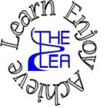
Home learning w/b: 20-4-20 Year: Reception
Message from Mrs Gallagher
Hello Reception!
I hope you have all had a lovely Easter with your family! We would have been starting some new topics this term – growing and animals. There are lots of fun things you can do with these. As you may have been very busy following the previous ideas for activities, I have now provided more to help your child to continue to challenge themselves!
I would love to see any work or pictures that you have done so please remember to send these to reception@lea-pri.herts.sch.uk so I can celebrate your achievements.
Personal Social and Emotional Development  Work on a ‘project’ together – this could be building a model, making a den, cooking/baking something. Get your child to lead the activity but ask questions and make suggestions throughout, getting them to think about different ideas and ways of doing the activity.  Talk about what to do if your child is finding an activity difficult – keep trying, don’t give up, ask for help etc. Get them to draw a picture showing this to help remind themselves when they are finding something hard. | Literacy  Phonics  These activities will depend on your child’s ability as to which sounds you focus on. However, recapping ones that they know will just consolidate learning.  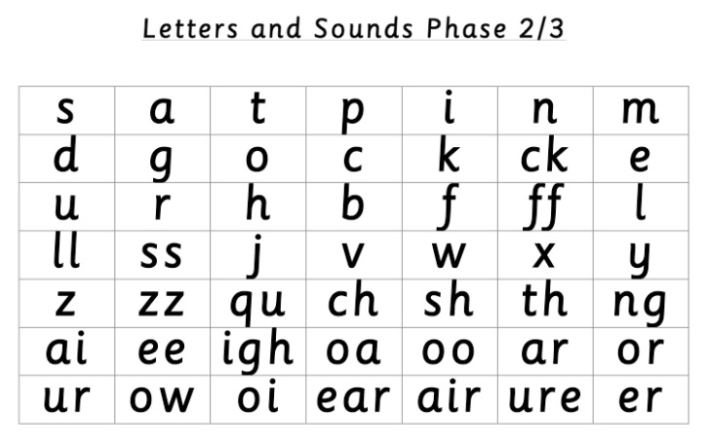  Use these sounds to have a go at some of the ideas for activities below:  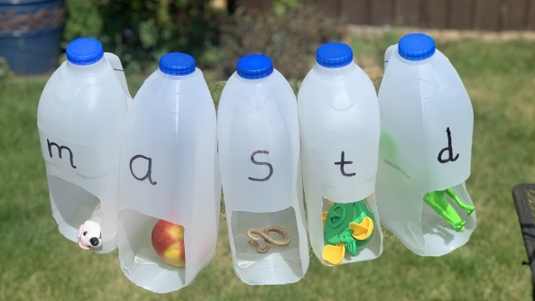  You could also have a go at writing some words onto slips of paper and get your child to sort the words based on how many sounds they can hear in each word. For example, sh-o-p =3, k-i-ng=3, g-oa-t-s=4  Note to parents - if you are unsure of how to say the individual sounds correctly, revisit the link on the school website:  https://lea-pri.herts.sch.uk/curriculum/phonics/  Reading  Read a book daily – share a book together, look for sound of the day you have been focusing on, find a tricky word, and discuss what is happening and what might happen next. If you have any non-fiction books it is important to share these with your child too! Talk about the differences between fiction books and non-fiction books – can your child find some similarities and differences?  Writing  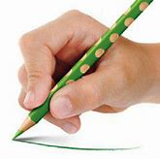  Whilst you are drawing, painting or writing, remember to hold your pencil correctly.  Parents – please make sure that you provide lines for your child to write on as this is how we have learnt to form our letters correctly.  Have a go at writing about a mini beast that you have seen – write a fact about it or describe what it looks like.  Physical Development (fine motor and health and self-care)  Continue practising your letter formation – https://www.letterjoin.co.uk  This can also be done without a pencil in sugar, salt, flour, glitter, rice using your finger – just make sure you follow the correct formation.  Have a look at some of the food in your house – talk about whether it is healthy or unhealthy and what makes it that. Sort food into different groups – your child can decide on the grouping, there is no wrong answer as long as they can say what the groups are. For example, colour, size, healthy/unhealthy etc just ensure that they understand which foods are important in our diet.
Communication and Language
Have your own ‘show and tell’ at home. Get your child to choose a piece of work, a book, a toy, a model etc and get them to talk about it like they would at school. Ask them how and why questions about it and encourage and model using full sentences to answer. The children are usually encouraged to use ‘because’ too – it’s Mrs Gallagher’s favourite word!
Maths
We would have been learning about money this term – have a look at different coins with your child. Just focus on what they look like – talk about what you can see, what colour it is, how big/small it is, the pictures on them, the numbers on them, the shapes of them. Get your child to have a go at putting them into groups – again, it can be any groupings as long as they can tell you why they have put them in that group.
Tell them the different names of the coins, have a go at playing games with them. For example, put them into a bowl, cover with rice/salt/whatever you have, and pick a coin out and identify it – you could always try with your eyes closed and have a feel of the coin and guess!
Expressive Arts and Design
Have a go at making some healthy snacks but be creative! Here are some ideas – enjoy eating them. I’d love to see your creations!

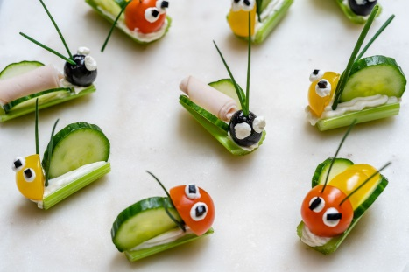
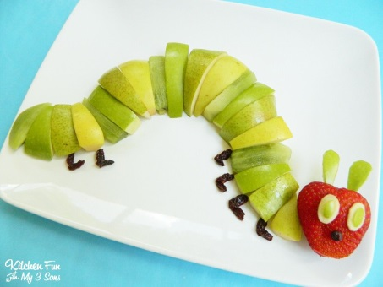

See what materials you have around the house – magazines, old clothes that you don’t mind cutting up, cardboard etc – and have a go at choosing an animal and making a collage of it. Either draw the outline for your child to stick pieces to or have a go together.

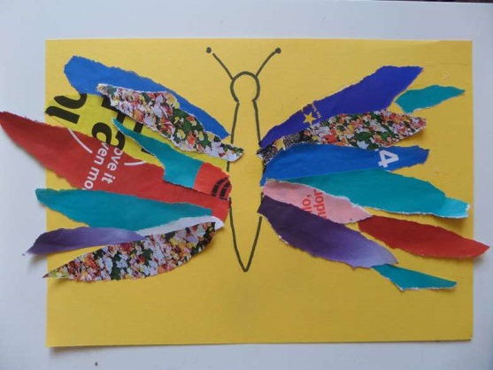
Understanding the World  Choose a mini beast to find out about – what do they look like? What do they eat? Where do they live? Have you got any stories with them in? Can you find any in the garden/on your daily walk? Have a go at writing a fact about it and drawing a picture.  If you have any seeds/are able to get hold of any then have a go at planting them and observing what happens to them. If you aren’t able to do this, go and find a plant in the garden/on your daily walk and take note of what is happening to it. Does it look any different when the weather changes? Is it growing? Does it look different from one week to the next? | Online Learning  Cosmic Kids Yoga – physical development  https://www.cosmickids.com/category/watch/  Education city- use individual log ins to access set work  https://www.educationcity.com/  Try the activity – Shrift shop (recognising coins)  Try the activity – I rode my bike today (answering how and why questions)  Numberblock adding and subtracting  https://www.bbc.co.uk/cbeebies/puzzles/numberblocks-number-magic-adding-and-subtracting?collection=numbers-and-letters
Daily basic skills
Write or trace the tricky words – the, to, I, no, go, into, you, they, all, are, my, her, he, she we, me, be, was
You could use pencils, pens, chalk, paint, paintbrush and water, glitter, salt etc. Please only focus on a couple of words a day/week and ensure the formation is correct before moving on to a new word.

Counting – count things in your house – how many light switches, light bulbs, door handles, windows, doors etc do you have? Have a go at making number sentences out of these X number of doors + X number of windows =

Reading – can be a book, flashcards, hide words around the house to find and read, read packets, read words in newspapers or magazines. Save some bottle lids and write different words on for your child to read, you can even build sentences using the bottle lids. Alternatively, you can also use paper to do this if you don’t have a sharpie available to write on bottle lids.

