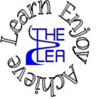
Home learning w/b: 27-4-20 Year: Reception
Message from Mrs Gallagher
Hello Reception
I hope you are all well and staying safe. We have had some lovely weather – I hope you have been out searching for mini beasts in your garden or on your daily walk! Some people have already shared the wonderful learning and work that they have been doing, please remember that you can send any work or pictures or just a description of what you have been doing – I love to look at it all – to reception@lea-pri.herts.sch.uk
Remember to keep challenging yourself, stay safe with your family and have fun!
Personal Social and Emotional Development  Think about what you are good at. It is so important to stay positive at the moment and to be confident in our learning so make time to talk about what you are good at – parents too! Then draw a picture to show what it is – there can be lots of things on the picture. You could even write a list if you want to and add to it when you have achieved something new. | Literacy  Phonics  These activities will depend on your child’s ability as to which sounds you focus on. However, recapping ones that they know will just consolidate learning.  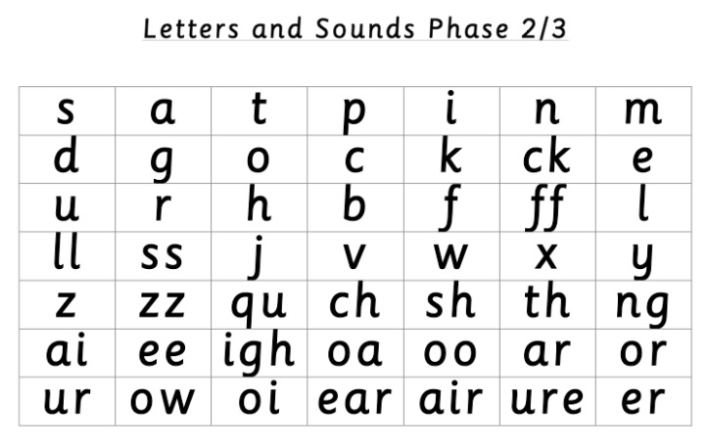  Use these sounds to have a go at some of the ideas for activities below:  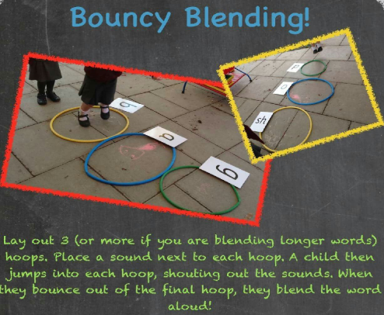  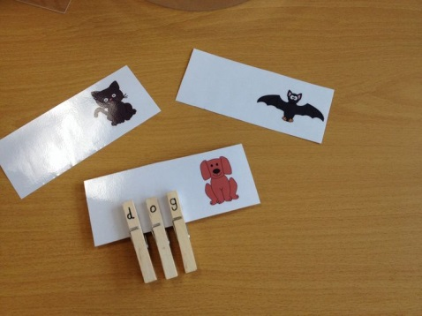  If you have some pegs and a black pen/sharpie at home then you can either use pictures, drawings or objects that need to be labelled using pegs with sounds on. Include some words with digraphs too such as, king, ship, spoon, train, seed.  If you have any bottles at home, have a go at writing either phonics sounds or words on them. Line them up like a game of bowling and roll a ball towards them – whichever ones fall down have a go at saying the sound, thinking of a word with that sound in or reading the word (depending what is on the bottle). Try and save a few bottles so that you can swap some during the game so it continues to be a challenge!  Note to parents - if you are unsure of how to say the individual sounds correctly, revisit the link on the school website:  https://lea-pri.herts.sch.uk/curriculum/phonics/  Reading  We would have been focusing on the story ‘The Tiny Seed’ if we were at school. The story is read on YouTube:  https://www.youtube.com/watch?v=ls6wTeT2cKA or if you have it at home that is great! Read the story together, discuss what is happening, what might happen next, what is different etc. Can you find any of our tricky words? Choose a sentence and muddle the words up – ask your child to then order the words so that they make sense.  Writing  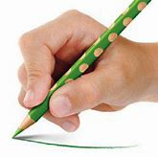  Whilst you are drawing, painting or writing, remember to hold your pencil correctly.  Parents – please make sure that you provide lines for your child to write on as this is how we have learnt to form our letters correctly.  Choose a picture from the story ‘The Tiny Seed’ and write your own CVC words, caption or sentence to say what is going on in the picture – The sun is big. The seed is now a flower.  Physical Development (fine motor and health and self-care)  Continue practising your letter formation – https://www.letterjoin.co.uk  This can also be done without a pencil in sugar, salt, flour, glitter, rice using your finger – just make sure you follow the correct formation.  Look at the food in your house or different pictures of food – try and decide which ones grow in the ground and which ones don’t. Talk about these foods – what do you notice about them? Have a go at drawing them too!
Communication and Language
Look at different flowers and plants together and have a go at a guessing game – describe what the flower/plant looks like and see if you can guess what it is. Think about what colour it is, how big or small it is, is it around just in the summer etc. Take turns at guessing and describing.
Maths
If you have a ruler or a tape measure at home, have a go at measuring different plants in the garden or out on your daily walk. Record the number and talk about the different sizes of the plants. Draw these on paper, cut them out and put them in the right order from tall to short.
You can also challenge yourself to find other plants, or objects, that are taller/shorter than your tallest or shortest plant. Focus on the number and whether it needs to be a bigger number or a smaller number in order for it to be taller or shorter.
Expressive Arts and Design
Have a go at some observational drawings of different plants that you can see either on your daily walk, in your garden or just out your window! Think about the colours you need so that it looks the same as what you are drawing.

If you have any access to paint at home you might want to try painting a flower but with a fork instead of a paintbrush!

Or try some finger painting or printing with a cork or a lid dipped in paint to make a picture.
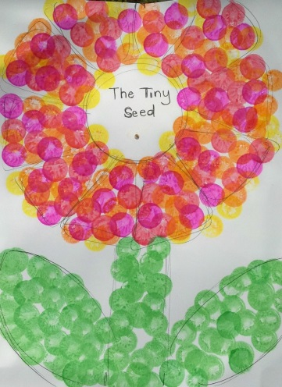

You could also have a go at retelling the story with a seed or a puppet of a seed and include all of the different places that the seed travelled before it grew.
Understanding the World  Look at the story ‘The Tiny Seed’ and talk about what happened to the seeds and the journey they went on. Think about what the seeds need to grow and have a go at drawing the life cycle of a seed, challenge yourself to label each part!  Here is a fun activity – if you have some different types of food with seeds inside, have a look at them and discuss where the seeds come from and what they all look like!  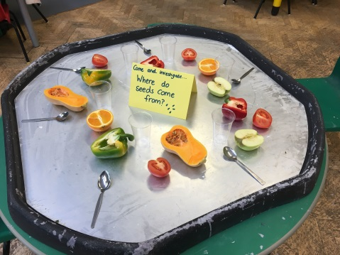 | Online Learning  Cosmic Kids Yoga – physical development  https://www.cosmickids.com/category/watch/  Education city- use individual log ins to access set work  https://www.educationcity.com/  Try the activity – Sparkler (reading tricky words and high frequency words)  Try the activity – Classy objects (ordering objects by length)  Numberblocks adding and subtracting  https://www.bbc.co.uk/cbeebies/puzzles/numberblocks-number-magic-adding-and-subtracting?collection=numbers-and-letters  Comparing the size of objects  https://www.topmarks.co.uk/early-years/lets-compare  Challenging game – measuring in cm – focus on reading the number with your child  https://www.topmarks.co.uk/maths-games/measuring-in-cm
Daily basic skills
Write or trace the tricky words – the, to, I, no, go, into, you, they, all, are, my, her, he, she we, me, be, was
You could use pencils, pens, chalk, paint, paintbrush and water, glitter, salt etc. Please only focus on a couple of words a day/week and ensure the formation is correct before moving on to a new word – provide your child with a line to write on to support correct formation.

Counting – count from 1 to 20, forwards and backwards. Write the numbers on paper or any objects you have available. Order the numbers 1 to 20, talk about what one more than X is, what one less than X is and what comes between the numbers X and X – use the numbers that have been ordered as a point of reference.

Reading – can be a book, flashcards, hide words around the house to find and read, read packets, read words in newspapers or magazines. If you have any blocks at home – lego, duplo, etc – have a go at writing words and sounds on them for your child to read and word build. Alternatively, you could write a word on paper and cut out letters for them to then build words with.

