Home learning w/b: 30.03.20 Year: 2
Message from Miss Tyler
Hi Year 2!
I hope everyone is well and have been doing some fun and interesting things at home. This week would have been a busy week at school as we finished the term and came to the end of some of the learning in our topic and other subjects. We would also have had our end of term treat and a visit from the Easter Bunny (so I have had to eat all the chocolate myself!) Keep up the good work, take care.
Celebrating your learning
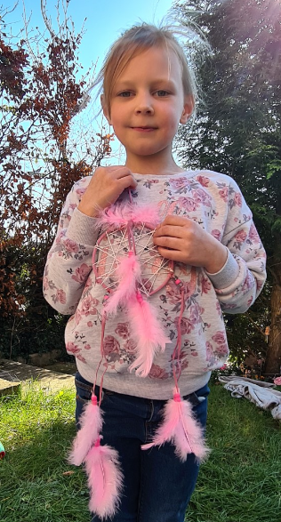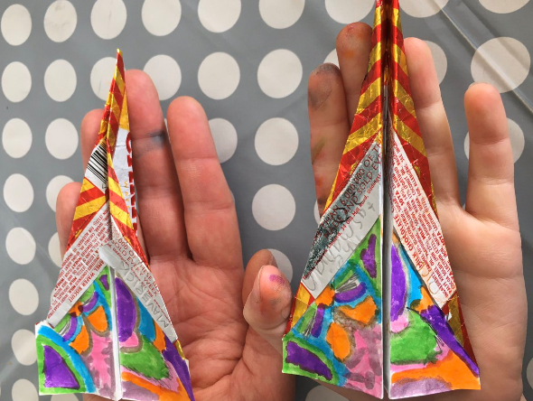
Grace and Teddy have both been getting crafty this week!
Remember to send me any examples of work or pictures of fun activities to year2@lea-pri.herts.sch.uk so that we can celebrate your efforts and learning at home.

Remember to complete your reading daily and your basic maths skills practice.
Here are this week's tasks:
Maths  3D shapes  Can you identify and describe the properties of these 3D shapes: cone, cylinder, sphere, pyramid, cube, cylinder.  How many faces do they have? How many edges? How many vertices?  Can you find any examples of these shapes around your house or in the local environment?  Make a poster to show your learning.  Daily live maths lessons which are age appropriate can be found on.  http://www.iseemaths.com/home-lessons/  https://whiterosemaths.com/homelearning/  Please join in on one a day. | Writing  Write the text for a radio advert, advertising your favourite breakfast food. Why is this cereal so delicious? What is it like? Why should you buy it? What else could you do with it apart from add milk? Is there a special deal on?  Remember to use adjectives and persuasive language and of course, remember capital letters, full-stops and exclamation marks.  Find or create a picture of a rainbow. Write a description about it. What does it look like? Where is it? How does it make you feel seeing it?  Remember to use adjectives and expanded noun phrases.
Grammar, punctuation & spelling  By the end of Year 2, all children should be able to identify and give examples of nouns, adjectives and verbs.  Ask an adult to write some simple sentences and then use different colours to highlight the different types of words. Can you explain how you know? Can you exchange the verb or noun for another verb or noun to make some silly sentences?!  If you are unsure of what these word types are, look at grammarmonster.com | Science  Our topic this term is Plants. Can you design and carry out a fair test to investigate whether plants need light to grow? Make sure you plan it carefully, consider how you will ensure it will be a fair test and how you could observe or measure changes.  After a period of time, you could draw labelled diagrams to show the results of the experiment and then write a short conclusion.
Topic  History – Who was Samuel Pepys and why was he famous? Following on from our work on the Fire of London, can you research Samuel Pepys and why he is famous. This might include some facts, some of his work and you might even have a go at sketching or painting his portrait.  Geography- Our local area. In geography we learnt about draw simple maps and using a key. We drew a map of the school. Can you draw a simple map of where you live? It could be a map of your house or of you street.  Remind yourself about keys by watching the following video  https://www.youtube.com/watch?v=oBzRq04rliY | Physical activity  Go to the Fitter Futures website and have a go at the workouts. These are between 6 and 9 minutes long and can be done at any time of the day. Try to mix up the type you choose of exercise you do, so you complete a balance of cardio and core strength activities. The new password for KS1 is 4aebp – this had to be reset so please ask an adult to log on for you, as we must not change the password.  Additionally, take a tennis ball (or any ball you have) and practise catching and throwing. If you can do 20 catches without dropping the ball try one handed!  Watch and have a go at the throwing and catching challenge on youtube  https://www.youtube.com/watch?v=FYS9o-__MwI
Art & Design
Learn about all different shading techniques. Practice each type of shading. Which is your favourite technique?
https://www.youtube.com/watch?v=-DDTrpJ4PXg
Get out into your garden or take photos during your daily walk/exercise. Sketch some seasonal plants or flowers from observation.
Use sharp pencils and use your favourite shading technique in your picture

PSHE  Pride in our World.  Draw two hearts – think about how the people in your family are important to you and help you. We cannot go to visit all of our family members at the moment, and this is true for many countries across the world. In the first heart, draw or write things that you can do to show family at home that you care about them. How can you help around the house? In the second heart, think about things you will look forward to doing with the family members you cannot see yet and what makes you smile about them. Decorate your hearts as creatively as you can and hang them up. You can always send a photo of your finished heart to your family members outside the home – and to us! We’d love to see them! Try a Mindful Moment activity from the Fitter Futures site – Hot Chocolate Breathing sounds tempting! | Other learning  Ask an adult to choose their favourite dance routine (e.g. The line dancing version of Cotton Eye Joe on Youtube!) and learn the dance with some other family members!  You may want to teach them one of the dances we do in class, Cha cha slide, superheroes unite or footloose.  https://www.youtube.com/watch?v=qSHxl9dhM8s  https://www.youtube.com/watch?v=ok7V1pWtRzs  https://www.youtube.com/watch?v=lJPvEs8qpQc

Daily basic skills and online learning
Recommended daily activity and timings to support basic skills
Practise handwriting, using the LetterJoin information and login sent home to help you. 10 - 15 minutes daily. This week please practice the letters v, s and r. Then practice the words vans, stars, rest and ever.
- Practice your number skills by going on numbots using the logins that were sent home.
- Practice counting in 2, 5, 10. This week can you verbally say them to someone else. Challenge- can you say them forwards and backwards?
- Practice your 2, 3, 5 and 10 times table. This week choose one and write it in order e.g 2x0=0, 2x1=2, 2x2=4 etc.
Can you draw the array to go with each one?
- Practice your number bonds to 10, 20 and 100. How quick can you get at matching them? Draw cherry model to represent them.
- Continue to read books from school and ones that you enjoy. Also get adults to read books and stories to you. Try to read 15 minutes a day.
- Practice reading and spelling the 100 high frequency words. https://www.highfrequencywords.org/
- Practice reading and spelling the Year 2 common exception words.
These can be found on Twinkl. You can find flashcards, posters, tick sheets etc.
- Do some daily writing-You may want to keep a diary of the activities you do every day. You could also write a story of your own, create a comic strip for a story that you know well, or create some non-fiction fact-files for topics that interest you.
Do not forget to use our every time we write rules:
-Say it before you write it
- Use capital letters and full stops
- Use finger spaces
- Spell the 100 high frequency words correctly

Websites:
email address for queries about logins and to send examples:
year2@lea-pri.herts.sch.uk

- Reading Eggspress – in addition to your own reading for enjoyment, there are comprehensions, spelling games and books to read on here. https://readingeggspress.co.uk

- Numbots- https://play.numbots.com/#/intro

- Education City – there will be a selection of tasks set for Maths and English, with Learn It sections to support some concepts if you need them. I have set some revision work and new learning in the homework section.
There are downloadable worksheets, too, to print out and try. There are lots of different games and activities on this site, so explore, learn and have fun! https://ec1.educationcity.com

- Fitter Futures subscription – we have a short-term access to a fitness website aimed at schoolchildren. This has workouts you can do at home and mental health and well-being activities you can try. https://app.fitterfuture.com/student/auth/login

- LetterJoin https://www.letterjoin.co.uk/

- Twinkl – parents can use this free from home for a month to support learning at home. A login offer code will be shared with your parents as soon as possible.
- If using Twinkl, these activities look useful.

