Home learning w/b: 20.04.20 Year: 2
Message from Miss Tyler
Hello Year 2!
I hope everyone is well and you had a lovely Easter weekend. It has been lovely and sunny and I hope you have had chance to do some PE or daily activity outside.
Celebrating your learning
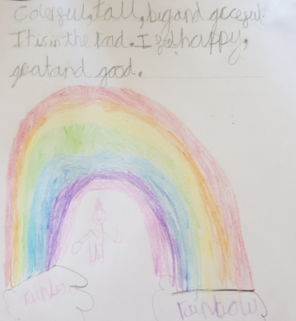
Over the last few weeks you have been sending me some fantastic writing about the colourful rainbows that you have created. My kitchen window looks really colourful with them all on display.
Remember to send me any examples of work or pictures of fun activities to year2@lea-pri.herts.sch.uk so that we can celebrate your efforts and learning at home.

Remember to complete your reading daily and your basic maths skills practice.
Here are this week's tasks:
Maths  Fractions  This week we will be learning about fractions.  Go onto the internet by using the link below and access week 1. Watch one video per day and have a go at the activities.  https://whiterosemaths.com/homelearning/year-2/  Independent challenge  On some paper have a go at drawing (or printing) some 2D shapes. Split all the shapes in half.  Can you show finding a quarter of these quantities, 8, 16, 40. You may want to draw them or physically move them and take a photo. | Writing  Choose a character from a book that you have read. Write them a letter which includes some questions that you would like to ask them.  Remember to use a question mark after each question and try and start each question in a different way.  Thinking about the same character from the book. Can you use adjectives and adverbs to write a character description about them? What do they look like? What do they do?
Grammar, punctuation & spelling  By the end of Year 2, all children should be able to identify and use suffixes.  https://www.bbc.co.uk/bitesize/topics/z8mxrwx/articles/zwgbcwx  Watch the video about suffixes and have a go at the challenges.  Can you think of some words that you can add a suffix too?  Does the word need to change when you add the suffix? | Science  As your experiment should have shown, plants do need light to survive.  Research what else plants need to be healthy and create a poster explaining to someone how to take care of a plant.  BBC bitesize may help you with this,  https://www.bbc.co.uk/bitesize/topics/zpxnyrd/articles/zxxsyrd
Topic  Geography  In Geography our topic this term is about Kampong Ayer.  Using google maps, an atlas, globe etc. Can you find where Kampong Ayer is located?  What is special about this place?  You may want to watch this video about Kampong Ayer  https://www.youtube.com/watch?v=NrztzWIjIKQ | Physical activity  Go to the Fitter Futures website and have a go at the workouts. These are between 6 and 9 minutes long and can be done at any time of the day. Try to mix up the type you choose of exercise you do, so you complete a balance of cardio and core strength activities. The new password for KS1 is 4aebp – this had to be reset so please ask an adult to log on for you, as we must not change the password.  This term we would have been looking at running techniques.  If you can, get outside and run!  Think about how you make yourself run faster, how can you stop yourself getting out of breath, how do you feel after you have been running?
Music
Have a go at the daily song on out of the Ark and try the activities.
https://www.outoftheark.co.uk/ootam-at-home/?utm_medium=email&utm_campaign=OOTA%20%20HOME%20week%204%20AB%20Winner&utm_content=OOTA%20%20HOME%20week%204%20AB%20Winner+CID_f374ffc977b0bd9956f2f3dc70bc9a4e&utm_source=Email%20newsletter&utm_term=CHECK%20OUT%20WEEK%204%20HOME

Can you make up your own song about the weather?
Can you create a beat to go with it? You may clap, stomp, bang on a pan, hit 2 spoons together.
PSHE  This term we would have looked at money in PSHE. Think about the reasons why you think we have money. Why do you think we have banks?  Design or create a money box that you save money in. | Other learning  Play a board game with a sibling or an adult.  Play bingo using the common exception words.

Daily basic skills and online learning
Recommended daily activity and timings to support basic skills
Practise handwriting, using the LetterJoin information and login sent home to help you. 10 - 15 minutes daily. This week please practice the letters f, z and x. Then practice the words fox, zoo, oxen and fuzzy.
- Practice your number skills by going on numbots using the logins that were sent home.
- Practice counting in 2, 5, 10. This week can you draw them as an array.
- Practice your 2, 3, 5 and 10 times table. This week choose one and write it in order e.g 2x0=0, 2x1=2, 2x2=4 etc.
Can you draw the array to go with each one?
- Practice your number bonds to 10, 20 and 100. How quick can you get at matching them? Draw a bar model to represent them.
- Continue to read books from school and ones that you enjoy. Also get adults to read books and stories to you. Try to read 15 minutes a day.
- Practice reading and spelling the 100 high frequency words. https://www.highfrequencywords.org/
- Practice reading and spelling the Year 2 common exception words.
These can be found on Twinkl. You can find flashcards, posters, tick sheets etc.
- Do some daily writing-You may want to keep a diary of the activities you do every day. You could also write a story of your own, create a comic strip for a story that you know well, or create some non-fiction fact-files for topics that interest you.
Do not forget to use our every time we write rules:
-Say it before you write it
- Use capital letters and full stops
- Use finger spaces
- Spell the 100 high frequency words correctly

Websites:
email address for queries about logins and to send examples:
year2@lea-pri.herts.sch.uk

- Reading Eggspress – in addition to your own reading for enjoyment, there are comprehensions, spelling games and books to read on here. https://readingeggspress.co.uk

- Numbots- https://play.numbots.com/#/intro

- Education City – there will be a selection of tasks set for Maths and English, with Learn It sections to support some concepts if you need them. I have set some revision work and new learning in the homework section.
There are downloadable worksheets, too, to print out and try. There are lots of different games and activities on this site, so explore, learn and have fun! https://ec1.educationcity.com

- Fitter Futures subscription – we have a short-term access to a fitness website aimed at schoolchildren. This has workouts you can do at home and mental health and well-being activities you can try. https://app.fitterfuture.com/student/auth/login

- LetterJoin https://www.letterjoin.co.uk/

- Twinkl – parents can use this free from home for a month to support learning at home. A login offer code will be shared with your parents as soon as possible.
- If using Twinkl, these activities look useful.

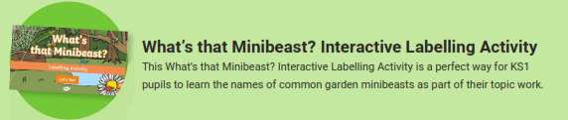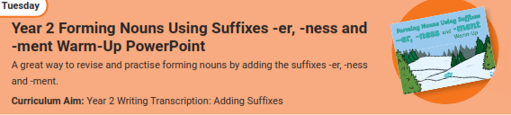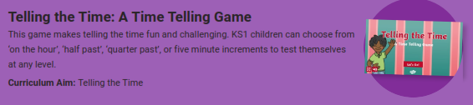

Phonics Play – https://new.phonicsplay.co.uk
While schools are closed, you will be able to access all the phonics games and resources on this website. Use the following to log in:
Username: march20
Password: home
When you have logged on, click on ‘Resources’ and then phase3, 4, 5 or 6.

