Home learning w/b: 27.04.20 Year: 2
Message from Miss Tyler
Hi Year 2! I hope you have all had a good week and have done lots of the home learning that was sent last week.
It has been a lovely sunny week again and I hope you have all been able to get outside to do some daily activity.
Celebrating your learning
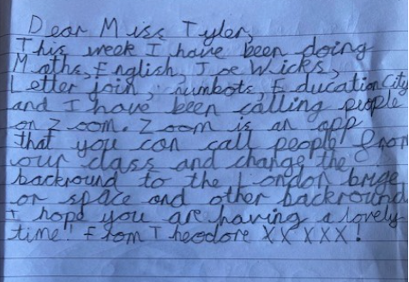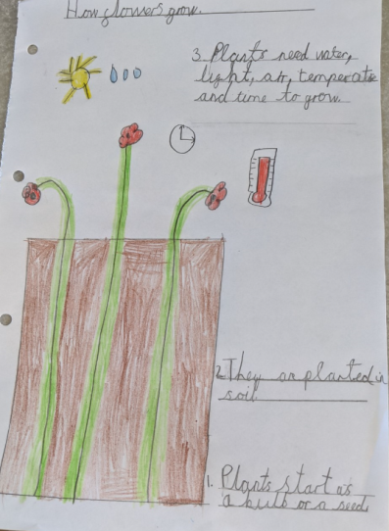
Remember to send me any examples of work or pictures of fun activities to year2@lea-pri.herts.sch.uk so that we can celebrate your efforts and learning at home.

Remember to complete your reading daily and your basic maths skills practice.
Here are this week's tasks:
Maths  Last week I asked you to start looking at fractions. This week we are going to continue with fractions.  If you can go onto the internet by using the link below and access week 2. Watch one video per day and have a go at the activities.  https://whiterosemaths.com/homelearning/year-2/  We will be comparing fractions and looking at equivalent fractions. Have a go at this activity  https://www.twinkl.co.uk/resource/t-n-252432-fractions-strip-activity-sheet  Using some buttons, smarties, dots etc tell me which fraction is bigger, smaller or equivalent.  1/2 or 1/3 of 6  2/3 or 3/4 of 12  3/6 or 1/2 of 18 | Writing  In class we learnt about the structure of a story, it needs a beginning, a middle and an ending.  Can you tell an adult the different parts of your favourite story?  Write me your own story. Remember to plan your writing first under each part so your story has a good structure.  Remember when writing to use the every time we write.  Challenge, can you include conjunctions, speech marks and expanded noun phrases.
Grammar, punctuation & spelling  In preparation for year 3 we are going to start learning about speech marks.  Watch this clip about speech marks  https://www.youtube.com/watch?v=jFLdsh47Nbc  Have a go at writing these sentences again and put in the speech marks.  I told you I was hungry! said the boy.  The man shouted Can you get me some tennis balls please? | Science  What is the lifecycle of a plant?  Watch the video and have a go at the quiz.  https://www.bbc.co.uk/bitesize/topics/zpxnyrd/articles/z2vdjxs  Draw and label the lifecycle of your favourite plant.
Topic  Geography  In Geography our topic this term is about Kampong Ayer.  Watch this video about Kampong Ayer  https://www.youtube.com/watch?v=NrztzWIjIKQ  What are the similarities and differences between the houses in Kampong Ayer and the houses we have here?  You may want to draw and label or write the differences. | Physical activity  Go to the Fitter Futures website and have a go at the workouts. These are between 6 and 9 minutes long and can be done at any time of the day. Try to mix up the type you choose of exercise you do, so you complete a balance of cardio and core strength activities. The new password for KS1 is 4aebp – this had to be reset so please ask an adult to log on for you, as we must not change the password.
Art & Design
This term we would be learning about Andy Goldsworthy.
Find a piece of artwork that he has created.
Write down what you like about it.
You may want to print it out and label or write around it. What materials do you think he has used? How does it make you feel?
What would make it better?
RE  How can we live together when we are all so different? Isn’t it wonderful that we are all so different! Our school values are: respect, kindness, ambition and pride. Can you think of some other values that are important to help us to live and learn together happily? Can you make a picture to show how we can live together happily when we are all so different? If you have a faith, how does it encourage you to live and behave towards other?  Here are some values you could consider https://www.twinkl.co.uk/resource/t-l-8542-kind-words-mindfulness-colouring-page- | Other learning  Get creative in the kitchen.  Last week I decided to get creative in the kitchen and made some scones!  What can you make in the kitchen safely with an adult?  You may want to make a sandwich, a cake, soup, fruit salad or a whole meal!  Do forget to take a picture and send it to me! I'd love to see your creations!

Daily basic skills and online learning
Recommended daily activity and timings to support basic skills
Practise handwriting, using the LetterJoin information and login sent home to help you. 10 - 15 minutes daily. This week please practice the letters v, s and r. Then practice the words vans, stars, rest and ever.
- Practice your number skills by going on numbots using the logins that were sent home.
- Practice counting in 2, 5, 10. This week can you verbally say them to someone else. Challenge- can you say them forwards and backwards?
- Practice your 2, 3, 5 and 10 times table. This week choose one and write it in order e.g 2x0=0, 2x1=2, 2x2=4 etc.
Can you draw the array to go with each one?
- Practice your number bonds to 10, 20 and 100. How quick can you get at matching them? Draw cherry model to represent them.
- Continue to read books from school and ones that you enjoy. Also get adults to read books and stories to you. Try to read 15 minutes a day.
- Practice reading and spelling the 100 high frequency words. https://www.highfrequencywords.org/
- Practice reading and spelling the Year 2 common exception words.
These can be found on Twinkl. You can find flashcards, posters, tick sheets etc.
- Do some daily writing-You may want to keep a diary of the activities you do every day. You could also write a story of your own, create a comic strip for a story that you know well, or create some non-fiction fact-files for topics that interest you.
Do not forget to use our every time we write rules:
-Say it before you write it
- Use capital letters and full stops
- Use finger spaces
- Spell the 100 high frequency words correctly

Websites:
email address for queries about logins and to send examples:
year2@lea-pri.herts.sch.uk

- Reading Eggspress – in addition to your own reading for enjoyment, there are comprehensions, spelling games and books to read on here. https://readingeggspress.co.uk

- Numbots- https://play.numbots.com/#/intro

- Education City – there will be a selection of tasks set for Maths and English, with Learn It sections to support some concepts if you need them. I have set some revision work and new learning in the homework section.
There are downloadable worksheets, too, to print out and try. There are lots of different games and activities on this site, so explore, learn and have fun! https://ec1.educationcity.com

- Fitter Futures subscription – we have a short-term access to a fitness website aimed at schoolchildren. This has workouts you can do at home and mental health and well-being activities you can try. https://app.fitterfuture.com/student/auth/login

- LetterJoin https://www.letterjoin.co.uk/

- Twinkl – parents can use this free from home for a month to support learning at home. A login offer code will be shared with your parents as soon as possible.
- If using Twinkl, these activities look useful.

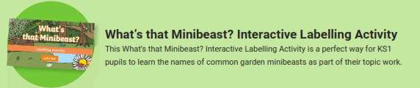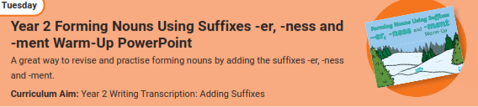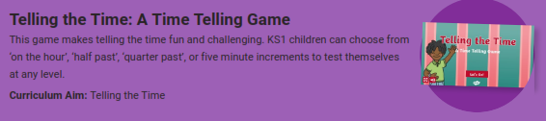
Phonics Play – https://new.phonicsplay.co.uk
While schools are closed, you will be able to access all the phonics games and resources on this website. Use the following to log in:
Username: march20
Password: home
When you have logged on, click on ‘Resources’ and then phase3, 4, 5 or 6.

