Home learning w/b: 27.4.20 Year: 3
Message from Mrs Roper and Mrs Davenport.
Hi Year 3! It was really lovely to speak to many of you this week on the Zoom session. We hope you are all now a little bit more used to doing your schoolwork from home. Here is another grid of activities. This week, in maths, we are going to do some fractions. You will remember we were looking at these at school in March. Have a go at the work and activities – the first few days are useful revision, before moving on to new work. We would also really like you to do Times Table Rock Stars daily……we have changed the way it is set up so it will identify and work on the times tables that YOU need to do. It will even work out when you have learned them well enough to move on to the next one! However, it is important that you choose the right activity when you log on. We have sent details to your parents about this. So do please give it a go, every day, and we are sure you will have made fabulous progress by the time we get back!
Remember to keep sending in any examples of work, or pictures of fun activities, to year3@lea-pri.herts.sch.uk so we can celebrate your efforts, too.
Maths  Try the new website www.thenational.academy/online-classroom.  Choose ‘subject’ and then ‘Year3’ to take you to a choice of three subjects. Select Maths.  Please then complete the 5 maths lessons from week 1 - do one each day. The first two lessons will be really useful revision of the work we did in March - looking at part and whole, and equal and unequal parts. The lessons then move on to unit fractions, finding fractions of a given quantity and describing fractions.  Let us know if you enjoy these lessons, each has a video with a real teacher to help guide you through the work! | Writing  Go to www.pobble365.com. Each day there is a different picture to look at with some questions underneath. This week, we would like you to look at the picture from 29th April (click on ‘Pick a day’ on the top right corner, then click on April 29th). The picture is called ‘An Unexpected Adventure’.  When you have had a good look, scroll down the page to the activities below. Please complete the following:  Question Time – talk about these questions with an adult or older sibling.  Perfect Picture – follow the instructions given  Sentence Challenge – follow the instructions given  Sick sentences – improve them by giving them different sentence openers, adjectives and adverbs. Write them neatly.  Story Starter – read this and copy it onto some lined paper. Then carry on the story of the girl in the bathtub. What happened next? Where did she go? What happened? What went wrong / what was the problem? How was it sorted out? Write neatly and remember to use adverbs, conjunctions and prepositions. Don’t forget sentence punctuation.
Grammar, punctuation & spelling  We can see that quite a few of you haven’t yet completed the homophones games on Education City yet so we will leave that on for another week.  Homophones are words that sound the same but are spelt differently (for example, see and sea).  If you haven’t already done the Education City activities, please log in and find the Homework folder called ‘Homophones’. Then complete the 4 homophone games. If you are able to print the worksheets off and do those too, that is great, but don’t worry if you can’t.  If you have already done the 4 games, then have a go at making your own pairs game using 8-10 pairs of homophones. | Science – Nutrition  In last week’s activity, you learnt about the different types of nutrients. This week you are going to be learning about eating the right amount of nutrients. It is important that we eat the right amount of food from each food group so that we stay healthy.  Have a look at the Eatwell Guide – we looked at this when we made out healthy sandwiches in school. Go to this website which tells you all about it:  https://www.nhs.uk/live-well/eat-well/the-eatwell-guide/  Then have a go at planning a breakfast, lunch and dinner for one day and record it on a piece of paper. Make sure that you include the right amount of each food group throughout the day. There is a list of foods in each food group at the end of this document that might help you. This video might be useful too:  https://www.youtube.com/watch?v=8aWqZd9RScQ  You might even want to try following your meal plan!
Topic  Last week you should have labelled the blank map we sent with the four countries of the United Kingdom, and their capital cities (another copy map attached, in case you forgot!) This week, we would like you to research and label the seas around the UK on that map. Then, use a map in a book or on the internet to find the name of some of the main rivers. If you want a challenge, choose a river to follow on a map and find out where it starts and finishes. Once you have done that, have a go at the art task below. | Physical activity  Go to the Fitter Futures website https://www.fitterfuture.com/ and log in using the details sent home. Please ask an adult to log on for you, as we must not change the password.  One you are logged in, have a go at the workouts. These are between 7 to 12 minutes long and can be done at any time of the day. Try to mix up the type you choose of exercise you do, so you complete a balance of cardio and core strength activities.  Extra Challenge – Joe Wicks has been doing a world quiz this week. It would link in well with our topic if you could create a “Round the UK” quiz, including questions about rivers, seas, landmarks, towns, cities and anything else you think is interesting. Don’t forget to research and write down the answers! Try it out on your family and friends.
Art & Design
Lots of artists have created pictures using the rivers and seas as inspiration. Have a go at creating your own watery landscape picture or painting. Challenge - Georges Seurat painted many seascape and river scenes using a technique called pointillism. If you want to, you can research what this is and use it when creating your picture. Have fun!
PSHE – Money  This week you are going to be thinking about where money comes from and different ways people can pay for things.  Frist of all watch this video:  https://www.youtube.com/watch?v=Vyheek2FqL4  Then talk to an adult about the following questions and make a list of all the answers you can think of together.  Question 1 – How do people get money (Adults and children)?  Question 2 – What are the different ways people can pay for things?  Then, ask an adult if they have any shopping receipts you can look at. Can you see how they paid for the items? Was it cash, debit card, credit card or another way? If they used a card, can you see any of the details such as expiry date or the last 4 digits? What other information is on the receipt? | Other learning  French  Learn how to say the days of the week in French. This video will help you:  https://www.youtube.com/watch?v=rim94Xp2XQ4&t=15s  Have a go at some games to practise the days of the week in French:  https://www.lightbulblanguages.co.uk/estrellas-french-index.htm#days  Click on ‘Days of The Week’ and then try some of the activities listed.  Music  We are sure lots of you will be missing your weekly violin lessons. Have a look at https://www.royalalberthall.com/about-the-hall/news/2020/april/meet-the-orchestra-with-alberts-band/?utm_source=wordfly&utm_medium=email&utm_campaign=e-newsletter&utm_term=royal-albert-home-newsletter-  Watch the episode about the Violin – if you want to, listen to the other episodes too! Enjoy.

Daily basic skills and online learning
Recommended daily activity and timings to support basic skills
- Handwriting – try to practise for 10 minutes a day. The Letter-join website can help you - click on ‘Easy letters’, ‘Harder letters’, ‘Easy words’ and ‘Harder words’ to practice. There are lots of other activities in the ‘Resources’ section that you can explore.
- Practise spelling High Frequency Words and words on the Y3/4 word list. Little and often is best. You can see the lists of words on the school website:
https://lea-pri.herts.sch.uk/curriculum/english/
This website is a good one to use to help you practise them:
https://www.ictgames.com/mobilePage/lcwc/index.html (Click on Y2 Tricky Words and Y3&4 Tricky Words)
- Practise your Times Tables for 10 minutes a day. Remember, you need to know your 2, 3, 4, 5, 8 and 10 times tables by the end of Year 3 as a minimum. Once you know them in order, practise them out of order, and then practise using them to answer division questions. Times Tables Rockstars is a good website to use. See our separate note to parents for advice on using this website effectively
- Continue to read every day for 15-20 minutes. You could read independently some days, but to an adult on other days. Also ask an adult or older sibling to read to you. Log onto Reading Eggspress as well.
- Log onto Education City – we have carefully selected learning activities for English, Maths, Science and Computing. We would like you to complete these. Look in the ‘Homework’ section to find them.
- Do not forget to use our Every Time We Write rules:
- Say it, write it, read it
- Use our neatest handwriting
- Use capital letters and full stops
- Check spellings of our High Frequency Words (you can find these on the school website https://lea-pri.herts.sch.uk/curriculum/english/)

Websites:
- email address for queries about logins and to show us any fantastic work:
year3@lea-pri.herts.sch.uk

- Reading Eggspress – in addition to your own reading for enjoyment, there are comprehensions, spelling games and books to read on here. https://readingeggspress.co.uk

- Times Tables Rockstars- https://ttrockstars.com/

- Education City – there will be a selection of tasks set for Maths, English, Science and Computing with Learn It sections to support some concepts if you need them. There are downloadable worksheets, too, to print out and try. There are lots of different games and activities on this site, so explore, learn and have fun! https://ec1.educationcity.com

- Fitter Futures subscription – we have a short-term access to a fitness website aimed at schoolchildren. This has workouts you can do at home and mental health and well-being activities you can try. https://app.fitterfuture.com/student/auth/login

- LetterJoin https://www.letterjoin.co.uk/

- Twinkl – parents can use this free from home to support learning at home while schools are closed.

- Phonics Play https//new.phonicsplay.co.uk – while schools are closed you will be able to access all the phonics games and resources on this website. It will be really good for everyone to revise some phonics, and if any of you are unsure of some sounds, it will be a good chance to practise! Use the following to log in. Username -march20 Password - home. When you have logged in, click on ‘Resources’ and then ‘Phase 3’, ‘Phase 5’ or ‘Phase 6’.

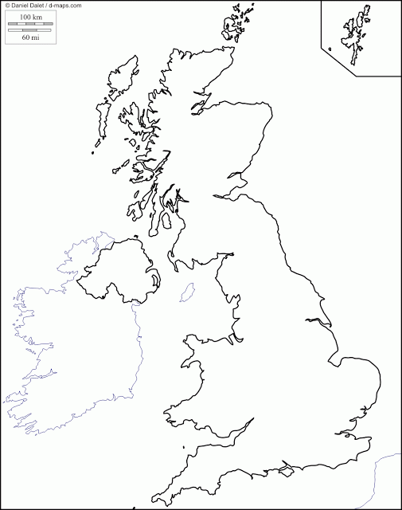

Food Groups
Food group | Food included in this group
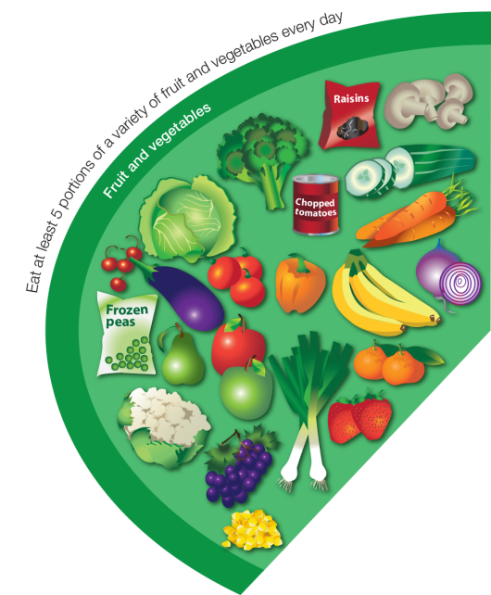  Fruit and vegetables | Apple, Baked beans, Banana, Broccoli, Cabbage, Carrots, Cauliflower, Cucumber, Fruit juice, Fruit smoothie, Kiwi, Lettuce, Melon, Oranges, Pears, Peas, Pineapple, Plums, Raisins, Strawberries, Sweetcorn  Fresh, frozen, dried, canned and juiced all count.
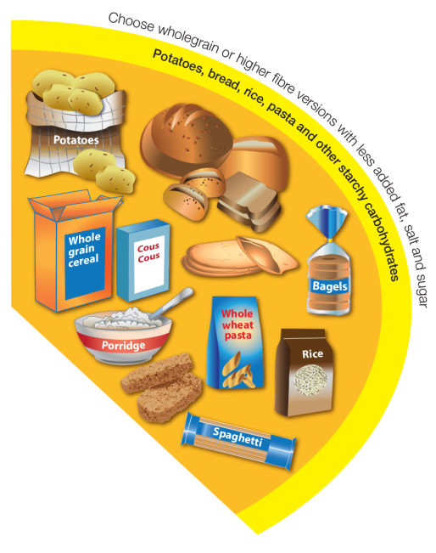  Potatoes, bread, rice, pasta and other starchy carbohydrates | Bread: soda bread, rye bread, pitta, flour tortilla, baguettes, chapatti, bagels  Rice, potatoes, breakfast cereal, oats, pasta, noodles, maize, cornmeal, couscous, bulgar, polenta, millet, spelt, wheat, pearl barley, yams, plantains.
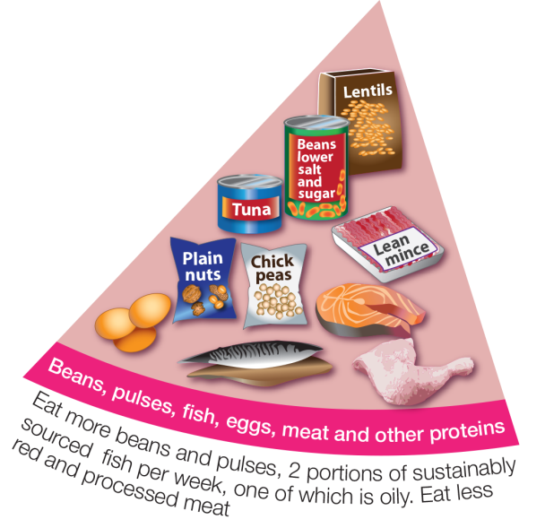  Beans, pulses, fish, eggs, meat and other proteins | Meat, poultry and game including: lamb, beef, pork, chicken, bacon, sausages, burgers  White fish (fresh frozen or canned) including: haddock, plaice, pollock, coley, cod, canned tuna  Oily fish (fresh frozen or canned) including: prawns, mussels, crab, squid oysters  Nuts, eggs, beans and other pulses including: lentils, chickpeas, baked beans, kidney beans, butter beans  Vegetarian meat alternatives e.g. tofu, micoprotein
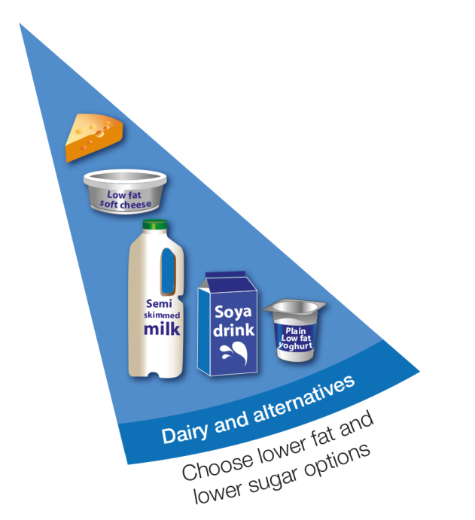  Dairy and alternatives | Milk, cheese, yogurt, fromage frais, quark, cream cheese.  This includes non-diary alternatives to these foods.
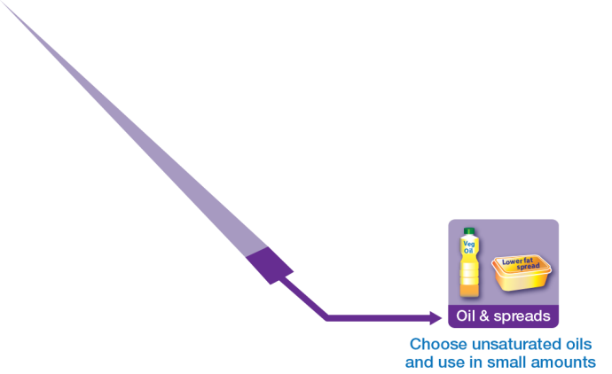  Oils and spreads | Vegetable oil, rapeseed oil, olive oil, sunflower oil.  Soft spreads made from unsaturated oils.

