Home learning w/b: 30.3.20 Year: 4
Message from Mrs Hills and Mrs Stevenson
Hello Year 4!
We hope you’re all ok and keeping well. We hope you’ve managed to keep yourselves busy with some of the activities we set for you on the grid last week. Please remember to send in any examples of work or pictures of fun activities to year4@lea-pri.herts.sch.uk so we can celebrate your efforts.
This week would have been a busy week at school as we finished the term and came to the end of some of the learning in our topic and other subjects. Remember to complete your reading daily and your basic maths skills practice.
Maths  Daily live maths lessons which are age appropriate can be found on.  http://www.iseemaths.com/home-lessons/  https://whiterosemaths.com/homelearning/  Please join in on one a day.  The lessons on whiterosemaths this week and last week are a great consolidation of what we have been learning the last few weeks and have an activity sheet for each day.  Remember to keep practising your times tables – every day! Can you get quicker than your parents? | Writing  The last two weeks of term we should have learnt more about using imagery in our writing and used it for a description of your secret garden in a story as well as writing and performing your own secret garden poems. You could have a go at writing a description of your garden using imagery. Here’s a reminder of how you could use imagery: https://www.bbc.co.uk/bitesize/clips/zpgfb9q  You could also write your own poem about your secret garden or you could choose a poem, learn it by heart and perform it for your family. You could also write it out in your most beautiful handwriting. I quite like this one:  I made myself a snowball  As perfect as could be.  I thought I'd keep it as a pet  And let it sleep with me.  I made it some pyjamas  And a pillow for its head.  Then last night it ran away,  But first it wet the bed.  Source: https://www.familyfriendpoems.com/poem/snowball-by-shel-silverstein
Grammar, punctuation & spelling  I have put a lot of activities, about the use of the apostrophe, on educationcity. It even has its own folder – that’s how important it is! Please have a go at some of these activities. It is one of our big targets for this term and I know a lot of you still get confused. I’ve put some help with apostrophe of possession at the end of this document.  Here are a couple of songs to help you. Apostrophe of contraction song:  https://www.youtube.com/watch?v=5xE-vw2ctqo  Apostrophe of possession song:  https://www.youtube.com/watch?v=8dY2SE1G900  Please continue to work on your spellings. | Science  Please complete some of the science activities I’ve put on the year 4 folder on educationcity. We should be finishing off our topic on electricity. There are futher clips and activities you could do on https://www.bbc.co.uk/bitesize/topics/zq99q6f for learning about circuits including games to make or if you want to learn more about conductors and insulators go on https://www.bbc.co.uk/bitesize/topics/z2882hv .  Make a poster or a leaflet about electricity.  You could also try out a science experiment at home – you must ask an adult first though! There are lots of examples on this website:  http://www.sciencekids.co.nz/experiments.html
Topic – Ancient Egyptians  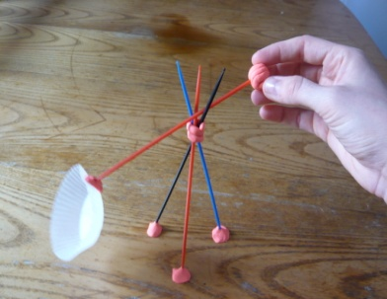  If you’d been at school, you would have been making an ancient Egyptian shaduf. You can have a go at this at home. I’ve included a picture of a very simple version. If you look on Pinterest there are lots of different version of it. Don’t buy anything especially for this. You could pick up some smalls sticks, use a small stone and a yogurt pot or whatever you can find. Find out what it was used for. | Physical activity  Go to the Fitter Futures website and have a go at the workouts. Try to mix up the type of exercise you do, so you complete a balance of cardio and core strength activities.  You can also try PE with Joe Wicks on Youtube. It really gets your heart beating fast! I’ve done it every day and am trying my very best to keep up with it! I bet you can do it better than me! I especially like the 30 second break between each exercise!  Before we started home learning, we were doing line dancing. You could make up a routine for your family to do with you. Remember to make up patterns and repeat them making sure you are following the beat of the music. This is a link to one of the line dances we did: https://www.youtube.com/watch?v=iqriKjRyzIs
Art & Design
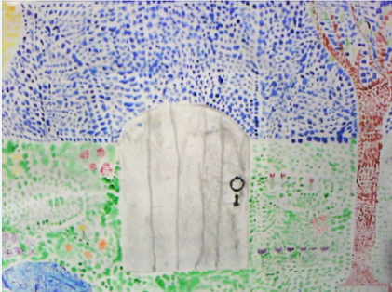
We were going to do our secret gardens using pointillism. Here is an example from a previous year. It has a big door on it because we opened the door and wrote a description of the garden. If you fancy it, you can have a go at this but you don’t have to include the door. There is some background to pointillism on this website:
https://www.happyfamilyart.com/art-lessons/art-history-for-kids/pointillism-georges-seurat-art-lesson/
PSHE - Pride in our World.  Pride in our World.  Draw two hearts – think about how the people in your family are important to you and help you. We cannot go to visit all of our family members at the moment, and this is true for many countries across the world. In the first heart, draw or write things that you can do to show family at home that you care about them. How can you help around the house? In the second heart, think about things you will look forward to doing with the family members you cannot see yet and what makes you smile about them. Decorate your hearts as creatively as you can and hang them up. You can always send a photo of your finished heart to your family members outside the home – and to us! We’d love to see them! Try a Mindful Moment activity from the Fitter Futures site – Hot Chocolate Breathing sounds tempting! | Other learning  RE – Choose one of the activities below  Next week is a very important week for Christians. It is called Holy Week and culminates with Easter Sunday. On BBC bitesize there is a short animation and some activities to do all related to Holy Week. https://www.bbc.co.uk/bitesize/topics/ztkxpv4/articles/z4t6rj6  If you can get access to the film called ‘The Miracle Maker’, it is an animated film about the life of Jesus. The last half-hour or so is all about what happened during Holy Week.  During this last term, we have been learning about Sikhism. You could make a leaflet, poster or powerpoint about Sikhism. There are lots of clips about Sikhism on the BBC bitesize website.  Music  In Music we have been learning the ‘Stop Bullying’ rap on Charanga. We were going to write our own verses about bullying. Have a look at this school’s version of the rap and then write your own verse.  https://www.youtube.com/watch?v=ocWpzD1NQAQ
Daily basic skills and online learning

- Practise your spellings as handwriting, using the LetterJoin information and login sent home to help you. 15 minutes 3 times per week. See links below.
- Practice your times tables on https://ttrockstars.com/ using the logins that were sent home. Focus on the times tables that you are less confident with.
- Practice your number bonds to 10, 20 and 100. How quick can you get at matching them?To those who are confident with whole numbers, make decimal numbers, ie 45.67 + 54.33.
- Continue to read books. Also get adults to read books and stories to you. Try to read 20 minutes a day.
- Practice reading and spelling all the high frequency words.
- Practice reading and spelling words from the year 3/4 spelling list. Write sentences using the words.
- Do some daily writing. See the grid above first. You may also want to keep a diary of the activities you do every day. You could also write a story of your own, create a comic strip for a story that you know well, or create some non-fiction fact-files for topics that interest you.
Do not forget to use our every time we write rules:
- Say it, write it, read it
- Use our neatest handwriting
- Use capital letters and full stops
- Check spellings of our High Frequency Words

Websites:
email address for queries about logins:
year4@lea-pri.herts.sch.uk

- Links to spelling lists are on our school website on https://lea-pri.herts.sch.uk/curriculum/english/

- Reading Eggspress – in addition to your own reading for enjoyment, there are comprehensions, spelling games and books to read on here. https://readingeggspress.co.uk

- Times Tables Rockstars on https://ttrockstars.com/

- Education City – there will be a selection of tasks set for Maths, English and Science with Learn It sections to support some concepts if you need them. There are downloadable worksheets, too, to print out and try. There are lots of different games and activities on this site, so explore, learn and have fun! https://ec1.educationcity.com

- Fitter Futures subscription – we have a short-term access to a fitness website aimed at schoolchildren. This has workouts you can do at home and mental health and well-being activities you can try. https://app.fitterfuture.com/student/auth/login

- LetterJoin https://www.letterjoin.co.uk/ Use this to practise writing spellings using your neat joined handwriting.

- Twinkl – parents can use this free from home for a month to support learning at home.

