Home learning w/b: 27.4.20 Year: 4
Message from Mrs Hills and Mrs Stevenson
Hello Year 4!
We hope you’re still all ok and keeping well. It was really lovely talking to some of you on your Zoom meeting on Thursday. Thank you so much to those of you who have sent us some pictures of what you have done. Keep sharing your pictures and work with us. We miss you and it’s a great way to keep in contact. The email address to send it to is year4@lea-pri.herts.sch.uk. Here are a few examples of what has been sent in. We also had a fantastic secret garden story from Sofia, some beautiful handwriting from William and Timothy has been practising his times tables on Skype with his grandparents. Good to see you are keeping active too. That’s really important.
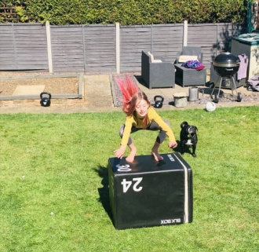
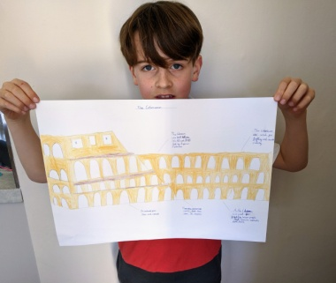
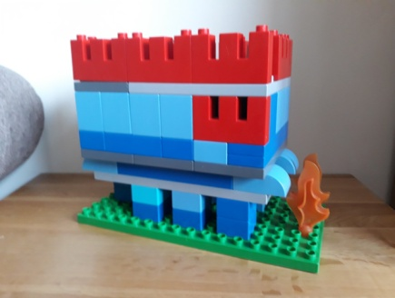

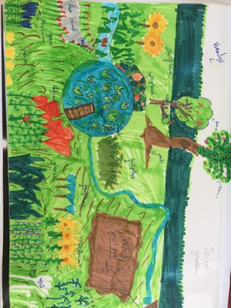

We also have a message for you from Mrs Dada
Dear Year 4,
It was so lovely seeing some of you on zoom and hearing about all the things you have been doing. I really miss you all and can’t wait until we get back to school.
I’m looking forward to seeing the Roman shields and all the other work you have been doing.
Take care everyone.
From Mrs Dada
Remember to do some reading, writing and maths every day. You don’t have to do everything on the grid, so don’t feel under pressure to do it all, just do what you can manage.
We recommend that you watch the BBC iplayer daily lesson. It is 20 minutes long and covers quite a few subjects. https://www.bbc.co.uk/iplayer/episode/p089p05x/bitesize-79-year-olds-maths-1-lesson-1
Remember to check out the activities on educationcity in the year 4 folders.
Maths  Please follow the daily maths lessons on  https://whiterosemaths.com/homelearning/  Please join in on one a day. This week continues with decimals and using decimals with money. Perhaps you could do some ‘shopping’ at home, ie a book costs £3.75 and a pencil case costs £2.12. How much is it altogether?  There is also some extra Maths attached with the email – Mystery of the Missing Shield. It’s a fractions challenge. The last 2 pages have the answers on, so don’t look at them!  If you would like to do more maths, you can also follow lessons on  http://www.iseemaths.com/home-lessons/ or there are also the daily maths lessons on BBC bitesize.  Remember to keep practising your times tables – every day! Don’t forget to practise the division facts too. | Writing  Please see the picture and activities at the end of this document. It’s taken from this website but you don’t have to log on to it unless you want to. https://www.pobble365.com/an-unexpected-adventure/  Look at the picture and imagine it is you. Do the activities on the sheet. You can spread them out over the week!  If you would like to do some more writing, you could also think back to the book ‘Journey’ you looked at last week. You could write a diary or a letter home telling about all the amazing places you visited or you could write the story or part of the story. Don’t forget to use ETWW.  You could watch this English lesson on using adverbial phrases to enhance your description. https://www.bbc.co.uk/bitesize/tags/z63tt39/year-4-lessons/1  Keep reading at home and listen to stories. On the following website, there are extracts of books read by some famous people https://www.bbc.co.uk/teach/class-clips-video/english-ks1--ks2-bringing-books-to-life/zvg4xyc
Grammar, punctuation & spelling  This week we are looking at homophones. I found a fun video reminding you what they are on: https://www.bbc.co.uk/teach/supermovers/ks2-english-homophones-with-johnny-inel/z6fjbdm  In case you can’t access it, homophones are words that sound the same but are spelt in different ways and have different meanings. How many homophones can you find? Practise spelling them and knowing what each word means. Here’s a few to start with:  to, too, two, there, they’re, their  break, brake night, knight  read, reed, fought, fort  toe, tow pray, prey | Science  https://www.bbc.co.uk/bitesize/topics/zkgg87h/articles/z9ck9qt  This week we will think about changing states of matter. Watch the video on BBC Bitesize.  Now, grab some ice from the freezer and investigate what causes it to melt and whether it will always melt at the same speed. You will need three ice cubes.  Place one somewhere you think it will melt quickly and one where you think it will melt slowly. Use the third one as a control (don't touch it).  Record how quickly each one melts. Were you correct -was the one you thought would melt the quickest first to change state? Why? Record what you have done - you could take pictures, do drawings or write about your experiment.
Topic – The Romans  This week I’d like you to look at the questions:  1. How did the Romans invade England?  2. Why did they want to invade England?  3. How long did they stay for?  4. Who was Boudica?  Here are some links to help you.  https://www.bbc.co.uk/bitesize/topics/zqtf34j/articles/z9j4kqt  http://www.primaryhomeworkhelp.co.uk/Romans.html#2  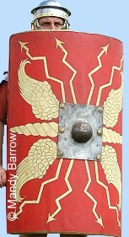  Over the next few weeks, please make a Roman shield. If you’ve got some cardboard, that would be ideal. Here’s an example of what it looked like. It doesn’t have to be as fancy as this! Keep it, so that you can bring it in to school when we return. | Physical activity  Do something active every day. You could go for a run with your parents, ride a bike or do some skipping. I can skip for 2 minutes, then I need a break! Can you beat me? You could also make up your own fitness routine. If you are able to, you can also do PE with Joe Wicks on Youtube or go to the Fitter Futures website and have a go at the workouts. Try to mix up the type of exercise you do, so you complete a balance of cardio and core strength activities.  Username: thelea2  Password: 3ffzx Please ask an adult to log on for you, as we must not change the password.  Why not keep a fitness diary so you can track your exercise.
Music  Try out music lessons with Myleene Klass on https://www.youtube.com/channel/UCQh2wgJ5tOrixYBn6jFXsXQ  Or try out a song a day with Out of the Ark on  https://www.outoftheark.co.uk/ootam-at-home/?utm_source=megamenu&utm_campaign=ootamathome1_f2&utm_medium=advertsquare | RE  Who was Jesus and what did he do? You will have heard some stories about Jesus in our RE lessons at school and you might know about him from your personal faith. You can watch this video to find out what the Bible teaches Christians about Jesus https://request.org.uk/restart/2018/03/07/bible-quest-the-teachings-of-jesus/. Is Jesus important in your faith? Can you make a picture or present your learning to show me what you know about Jesus or what your faith tells you about him?
PSHE - Money  We are continuing to look at money. This week we are looking at different ways to pay for things and how we get money. Discuss the following questions with an adult:  How do people get money?  How come people have different amounts of money?  Think about when you have been shopping with your parents. How have they paid? Is it always the same way? Watch this clip. It’s American so it has dollar signs instead of pound signs but it works in the same way in the UK.  https://www.youtube.com/watch?v=Vyheek2FqL4  What are the different ways of paying for things?  Consider which way you would pay for each of these things? An ice-cream, a Nintendo, a house, a holiday, a book and a pencil case, a meal in a restaurant.  Ask your parents if you can look at an old receipt. What information is on the receipt apart from the cost of the items? | Other learning  We are living in an extraordinary time. None of us have experienced having to stay in our homes for a long period of time before. You should receive an attachment with this letter. It is a suggested time capsule. You don’t have to do this, but it might be a nice way for you to think about the whole experience and then one day, when you are much older and this is just a memory, you can open it and remind yourself of what it was like.  French  Have a go at learning how to say fruits and food in French. Watch this clip  https://www.youtube.com/watch?v=l6Vm6cxoeug  and listen to the words on the French powerpoint attached with the email. It will need to be on slideshow for you to be able to hear the pronunciations. Can you teach the new vocabulary to your parents? Or maybe you could draw a shopping basket with some of the food in.
Daily basic skills and online learning
- Practise your spellings as handwriting, using the LetterJoin information and login sent home to help you. 15 minutes 3 times per week. See links below.
- Practice your times tables on https://ttrockstars.com/ using the logins that were sent home. Focus on the times tables that you are less confident with.
- Practice your number bonds to 10, 20 and 100. How quick can you get at matching them?To those who are confident with whole numbers, make decimal numbers, ie 45.67 + 54.33.
- Read for at least 20 minutes a day. Also get adults to read books and stories to you.
- Listen to David Walliams reading extracts from his books at 11am every day on https://www.worldofdavidwalliams.com/elevenses/
- Practice reading and spelling all the high frequency words.
- Practice reading and spelling words from the year 3/4 spelling list. Write sentences using the words.
- Do some daily writing. See the grid above first. You may also want to keep a diary of the activities you do every day. You could also write a story of your own, create a comic strip for a story that you know well, or create some non-fiction fact-files for topics that interest you.
Do not forget to use our every time we write rules:
- Say it, write it, read it
- Use our neatest handwriting
- Use capital letters and full stops
- Check spellings of our High Frequency Words

Websites:
Email address for queries about logins:
year4@lea-pri.herts.sch.uk - Please do let us know if you are having trouble with logins.
- Links to spelling lists are on our school website on https://lea-pri.herts.sch.uk/curriculum/english/
- Reading Eggspress – in addition to your own reading for enjoyment, there are comprehensions, spelling games and books to read on here. https://readingeggspress.co.uk
- Times Tables Rockstars on https://ttrockstars.com/
- Education City – there will be a selection of tasks set for Maths, English and Science
with Learn It sections to support some concepts if you need them. There are downloadable worksheets, too, to print out and try. There are lots of different games and activities on this site, so explore, learn and have fun! https://ec1.educationcity.com
- Fitter Futures subscription – https://app.fitterfuture.com/student/auth/login
- LetterJoin https://www.letterjoin.co.uk/ Use this to practise writing spellings using your neat joined handwriting.

- Twinkl – parents can use this free from home for a month to support learning at home.

- If you would like more, there are also the daily lessons on BBC bitesize. They are very good if you are happy to have extra screen time. https://www.bbc.co.uk/bitesize/dailylessons

English for this week:
An unexpected adventure

Question time!
Where did her journey begin?
Why was it ‘unexpected’?
Where will she go on her adventure?
What different things will she encounter?
How will she get back home?
How might she be feeling about the adventure?
What will her parents be thinking?
Would you like to go on an adventure like this?

Perfect picture!
Can you draw another place she might visit on her adventure in the bath?

Sentence challenge!
Verbs are actions/doing words. Can you think of a verb that would match with the following nouns to describe what they are doing?
E.g. water – trickled
Bath
turtle
water
sun
the girl
fish
plug
shower curtain
Now put them into sentences.

Sick sentences!
These sentences are ‘sick’ and need your help to get better. Can you help? What can you add or change to help them get better?
The bath went through the water.
It was a sunny day.
The girl watched a turtle.
Story writing
Write your own unexpected adventure. Use ETWW. Try to use some of the things you have learned over the last few weeks: expanded noun phrases, conjunctions, powerful verbs, fronted adverbials and similes.

