Home learning w/b: 20.04.20 Year: 6
Message from Miss Weston
Hello, Year 6!
I hope you all had a good Easter and are all well, keeping yourself busy and active!
We are all missing you here, so please remember to send in any examples of work or pictures of fun activities to year6@lea-pri.herts.sch.uk so we can celebrate your efforts.

Celebrate learning
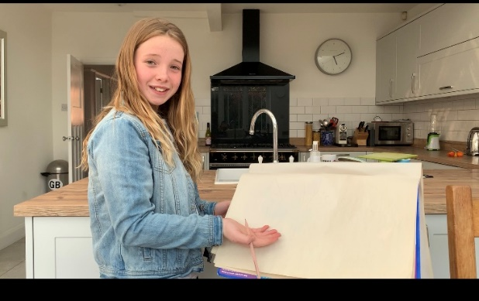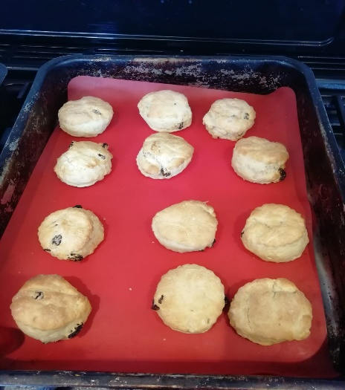
Amy designed her own school that had so many creative areas included in it. The sports area was very impressive! We have a future TV presenter in the making as she presented it via a video! Frankie made some scones for his family the other day, Mrs Milioto said they were absolutely delicious! Alexandra and her sister, made up a play to show to her grandparents on Easter day via a video link, I heard it was a great success! Well done guys, very proud!
Maths  There are set maths tasks ready in the My Homework section of Education City for you to practice past learning – fractions and begin to look at our new topic of angles. https://ec1.educationcity.com  How to use a Protractor  https://www.mathsisfun.com/geometry/protractor-using.html  Interactive protractor  http://www.crickweb.co.uk/ks2numeracy-tools.html  Online Maths lessons can be found on:  https://whiterosemaths.com/homelearning/ Summer term week 1 is based around angles.  Try these SATs style questions:  Arithmetic: https://iikiiic.exampro.net/  Reasoning: https://lidioud.exampro.net/  SPAG and Reading  SATs questions:  SPAG  https://puxeoua.exampro.net/  Reading  https://picyvuq.exampro.net/ | Writing  Click on the following link:  - https://www.talk4writing.co.uk/wp-content/uploads/2020/04/Y6-Unit.pdf  Read about ‘Doors – the world of possibility.’  Complete the following activities: (one a day)  Activity 1: The world we live in.  Activity 2: I opened the magical door and saw …  Activity 3: Artistic challenge.  Activity 4: Idioms.  Activity 5: ‘The Door’.  Activities 6-10 will be next weeks focus.
Science
There is a Science folder with set tasks ready in the My Homework section of Education City, based on our new term’s work – animals including humans. In addition to this, you could make a model of the circulatory system, or a PowerPoint about your learning.

Topic  We would have been learning about the amazing Americas (North and South America) over the summer term. For your first task, can you find the following countries on a map?  Uruguay, Canada, Mexico, Colombia, Ecuador, Costa Rica, Venezuela, Belize, Bolivia, USA.  (If you have access to a printer, you can print off a blank map and label them but if not, please do not worry just locate them on a map)  https://www.3dgeography.co.uk/blank-maps-continents  Challenge: Research and record an interesting fact for each of the countries and find its capital city.  Quiz: There are 50 states which make up the United States of America. How many can you name without finding out? Once you have had a go, can you find out what they all are?  https://www.ducksters.com/geography/usgeography.php | Physical activity  Complete Joe Wicks PE every morning (via You tube).  Go to the Fitter Futures website and have a go at the workouts. Try to mix up the type of exercise you do, so you complete a balance of cardio and core strength activities.  Username: thelea2  Password: 3ffzx  (please do not change the password)  Can you design an obstacle course? You could either draw it out on paper or set it out in your garden. Can you time yourself completing it? How can you make it more challenging?
Art & Design
I love sunflowers! Could you have a go at drawing ‘sunflowers’ by Vincent Van Gough? https://www.nationalgallery.org.uk/paintings/vincent-van-gogh-sunflowers
You could sketch it using pencil and colour pencils, paint it, use pastels or even create a collage – depending on the resources you have at home.
https://www.youtube.com/watch?v=d-eT5kJk1rI
https://www.youtube.com/watch?v=etaZdrjIpzU
https://www.youtube.com/watch?v=rU_-LTH2Qts

PSHE – Pride in our world – the environment.  Time yourself for two minutes – write down as many ways as you can think of that we use water in our daily lives?  97% of all water on earth is salt water. We can’t drink this. Only 3% of the water on earth is fresh water and of this fresh water, only 1for drinking. The other 2% is locked in ice caps and glaciers. Can you represent this information on a diagram of a glass of water? Ask an adult to help you.  The number of people living in our world is growing, the amount of water is not. It is a precious, not a natural resource that all living things need to survive.  Create a poster to answer these key questions: Why is it important not to waste water? How can we use water responsibly?  https://waterwise.org.uk/save-water/  https://www.anglianwater.co.uk/in-the-community/schools/primary-resources/ | Other learning  Read through our school play to get a good idea of the storyline and plot. What character(s) would you like to audition for? Try reading through various scenes with that character/those characters in – focus on clarity, expression, use of humour or sarcasm or evil hint to the lines. Ask your parents or siblings to help or go onto zoom and run through lines with fellow class mates. Auditions will happen end of May.  Learn how to play chess, or a word game, like hangman or boggle, or a maths game, like battleships.  Do some cooking or baking – take pictures or film yourself then email it in!
Daily basic skills and online learning
- Practise times tables regularly, and as divisions. Use TT Rockstars for 10 minutes a day – try a variety of tasks, e.g. garage/gig, not just one type.
- Practise your spellings as handwriting, using the LetterJoin information and login sent home in the Autumn Term to help you. 10 - 15 minutes daily
- Reading – independent, or with an adult, 30 minutes daily.
- Practise spellings from Y5/6 words list and tricky high frequency words. 10 - 15 mins.

conscious | marvellous | nuisance | independence
disastrous | mischievous | tolerance | convenient
special | available | sufficient | convenience
especially | vegetable | excellent | immediate
language | restaurant | apparent | immediately
neighbour | relevant | independent | explanation

Keep a diary of the activities you do every day.
- Do not forget to use our ETW rules – Every time we write we:
- take pride in our presentation
- say it, write it, read it
- punctuate each sentence correctly
- check that High Frequency Words are spelled accurately.

Websites.
email address for queries about logins, and to send examples of your work to:
year6@lea-pri.herts.sch.uk

- Reading Eggspress – in addition to your own reading for enjoyment, there are comprehensions, spelling games and books to read on here. https://readingeggspress.co.uk

- TT Rockstars – keep rocking those times tables! https://play.ttrockstars.com

- Education City – there are a selection of tasks set for Maths, English, Science and Computing with Learn It sections to support some concepts if you need them. There are downloadable worksheets, too, to print out and try. Well done to those who have had a go already! Just try your best and have fun! https://ec1.educationcity.com

- LetterJoin https://www.letterjoin.co.uk/

