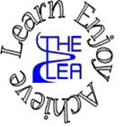
Home learning w/b: 04-05-20 Year: Reception
Message from Mrs Gallagher
Hello Reception
I am so proud of how well you are all doing with your learning at home! I am really enjoying looking at what you have been doing from baking, letter and number formation, working with your siblings, looking after mini-beasts, making dens, producing fantastic artwork and junk models and doing some great writing – keep it up! Please stay safe and as happy as you can and continue to send updates to reception@lea-pri.herts.sch.uk
Mrs Lewis says, “I am missing you all lots and can’t wait to hear about all the fun things you have been doing. X”
Mrs Tomlinson says, “I am really missing you all and you are all amazing!”
Personal Social and Emotional Development  Have a go at recreating your own circle time. We sit together and pass round a toy – you are only allowed to speak when you are holding the toy. You could use this time to discuss what you are enjoying at the moment, what you have been learning, what you are looking forward to.  We would have been thinking about how to make sure everyone’s voice is heard during different activities – listen to others, take turns, assign roles/jobs in activities etc. See if you can then use this when doing an activity together. | Literacy  Phonics  These activities will depend on your child’s ability as to which sounds you focus on. However, recapping ones that they know will just consolidate learning.  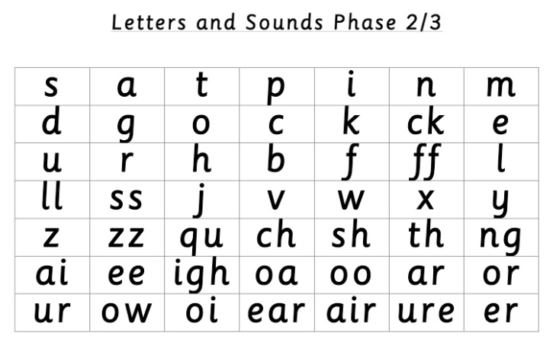  Use these sounds to have a go at some of the ideas for activities below:  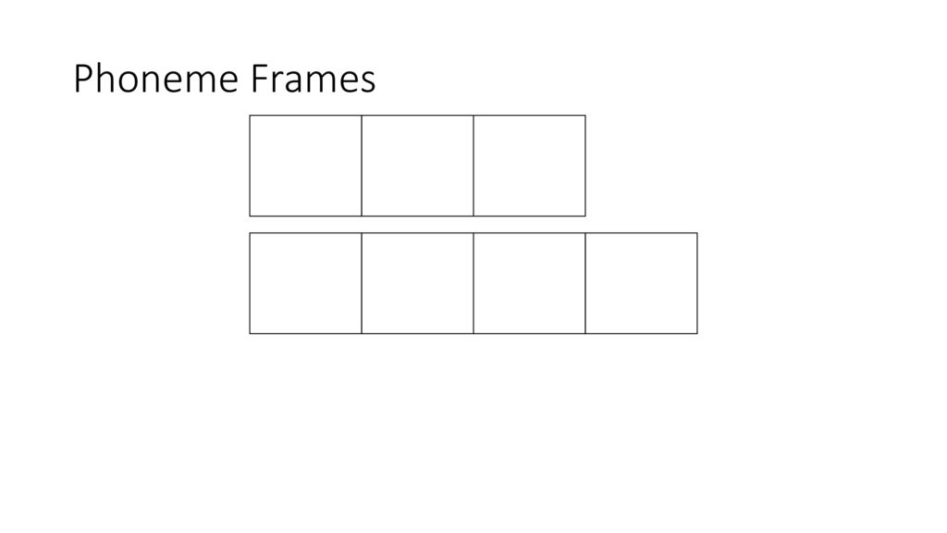  Make phoneme frames with your child with two, three or four boxes – either draw them on paper or use long objects to make physical ones (we have used rulers on the carpet before). Provide your child with either words or pictures for them to then sound out and write the sounds in each box. If you have made a phoneme frame then ensure you have phonics flashcards to put into the boxes. There are lots of examples on twinkl (see online learning).  Note to parents - if you are unsure of how to say the individual sounds correctly, revisit the link on the school website:  https://lea-pri.herts.sch.uk/curriculum/phonics/  Reading  We would have been focusing on the story ‘How to grow a dinosaur’ if we were at school. The story is read on YouTube:  https://www.youtu.be/AtP9Ja9xMgQ or if you have it at home that is great! Read/listen to the story together, discuss what is happening, what might happen next, what is different etc. Can you find any of our tricky words? Choose a sentence and muddle the words up – ask your child to then order the words so that they make sense.  Write the key words from the story down – either decodable ones or the tricky words – and hide them around your home. Get your child to go on a word hunt (if you have a magnifying glass this would be perfect and add to the fun! Feel free to make your own for this task though – plastic from a bottle would work well to look through) and see if they can read and collect all of the words from around your home.  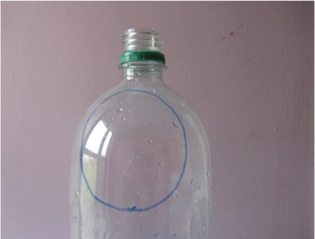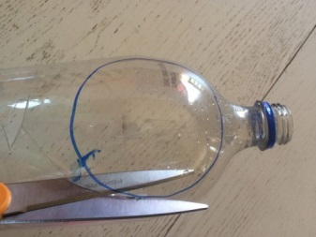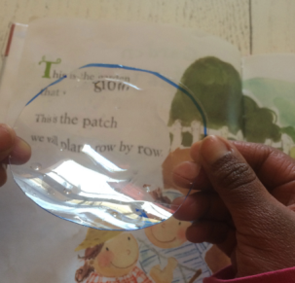  Writing  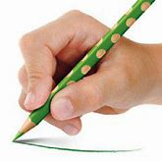  Whilst you are drawing, painting or writing, remember to hold your pencil or paintbrush correctly.  Parents – please make sure that you provide lines for your child to write on as this is how we have learnt to form our letters correctly.  Have a go at making your own garden on a tray – use things from around your house to make it or even get some grass and sticks and stones from outside. Make some little signs for your garden to label it – mud, trees, grass, pond etc (whatever you want – it’s your garden!)  Think about what you would like to grow from some seeds – it can be absolutely anything, use your imagination! Have a go at writing it in the style of a traditional story, starting with ‘Once upon a time’ – for example, Once upon a time there was a boy/girl called *your name*and they planted some seeds. Parents please remember that at this stage in Reception your child’s writing does not have to be spelt correctly, just phonetically plausible (unless it’s the tricky words – try to encourage and support these being spelt correctly) for example, wuns (once) upon a tighm (time) their (there) was a boi/gurl coold (called) and thai plarntid (planted) sum seeds.  Physical Development  Continue practising your letter formation – https://www.letterjoin.co.uk  This can also be done without a pencil in sugar, salt, flour, glitter, rice using your finger – just make sure you follow the correct formation.  Remember to also practise your numbers, starting at the correct place and form them correctly:  (This can be found on twinkl)
Communication and Language
Share a story together and discuss what is happening – ask lots of questions for children to answer for example, why has the character done that? How can they do X? What might happen next? What would you do if you were the character?
Start looking at the differences between fiction and non-fiction books if you have both. If not, have a look online at:
https://www.nationalgeographic.com
Look up different animals or plants. Look at the differences in fiction and non-fiction and talk about pictures vs photographs, stories vs facts – why do we have these? Is one type of book better than the other?
Maths
Have a go at making your very own dice board game this week to play with your family! Here’s an example to give you an idea of what you could do:
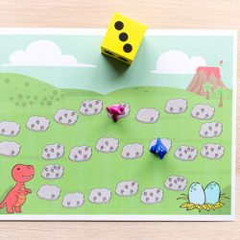
See if you can roll the dice and say the number of spots without counting them!

Try cutting out some shapes, if you have enough paper at home, and make some pictures. You could make dinosaurs from the story, different plants, things you can see out your window, different animals etc. The challenge is to describe the properties of the shapes you have used – how many sides does it have? How many corners? Is that a triangle? How do you know? Why is this shape not a square?
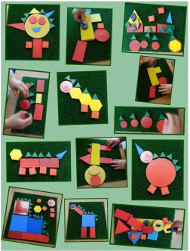
Expressive Arts and Design
Think about our story, How to grow a dinosaur, what seeds would you like to have if you could grow anything in the world? What do the seeds look like? Have a go at designing or drawing your own.

If you have any junk modelling around, have a go at making your own dinosaur – think about what they look like and what sort of shapes you will need.
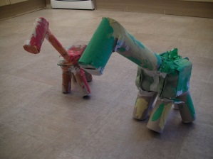
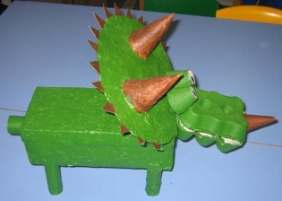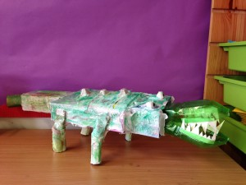

You can also have a go at recreating the garden from the story or your own place for the dinosaurs to live in – use any building blocks you may have or have a go at drawing a background for them. During the story the dinosaurs don’t speak – what might they have said? Have a go at acting out your version of the story.

If you can get hold of a balloon, give this fun activity a go and try making your very own roaring mouth dinosaur!

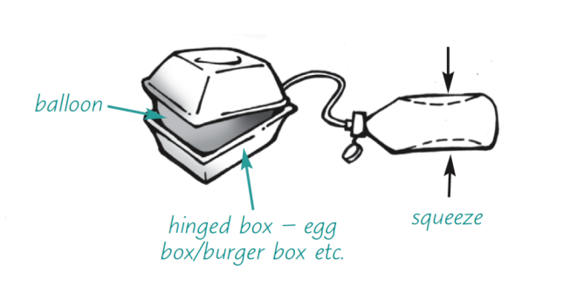
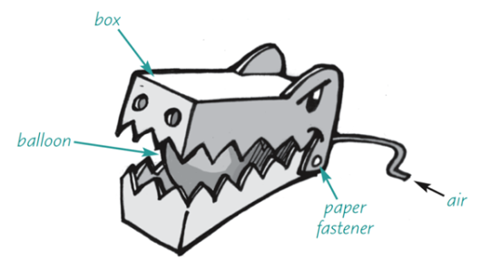
Try using a straw to get the air into the balloon to blow it up and make the mouth move – I would love to see any creations you manage!
Understanding the World  The story ‘How to grow a dinosaur’ talks about planting seeds – if you are able to get hold of any it might be fun to try and experiment. Plant some seeds in a plant pot/cup and make sure you put them somewhere that they will get plenty of sunlight. Then plant the rest of the seeds in a separate pot/cup and put it somewhere dark. Discuss what you think might happen to each of the pots of seeds and why – can you draw a picture and write a sentence about your prediction. This will help to understand the importance of sunlight for plants to grow.  Here is a fun activity to explore ice and water. Choose some small toys (or numbers, letters, coins for added learning experiences) and you can either put them into a balloon or choose a container. Different sized and shaped containers will be more interesting to look at – if you have the space in your freezer! Once the water has frozen, get them out and think of different ways to get the toys out of the ice. If you used numbers, letters or coins then have a go at trying to work out what they are through the ice before trying the melt it.  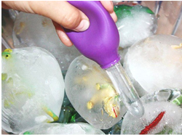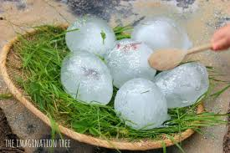  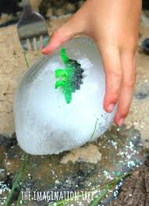 | Online Learning  Cosmic Kids Yoga – physical development  https://www.cosmickids.com/category/watch/  Education city- use individual log ins to try out these games  https://www.educationcity.com/  Try the activity – I cart believe it (supports children in hearing all of the sounds in a word)  Try the activity – Let’s play (listen to a sentence and then use the words to build the sentence)  Try the activity – Jack in the Box (listen to the numbers and click on the correct one – numbers to 20)  Try the activity – Nine lives (shape game – challenge: describe what each shape looks like)  Numberblocks adding and subtracting  https://www.bbc.co.uk/cbeebies/puzzles/numberblocks-number-magic-adding-and-subtracting?collection=numbers-and-letters  Twinkl – find pages of these for children to sound out the word (type in CVC/CVCC/CCVC words phoneme frames)  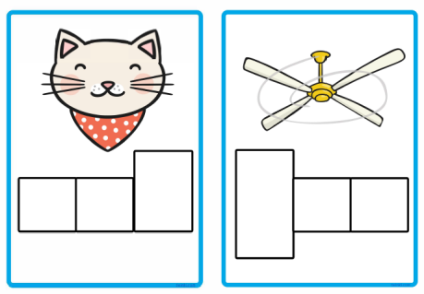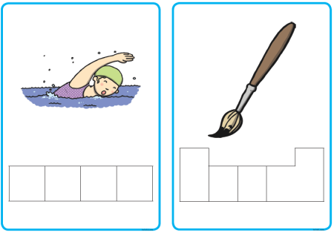  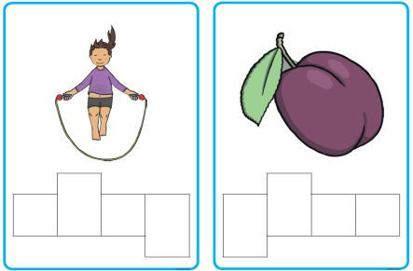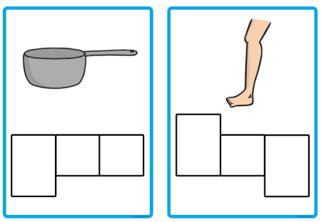
Daily basic skills
Write or trace the tricky words – the, to, I, no, go, into, you, they, all, are, my, her, he, she we, me, be, was
You could use pencils, pens, chalk, paint, paintbrush and water, glitter, salt etc. Please only focus on a couple of words a day/week and ensure the formation is correct before moving on to a new word – provide your child with a line to write on to support correct formation.

Counting – count the number of steps it takes to get to different places in your home or when you are out on a walk and record the number, using correct formation. For example, how many steps is it from your kitchen to the front door? How many steps is it from your chair to the tele?

Reading – this can be a book, flashcards, hide words around the house to find and read, read packets, read words in newspapers or magazines, read signs on your daily walk – expose your child to lots of different things to read. Have a go at reading a sentence with them and hide a word – what could the word be? What makes sense?

