Home learning w/b: 11-05-20 Year: Reception
Message from Mrs Gallagher
Hello Reception
Here are some fun activities this week to do with frogs and their life cycle – I hope you learn lots and find out lots of facts! I can’t wait to see what you write, make, create and enjoy doing this week. I really enjoy receiving all of the updates so please continue to send them - reception@lea-pri.herts.sch.uk
You are all doing really well at this strange time and I am very proud of you all! I am certainly missing spending time with you all and teaching you new things – I’m sure your grownups are doing a fantastic job though ☺

Personal Social and Emotional Development  We talk about different zones that people can be in. Look at the picture below and discuss the different zones together. Can you think of situations when you may be in each of these zones? What is the best way to get out of the red zone? | Literacy  Phonics  These activities will depend on your child’s ability as to which sounds you focus on. However, recapping ones that they know will just consolidate learning.  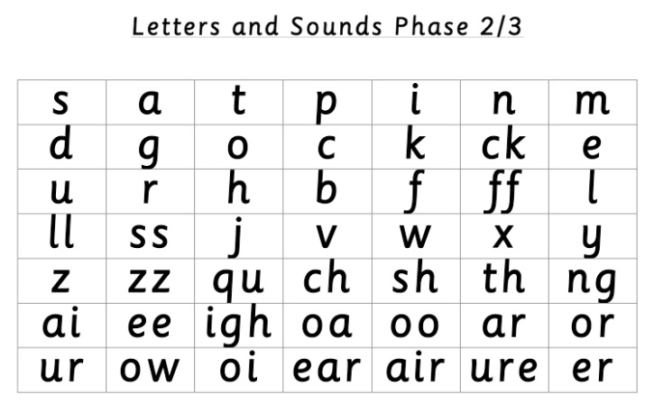  Use these sounds to have a go at some of the ideas for activities below:  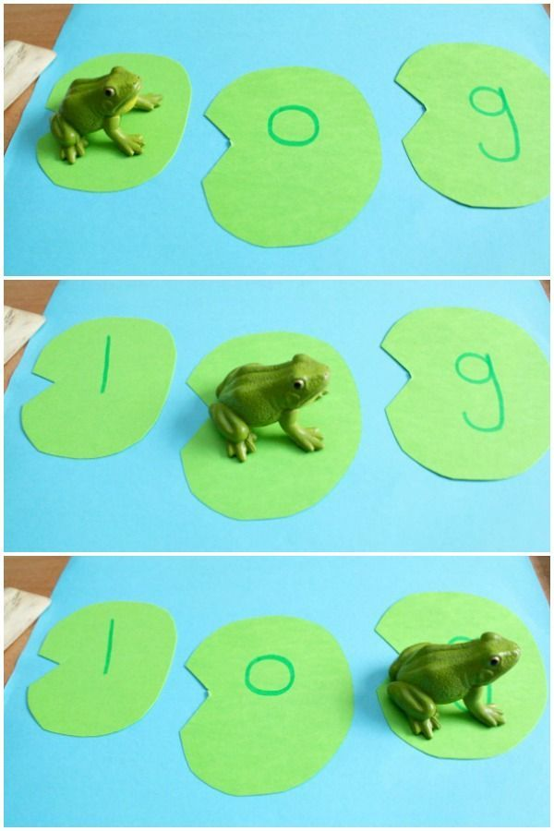  Have a go at writing CVC or CVCC/CCVC words onto lily pads and sounding out and blending the words – you can also build a word this way too. If you don’t have a frog, have a go at making a little paper one and you can even put it on a lolly stick/stick from outside and have it jump on each lily pad as you say each sound in the word. Here are some words to get you started – log, big, got, sat, green, frog, hop  Note to parents - if you are unsure of how to say the individual sounds correctly, revisit the link on the school website:  https://lea-pri.herts.sch.uk/curriculum/phonics/  Reading  Choose your favourite story that you would like to make your story of the week – talk about why it’s your favourite book, what is the best part of the book, what would you change about the story, how would you change the ending?  Have a go at reading this poem together – can you try to learn it together, put actions to go with it as you read it, draw illustrations to go with the poem? Once you have rehearsed the poem, I would love it if you could record it and send it to me so that I can see! ☺  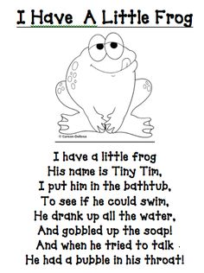  Writing  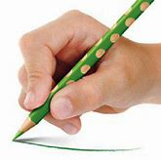  Whilst you are drawing, painting or writing, remember to hold your pencil or paintbrush correctly.  Parents – please make sure that you provide lines for your child to write on as this is how we have learnt to form our letters correctly.  Can you think of a sentence that rhymes with my sentence:  I once had a big green frog…  Think of words that rhyme with frog and then put it into a sentence to go with mine. Challenge – can you think of 3 sentences that have a word that rhyme with frog? Have a go at writing it down.  Physical Development  Continue practising your letter formation – https://www.letterjoin.co.uk  This can also be done without a pencil in sugar, salt, flour, glitter, rice using your finger – just make sure you follow the correct formation.  Practise your fine motor skills this week by making a frog from a tissue box and if you have any small, plastic animals or some pasta then use some tweezers or a spoon/fork to pick them up and feed them to the frog – try and do this one handed!  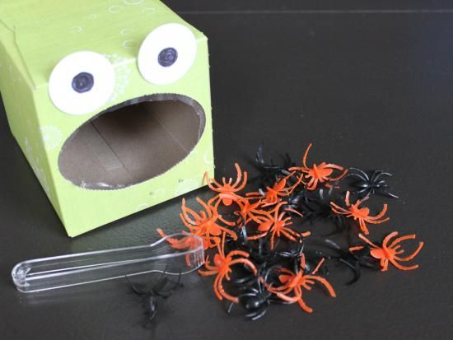
Communication and Language
Use the lifecycle of the frog to promote using full sentences when speaking and explaining things for example The frog lifecycle starts with frogspawn which is little eggs.

When looking at books this week, make sure you are explaining what your favourite parts are and why – again, promoting using full sentences.
Maths
This week have a go at learning about sharing. Use two frogs and some flies (if you’re feeling creative and want to draw and cut these out!) Use numbers 1-10 (even numbers) and choose one. Count out that number of flies and then give one fly to one frog at a time and say “One fly for this frog, one fly for that frog, one fly for this frog…etc” When all of the flies have gone, count the amount that each frog has and check that they are the same. “This frog has X and that frog has X.” Feel free to name your frogs too instead of this and that! You can do this with lots of things around your house such as, toys, buttons, pasta, cutlery, coins, stones etc. You can even do this at snack time/lunch/dinner with the food – as long as you make sure they are sharing the things/objects corretly.
Challenge: try sharing an odd number and discuss whether they can share it or not, why? What can we do with the odd one?
Expressive Arts and Design
Have a go at making your own frogs this week. Use whatever resources and materials that you have at home to make them. Below are just a few ideas using stones, card, toilet rolls, paper, cardboard etc. Focus planning your model first, draw what you would like your frog to look like, what materials you are going to use and how you will attach it all – label your plan and then follow it to make your frog!

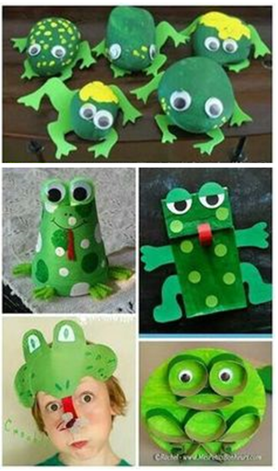

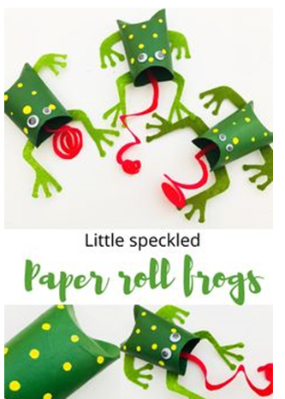
Understanding the World  Have a think about some different animals – which ones lay eggs and which ones don’t. Can you sort the animals and then make a table to show this in? You can draw the animals or write them in the correct column.  Animals that lay eggs Animals that don’t lay eggs  Look at this video of the lifecycle of a frog – it will give you information on the lifecycle and frogs:  https://youtu.be/rJOOxlFs9Is  Discuss what happens during a frog lifecycle and use your own words to describe what happens at each part – eggs, tadpole, baby frog, adult frog.  Have a go at making your own lifecycle of a frog and write a fact that you learnt from the video. You can always draw the lifecycle if you don’t have any of the resources below.  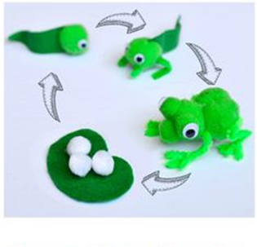  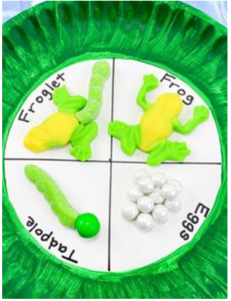 | Online Learning  Cosmic Kids Yoga – physical development  https://www.cosmickids.com/category/watch/  Education city- use individual log ins to try out these games  https://www.educationcity.com/  Try the activity – Dino Day Out (Recognising and matching coins)  Try the activity – Sparkler (read tricky words/match tricky words)  Numberblocks adding and subtracting  https://www.bbc.co.uk/cbeebies/puzzles/numberblocks-number-magic-adding-and-subtracting?collection=numbers-and-letters  Topmarks –  https://www.topmarks.co.uk/learning-to-count/chopper-squad  One more or less (find the number more or less than is given to you)  https://www.topmarks.co.uk/addition/robot-addition  Adding to 10 (drag the robot to the correct answer – use fingers or objects to work out the answer)
Daily basic skills
Write or trace the tricky words – the, to, I, no, go, into, you, they, all, are, my, her, he, she we, me, be, was
You could use pencils, pens, chalk, paint, paintbrush and water, glitter, salt etc. Please only focus on a couple of words a day/week and ensure the formation is correct before moving on to a new word – provide your child with a line to write on to support correct formation.

Counting – have a go at drawing around your hand four times and cut them out. Then have a go at counting things around the house – use the hands that you have just cut out and show the same amount to represent how many you just counted. You can also use them to do this activity:
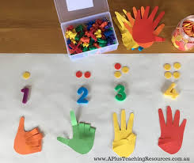

Reading – this can be a book, flashcards, hide words around the house to find and read, read packets, read words in newspapers or magazines, read signs on your daily walk – expose your child to lots of different things to read. Have a go at reading a sentence with them and hide a word – what could the word be? What makes sense?

