Home Learning w/b: 11/5/20 Year: 1
Messages from the Year 1 Team:
Mrs Monson: Hello again everyone! I’ve received so many wonderful photos of your home learning over the past week, keep them coming to year1@lea-pri.herts.sch.uk! I hope you’re all having lots of fun and helping out lots at home. Missing you!
Mrs O’Donnell: You are all doing a fantastic job. I can’t wait to see what new things you’ve learnt!
Mrs Lewis: You are all amazing and I can’t wait to hear all about the things you have been up to!
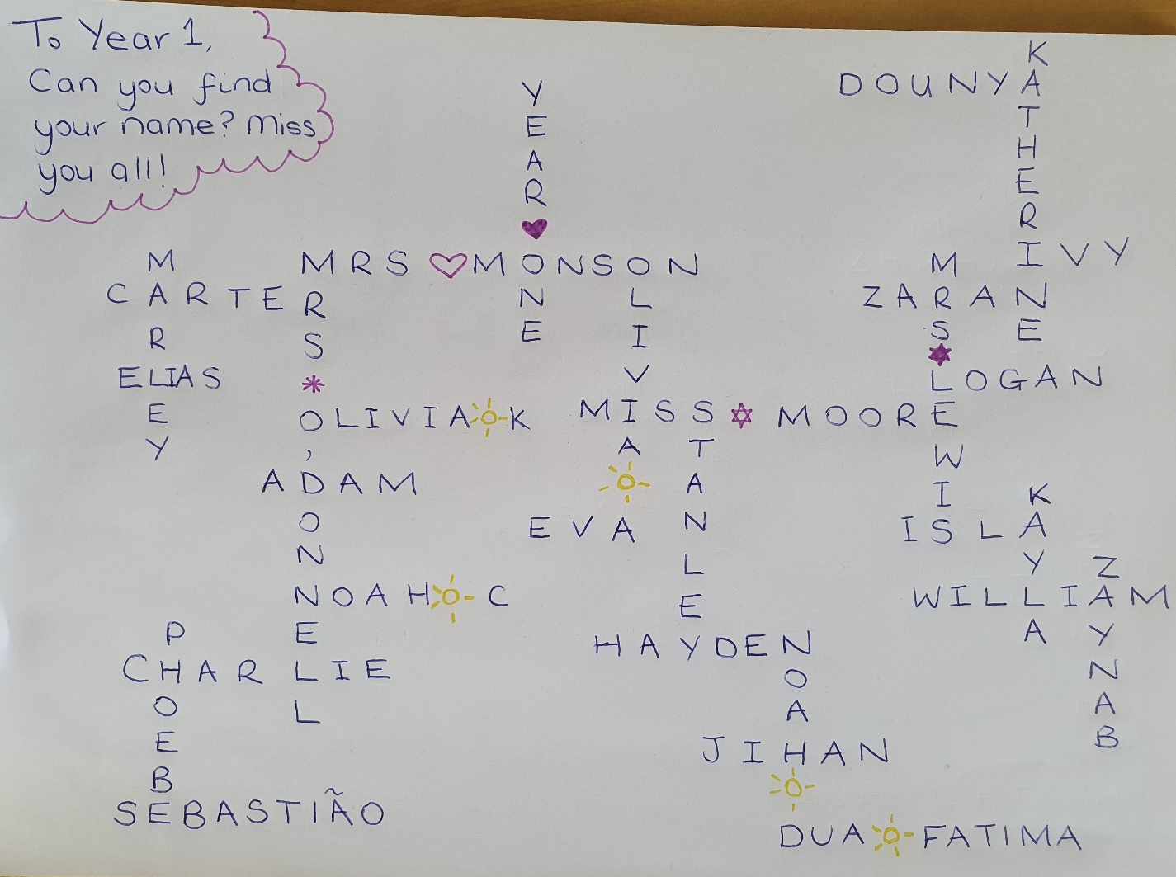
Miss Moore made this picture for you! Have a close look…

Maths  This week we’ll be looking at money! By the end of Year 1, you should be able to recognise and know the value of all British coins and notes. Practise looking at British money at home and learn the values of the coins and notes. A great way of learning is by opening your own play shop! If you don’t have all the coins or notes handy, have a look at Twinkl for printable versions.  Additionally, daily live maths lessons which are age appropriate can be found on:  www.iseemaths.com/home-lessons/  whiterosemaths.com/homelearning/  Please join in on one a day! | Writing  This week I’d like to ask you to create your own play! It can be one you make up or based on a story you know well. Write out different characters’ lines and see if you can perform it with the help of your family! I’d love to see pictures from your performance!  Remember to keep practising your joined-up writing using the methods you’ve been taught. You should be able to access our school’s handwriting scheme, Letter Join, at home to help you.  www.letterjoin.co.uk/
Grammar, punctuation & spelling  By the end of Year 1, children should be able to add the prefix un- to a word and recognise how it changes the meaning of the root word. Practise adding un- to the beginning of verbs and adjectives to explore how it changes the meaning. E.g. kind – unkind, tie – untie, etc. | Science  Last week you explored wild plants! This week, I’d like you to go on a scavenger hunt for garden plants in your back garden or local area. Garden plants are plants that people grow intentionally, like roses! If you could draw another sketch of your favourite garden plant and label it, I would love to see it!
Topic  This term so far we’ve learnt about the role of nurses and Florence Nightingale. This week I’ll ask you to research what hospitals are like in the 21st century versus what they were like in Florence Nightingale’s time (mid-1800s). How have things changed since then? There are some great resources on Twinkl to help you with this! | Physical activity  Go to the Fitter Futures website and have a go at the workouts. These are between 6 and 9 (KS2 - 7 to 12) minutes long and can be done at any time of the day. Try to mix up the type you choose of exercise you do, so you complete a balance of cardio and core strength activities. The new password for KS1 is 4aebp – this had to be reset so please ask an adult to log on for you, as we must not change the password.  Please also practise throwing and catching a ball with just one hand!
Music  This week for music, ask your parents about their favourite bands/singers and see if you can learn their favourite song together! Use this opportunity to find out what music was like during that particular decade and compare it to music nowadays. Take photos of your performance! Can you even include homemade instruments? | Phonics  Please have a look at Letters and Sounds online: www.youtube.com/channel/UCP_FbjYUP_UtldV2K_-niWw/  These are daily phonics lessons for Reception and Year 1 which your children can take part in from home. Let us know what you think!
PSHE -  This term we’ll be discussing money, linking in with our maths learning! What kinds of money are there (E.g. cash, bank accounts, cheques, credit/debit cards) and how can your parents access it? What does money look like in different countries? See what you can find out! | Other learning  This week I’d like to ask you to get cracking on another very important life skill – laundry! Can you help your parents collect the dirty laundry, wash and dry it, and learn how to do some basic folding? I’d love to see some photos of how helpful you’re being!

Daily basic skills and online learning
- Practise your handwriting, using the LetterJoin information and login sent home to help you.
5-10 minutes daily would be ideal!
- Practice your number skills by going on NumBots using the logins that were sent home. If you have lost yours, please email the address listed below for queries.
- Practice counting in 2s, 5s and 10s. There are a number of very helpful YouTube videos to support you!
- Practice your number bonds to 10, 20 and 100. How quick can you get at matching them? Impress your parents and me by showing me the corresponding cherry and bar models!
- Continue to read books from school and ones that you enjoy. Also please ensure that you read to and with your child daily. 15 minutes a day at least is recommended!
- Practice reading and spelling the 100 high frequency words.
- Practice reading and spelling the Year 1 and 2 common exception words.
- Practise your sounds and sound buttons from our phonics lessons often. You can find the Phase 3 and 5 sound mats, as well as numerous phonics activities, on the Twinkl website.
Do not forget to use our every time we write rules:
-Say it before you write it/use your phonics
- Every letter sits on the line
- Use capital letters, finger spaces and punctuation
- Ensure you form your letters properly

Websites:

Email address for queries about logins/sharing photos of home learning:
year1@lea-pri.herts.sch.uk

- Reading Eggs – in addition to your own reading for enjoyment, there are comprehensions, spelling games and books to read on here. Your child should have their login information in their reading record. https://readingeggs.co.uk/

- Phonics Play – https://new.phonicsplay.co.uk While schools are closed, you will be able to access all the phonics games and resources on this website. Use the following to log in:
Username: march20 Password: home
When you have logged on, click on ‘Resources’ and then Phase 2, 3, 4 or 5 for Year 1 children.
We’ve used this website a lot in our phonics lessons so the children should recognise which activities and games we’ve played!

- Numbots https://play.numbots.com/#/intro

- Education City – there will be a selection of tasks set for Maths and English, with Learn It sections to support some concepts if you need them. There are downloadable worksheets, too, to print out and try. There are lots of different games and activities on this site, so explore, learn and have fun! https://ec1.educationcity.com

- Fitter Futures subscription – we have a short-term access to a fitness website aimed at schoolchildren. This has workouts you can do at home and mental health and well-being activities you can try. https://app.fitterfuture.com/student/auth/login

- LetterJoin https://www.letterjoin.co.uk/

- Twinkl – parents can use this free from home for a month to support learning at home. A login offer code will be shared with your parents as soon as possible.
- If using Twinkl, this activity looks useful:
- 