Home learning w/b: 04.05.20 Year: 2
Message from Miss Tyler
Hi Year 2! I hope you all have had another good week. I have been so excited by and proud of the home learning that you have sent me this week! Keep up the excellent learning, I know it can sometimes be hard but you're doing such an amazing job with your learning at home.
Message from Mrs Wright
Hello everyone, I hope you are all well. I am missing you all and I do hope we will all be back together very soon. Keep up with your good reading and feel free create a book list of all the books you complete whilst at home so you can show me what you have read when we return to school. Have a good week. x

Celebrating your learning
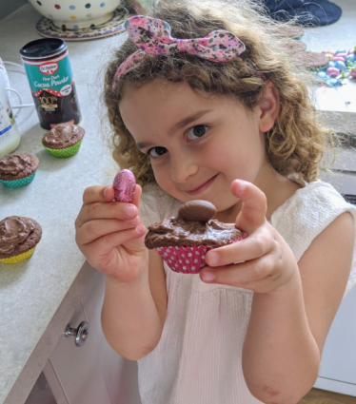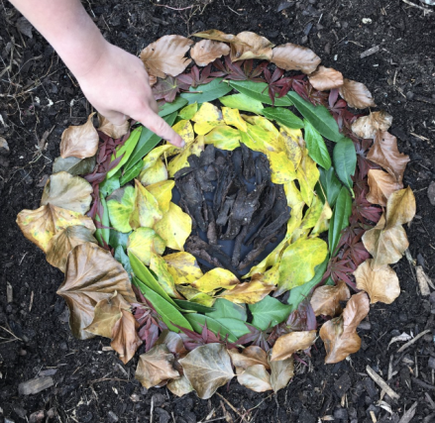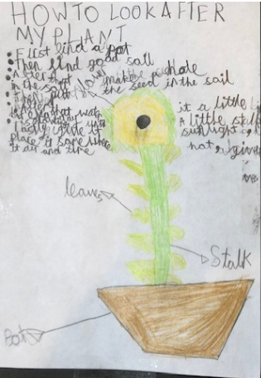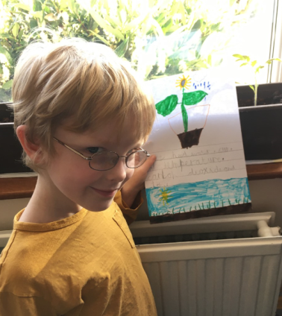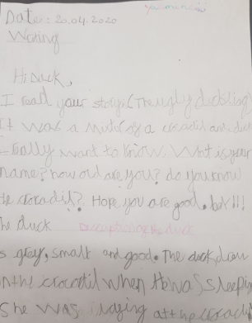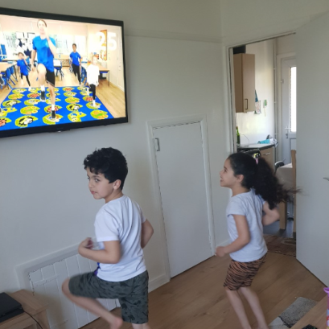
Remember to send me any examples of work or pictures of fun activities to year2@lea-pri.herts.sch.uk so that we can celebrate your efforts and learning at home.

Remember to complete your reading daily and your basic maths skills practice.
Here are this week's tasks:
Maths  Last week I asked you to start looking at fractions. This week we are going to continue with fractions and then moving on to measurements.  If you can, go onto the internet by using the link below and access Summer Term- Week 1. Watch one video per day and have a go at the activities.  https://whiterosemaths.com/homelearning/year-2/  Can you find and item in your home that is  15cm long?  30cm long?  1m long ? | Writing  Last week I asked you to get creative in the kitchen, and I did too!  This week I'm not sure what to make!  Write me recipe or instructions for something to make in the kitchen.  You might tell me how to make your favourite sandwich or how to bake cupcakes.  Remember to include numbered steps, commands with imperative verbs and adjectives so I know exactly what you mean.
Grammar, punctuation & spelling  We have done a lot of work on types of sentences this year.  Can you remember the 4 types?  Watch this clip  https://www.youtube.com/watch?v=n_foMADqjSc  Write a sentence for each type of sentence. | Science  Tell me how plants are changing over time.  I know many of you are growing something at home, how has it changed? Can you write a description of what it looks like now? Why do you think this has happened?  If you haven't been growing your own plant or if it hasn't changed much yet, watch this clip of a bean growing over time.  https://www.youtube.com/watch?v=w77zPAtVTuI
PSHE  As part of our PSHE topic we will be learning about money.  Our money needs to be kept safe. Can you think of different ways of how you can keep money safe?  Play this game about keeping money safe and how to save money.  https://natwest.mymoneysense.com/students/students-5-8/keep-helens-money-safe/ | Physical activity  Go to the Fitter Futures website and have a go at the workouts. These are between 6 and 9 minutes long and can be done at any time of the day. Try to mix up the type you choose of exercise you do, so you complete a balance of cardio and core strength activities. The new password for KS1 is 4aebp – this had to be reset so please ask an adult to log on for you, as we must not change the password.
RE  Whose world is it?  What does ‘responsibility’ mean? It is something that you are expected to do; it’s your job! Should everyone in the world take responsibility for looking after our world? If you have a faith, what does your faith teach you about looking after the world? Can you make a poster or explain to someone else why it is important to look after the world? Is it fair if some people choose not to look after the world? How can we help to look after the world? Here is a sheet that might help: https://www.twinkl.co.uk/resource/t-re-069-caring-for-the-environment-worksheet | Other learning  Bonjour!  Can you teach yourself how to say hello (and any other words) in a different language.  How many different ways can you learn to say hello?  Friday is the 75th anniversary of VE day. Do some research with an adult about why this is a special day.

Daily basic skills and online learning
Recommended daily activity and timings to support basic skills
Practise handwriting, using the LetterJoin information and login sent home to help you. 10 - 15 minutes daily.
- Practice your number skills by going on numbots using the logins that were sent home.
- Practice counting in 2, 5, 10. This week can you verbally say them to someone else. Challenge- can you say them forwards and backwards?
- Practice your 2, 3, 5 and 10 times table. This week choose one and write it in order e.g 2x0=0, 2x1=2, 2x2=4 etc.
Can you draw the array to go with each one?
- Practice your number bonds to 10, 20 and 100. How quick can you get at matching them? Draw cherry model to represent them.
- Continue to read books from school and ones that you enjoy. Also get adults to read books and stories to you. Try to read 15 minutes a day.
- Practice reading and spelling the 100 high frequency words. https://www.highfrequencywords.org/
- Practice reading and spelling the Year 2 common exception words.
These can be found on Twinkl. You can find flashcards, posters, tick sheets etc.
- Do some daily writing-You may want to keep a diary of the activities you do every day. You could also write a story of your own, create a comic strip for a story that you know well, or create some non-fiction fact-files for topics that interest you.
Do not forget to use our every time we write rules:
-Say it before you write it
- Use capital letters and full stops
- Use finger spaces
- Spell the 100 high frequency words correctly

Websites:
email address for queries about logins and to send examples:
year2@lea-pri.herts.sch.uk

- Reading Eggspress – in addition to your own reading for enjoyment, there are comprehensions, spelling games and books to read on here. https://readingeggspress.co.uk

- Numbots- https://play.numbots.com/#/intro

- Education City – there will be a selection of tasks set for Maths and English, with Learn It sections to support some concepts if you need them. I have set some revision work and new learning in the homework section.
There are downloadable worksheets, too, to print out and try. There are lots of different games and activities on this site, so explore, learn and have fun! https://ec1.educationcity.com

- Fitter Futures subscription – we have a short-term access to a fitness website aimed at schoolchildren. This has workouts you can do at home and mental health and well-being activities you can try. https://app.fitterfuture.com/student/auth/login

- LetterJoin https://www.letterjoin.co.uk/

- Twinkl – parents can use this free from home for a month to support learning at home. A login offer code will be shared with your parents as soon as possible.
- If using Twinkl, these activities look useful.

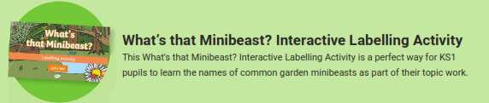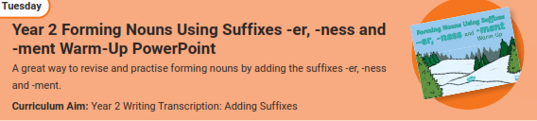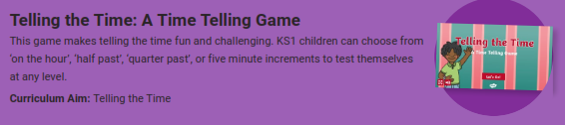
Phonics Play – https://new.phonicsplay.co.uk
While schools are closed, you will be able to access all the phonics games and resources on this website. Use the following to log in:
Username: march20
Password: home
When you have logged on, click on ‘Resources’ and then phase3, 4, 5 or 6.

