**Home learning w/b:** 4.5.20 **Year: 3**

**Message from Mrs Roper and Mrs Davenport.**

Hello Year 3! How are you all? We hope you are all well, having fun and working hard! It certainly looks like many of you are working hard as we have been receiving lots of photos of fantastic work. Well done to all of you for trying so hard to do your schoolwork at home. We know it isn’t always easy but you should be very proud of how hard you are trying – we are incredibly proud of you all!

We hope you are enjoying Mrs Parsell’s weekly challenges that we send in our Friday email to you all. We are finding them quite tricky and have got our whole families trying to work them out!

Remember to keep sending in any examples of work, or pictures of fun activities, to year3@lea-pri.herts.sch.uk so we can celebrate your efforts, too.

|  |  |
| --- | --- |
| **Maths**  Thanks to those of you who let us know that you were enjoying the Oak Academy lessons. We are glad they went down well!  This week, we would like you to try following the maths lessons on the White Rose maths website. It is now connected to the BBC bitesize daily lessons, with links going straight there for activities and further teaching, so you will have lots of options if you want to challenge yourself with extra maths! Please go to the year 3 section of  <https://whiterosemaths.com/homelearning/>  and join in week 3. You will learn about money, multiplication and division. Do one lesson a day.  Please ask your parents to let us know whether you prefer the Oak Academy, or White Rose, approach? We really value your views on the learning. | **Writing**  This week, we have chosen another picture from [www.pobble365.com](http://www.pobble365.com). Look at the picture from 15th November (click on ‘Pick a day’ on the top right corner, then click on November 15th). The picture is called ‘Look Down!’  When you have had a good look, scroll down the page to the activities below. Please complete all of them – you could try doing one a day, though some will take you longer than others.  Question Time – talk about these questions with an adult or older sibling.  Perfect Picture – follow the instructions given  Sentence Challenge – follow the instructions given.  Sick sentences – improve them by giving them different sentence openers, adjectives and adverbs. Write them neatly.  Story Starter – read this and copy it onto some lined paper. Then carry on the story of the girl in the bathtub. What could they see? What happened next? Write neatly and remember to use adverbs, conjunctions and prepositions. Don’t forget sentence punctuation. |
| **Grammar, punctuation & spelling**  This week, we would like you to investigate the suffix that sounds like ‘shun’. There are different ways of spelling this suffix and it depends on the root word.  To help you, there are some activities to complete in Education City. Look for the Homework folder called *Spellings – ‘shun’ suffix.* The activities are in order – there is a Learn Screen to tell you about it, then an activity, then a sheet to print off (if you are able to) and then an answer sheet. | **Science – Animals**  Animals can be classified into 2 groups – vertebrate and invertebrate. We would like you to find out as much as you can about each of these. Can you explain what each one is and give examples of animals in each group? There is some useful information on BBC Bitesize:  <https://www.bbc.co.uk/bitesize/topics/zn22pv4/articles/zp6g7p3>  <https://www.bbc.co.uk/bitesize/topics/zn22pv4/articles/z8mbqhv>  <https://www.bbc.co.uk/bitesize/clips/zmj8q6f>  There are also activities in Education City for you to complete on this topic. Look for the Homework Folder called *Science – animals.*  Extra challenge! Can you find out what these words mean and give examples of each:  endoskeleton, exoskeleton, hydrostatic skeleton |
| **Topic**  This week, we would like you to learn about the counties of the UK, and practise locating them by using the points of a compass. Use the map attached to look at the counties of England. A county is a small part of the UK containing lots of towns and villages, that is used in local government to control the local area and its services eg schools, transport, policing, waste management etc. The Lea School is in Hertfordshire. Have a go at using the compass points to answer the questions (answers attached so you can check if you got it right!).  If you need a reminder how to use the compass points, or are interested in map reading, see also <https://www.bbc.co.uk/bitesize/articles/zhtyvk7>  For a video teaching you about this. | **Physical activity**  Go to the Fitter Futures website <https://www.fitterfuture.com/> and log in using the details sent home. *Please ask an adult to log on for you, as we must* ***not*** *change the password.*  One you are logged in, have a go at the workouts. These are between 7 to 12 minutes long and can be done at any time of the day. Try to mix up the type you choose of exercise you do, so you complete a balance of cardio and core strength activities.  Challenge – Joe Wicks has been making his daily workouts more challenging by adding general knowledge questions, and you might have had a go at creating a UK Quiz as we suggested last week! This week, make a set of five true/false questions about UK counties of your choice, then keep them safe so we can share them when we go back to school! |
| **Art & Design** This week is a special week as we celebrate VE day on Friday. This is when we remember the day the Second World War ended in Europe 75 year ago. Please watch the clip on BBC Bitesize about VE day  <https://www.bbc.co.uk/teach/class-clips-video/history-ks2-ve-day/z7xtmfr> Your task is to design a medal to celebrate this! Have a look on the internet for a picture of the medal that was given to all soldiers who fought in the *First* World War, to celebrate the ending of the war. It had a rainbow ribbon, and a picture of a winged goddess called Victory. Now design your own for VE Day. |
| **PSHE**  Our planet has many natural resources that are really important for us to live our lives and survive. These include water, air, animals, minerals, soil and plants (including trees). Try to think about each of these, and the ways in which we use them. List as many ways as you can for each resource.  Then look at the pictures at the end of this document that show where people have used the Earth’s natural resources but haven’t looked after them. How do they make you feel? Why? Can you do anything about it? | **Other learning**  **Computing**  It is really important to be kind to each other! This applies to many different areas of life – and also to computing. Have a look on Education City – homework section – to find an activity about Cyber Kindness**.** Have a go at completing it.  **Music**  Go to [www.thenational.academy](http://www.thenational.academy) and try the Year 3 music lessons on pulse and beatboxing. (Find them under foundation/creative subjects) The teacher, Miss Roberts, uses violin and guitar to accompany, and we think you will really enjoy the singing and skills she is teaching! |

|  |
| --- |
| **Daily basic skills and online learning**  **Recommended daily activity and timings to support basic skills**   * Handwriting – try to practise for 10 minutes a day. The Letter-join website can help you - click on ‘Easy letters’, ‘Harder letters’, ‘Easy words’ and ‘Harder words’ to practice. There are lots of other activities in the ‘Resources’ section that you can explore. * Practise spelling High Frequency Words and words on the Y3/4 word list. Little and often is best. You can see the lists of words on the school website:   <https://lea-pri.herts.sch.uk/curriculum/english/>  This website is a good one to use to help you practise them:  <https://www.ictgames.com/mobilePage/lcwc/index.html> (Click on Y2 Tricky Words and Y3&4 Tricky Words)   * Practise your Times Tables for 10 minutes a day. Remember, you need to know your 2, 3, 4, 5, 8 and 10 times tables by the end of Year 3 as a minimum. Once you know them in order, practise them out of order, and then practise using them to answer division questions. Times Tables Rockstars is a good website to use. **See our separate note to parents for advice on using this website effectively** * Continue to read every day for 15-20 minutes. You could read independently some days, but to an adult on other days. Also ask an adult or older sibling to read to you. Log onto Reading Eggspress as well. * Log onto Education City – we have carefully selected learning activities for English, Maths, Science and Computing. We would like you to complete these. Look in the ‘Homework’ section to find them. * Do not forget to use our Every Time We Write rules:   - Say it, write it, read it  - Use our neatest handwriting  - Use capital letters and full stops  - Check spellings of our High Frequency Words (you can find these on the school website <https://lea-pri.herts.sch.uk/curriculum/english/>)  **Websites:**   * email address for queries about logins and to show us any fantastic work:   [year3@lea-pri.herts.sch.uk](mailto:year3@lea-pri.herts.sch.uk)   * Reading Eggspress – in addition to your own reading for enjoyment, there are comprehensions, spelling games and books to read on here. [https://readingeggspress.co.uk](https://readingeggspress.co.uk/) * Times Tables Rockstars- <https://ttrockstars.com/> * Education City – there will be a selection of tasks set for Maths, English, Science and Computing with Learn It sections to support some concepts if you need them. There are downloadable worksheets, too, to print out and try. There are lots of different games and activities on this site, so explore, learn and have fun! <https://ec1.educationcity.com> * Fitter Futures subscription – we have a short-term access to a fitness website aimed at schoolchildren. This has workouts you can do at home and mental health and well-being activities you can try. <https://app.fitterfuture.com/student/auth/login> * LetterJoin <https://www.letterjoin.co.uk/> * Twinkl – parents can use this free from home to support learning at home while schools are closed. * Phonics Play https//new.phonicsplay.co.uk – while schools are closed you will be able to access all the phonics games and resources on this website. It will be really good for everyone to revise some phonics, and if any of you are unsure of some sounds, it will be a good chance to practise! Use the following to log in. Username -march20 Password - home. When you have logged in, click on ‘Resources’ and then ‘Phase 3’, ‘Phase 5’ or ‘Phase 6’. |

[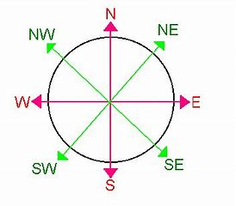](https://www.bing.com/images/search?view=detailV2&ccid=5Ygc5GPx&id=A28218940811F49503049F9F21522EDFB97809C3&thid=OIP.5Ygc5GPxPEckcUngunJHfwAAAA&mediaurl=http%3a%2f%2fwww.teachingcave.com%2fwp-content%2fuploads%2f2013%2f11%2fCompass.gif&exph=316&expw=353&q=compass+points+ks2&simid=608021047827694962&selectedIndex=6)

**Locate the counties of England**

1)Norfolk is north of ________________.

2)Herefordshire is west of __________________.

3)Buckinghamshire is east of __________________ .

4)Hampshire is south of ______________________.

5)Merseyside is bordered by____________ , and__________________ .

6)Essex is _____________of Hertfordshire.

7)Berkshire is _________________of Greater London.

8)East Riding of Yorkshire is __________________of Lincolnshire

9)Wiltshire is ___________________of Gloucestershire.

10)The most south-western county is______________________ .

ANSWERS

1)Norfolk is north of Suffolk.

2)Herefordshire is west of Worcestershire.

3)Buckinghamshire is east of Oxfordshire.

4)Hampshire is south of Berkshire.

5)Merseyside is bordered by Lancashire, Greater Manchester and Cheshire.

6)Essex is east of Hertfordshire.

7)Berkshire is west of Greater London.

8)East Riding of Yorkshire is north of Lincolnshire

9)Wiltshire is south of Gloucestershire.

10)The most south-western county is Cornwall

PSHE Pictures

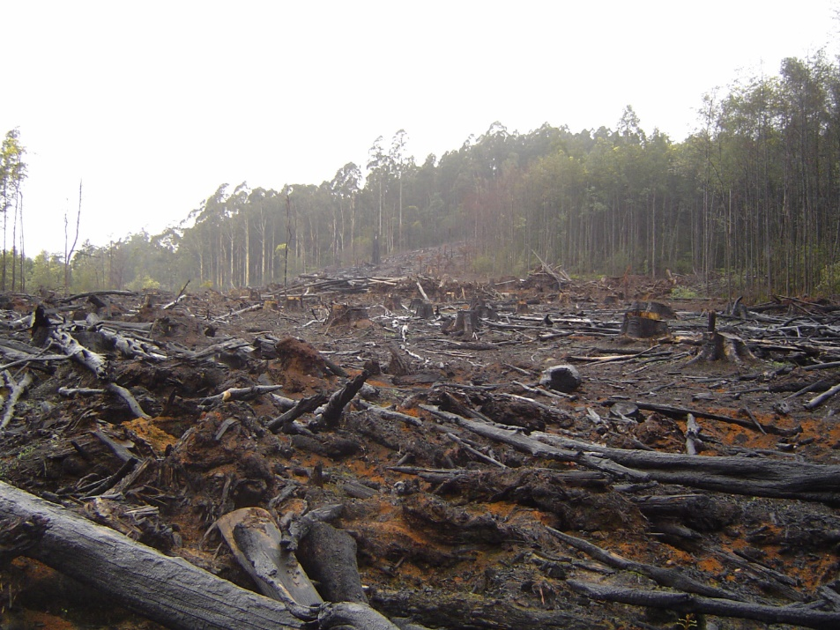 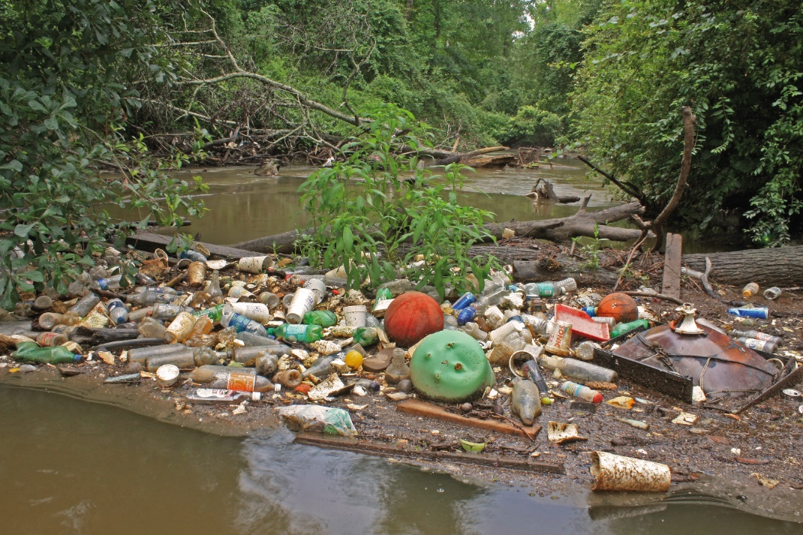

Polluting water with rubbish, harming animals and people,

Cutting down too many trees and destroying animal homes.



Burning too much fuel and making the air unhealthy to breathe.