**Home learning w/b:** 11.5.20 **Year: 3**

**Message from Mrs Roper and Mrs Davenport.**

Hello Year 3!

It was lovely to see some of you on Zoom this week. It was a shame that we didn’t have more time as we know a couple of you didn’t get to say much this time. We will make sure that those people go first next time. It sounded like lots of you have been out for walks and bike rides which is really great!

Thank you for all the photos of work and other activities that you and your parents have been sending us. We were planning to put some of them at the top of this grid each week, but we have had so many that we just can’t pick! Keep sending them in as we love to see what you have been up to! The email address is [year3@lea-pri.herts.sch.uk](mailto:year3@lea-pri.herts.sch.uk).

All of the activities on the grid each week are either things that we would have been learning in school or things to revise. We know that you might not be able to do everything and we are not expecting everyone to do so. Just do what you can and make sure you have plenty of time to have fun too! 😊

|  |  |
| --- | --- |
| **Maths**  This week, we would like you to continue to follow the maths lessons on the White Rose maths website. Please go to the year 3 section of  <https://whiterosemaths.com/homelearning/>  and join in week 4. Please watch the daily video. After that, instead of doing the activity sheet (which is no longer free to view), go to the BBC Bitesize maths site, and do the activity sheet and/or online activity there. The home learning focus on BBC Bitesize is *exactly the same* as on White Rose, so this should work well.  You will learn about money, multiplication and division. Do one lesson a day.  Twinkl also has some worksheets that support White Rose, as an alternative, if you prefer.  There is a related task on Education City if you want extra practice. | **Writing**  Many of you seem to be enjoying the activities on Pobble 365 so we have chosen another picture for this week. Go to [www.pobble365.com](http://www.pobble365.com) and find the picture from May 25th. It is called ‘A Port Key’.  There are lots of stories which have ‘Portals’ in them – these are things that take you from one world to another (for example, the wardrobe in The Lion, The Witch and The Wardrobe, or the washing machine in the video of ‘Something Fishy’ that we watched at school). I think a ‘port key’ is probably a special key that will take you to new worlds.  When you have had a good look at the picture, scroll down the page to the activities below. Please complete all of them – you could try doing one a day, though some will take you longer than others.  The picture and tasks are also at the end of this grid if you are unable to access them online. |
| **Grammar, punctuation & spelling**  Prefixes! You will hopefully remember that a prefix goes on the front of a root word and changes the meaning of the root word.  Some of the prefixes we have already learnt about are *un, il, dis, mis,* and *in*. The activity this week you will help you revise these and also to learn a new prefix – *im*.  Look for the Homework folder in Education City called Spelling - Prefixes Part 1. Complete the activity. If you are able to print the worksheet off, then please complete that too. If not then see how many words you can find beginning with the prefixes un, il, dis, mis, in and im. | **Science – Animals**  This week we would like you to find out about the bones in our bodies.  To start off, watch this video about skeletons:  <https://www.bbc.co.uk/bitesize/clips/ztfnvcw>  Then go to Education City and complete the activities in the Homework folder called Science – bones. The final activity is a worksheet to complete. You will need to print it out but I know some people have had problems with the sheets so you will find it at the end of this email. If you don’t have a printer, then write down the name of each bone and copy the description that you think matches it (from the sheet). |
| **Topic**  <https://www.bbc.co.uk/programmes/p0113yr9>  This week, we are looking at hills and mountains. First, have a look at the BBC Geography video above, it compares Mount Snowdon in Wales to other mountains in the rest of the World! Then, get your map of the United Kingdom that you have been using, and add to it the highest mountains in each of England, Wales , Scotland and Northern Ireland. If you want more challenge, try adding some areas of high ground. For example, can you locate and add Dartmoor, The Grampian Mountains., The Cambrian Mountains, The Pennines, The Brecon Beacons and the North Yorkshire Moors? And any other regions? | **Physical activity**  Go to the Fitter Futures website <https://www.fitterfuture.com/> and log in using the details sent home. *Please ask an adult to log on for you, as we must* ***not*** *change the password.*  One you are logged in, have a go at the workouts. These are between 7 to 12 minutes long and can be done at any time of the day. Try to mix up the type you choose of exercise you do, so you complete a balance of cardio and core strength activities.  Challenge – Joe Wickes has been playing “higher or lower” with playing cards, so there are two possible choices for the next exercise. Design a quiz based on any part of your year 3 learning, where there are TWO questions each time – one hard and one easy. (Make sure you have answers for BOTH questions!) Then play it with your family using playing cards – if they guess right, they get the easy question, if wrong, the hard one. Have fun!. |
| **Art & Design**  Go to <https://squidgydoodle.co.uk/how-to-make-torn-paper-mountains/>  There are easy to follow instructions explaining how you can have a go at making your own torn paper mountains. All you need is paper and glue, don’t worry too much about the colours, just use whatever you have at home.  These type of pictures are really effective, and we know you will have fun trying the technique out. For extra challenge, you could try the technique out for other geographical features as well. Enjoy! |
| **French**  Try to learn how to say some pet animals in French. These videos on You Tube will help you:  [**https://www.youtube.com/watch?v=qJIGw_rsTD8**](https://www.youtube.com/watch?v=qJIGw_rsTD8)  [**https://www.youtube.com/watch?v=TW-9kzgyzN0**](https://www.youtube.com/watch?v=TW-9kzgyzN0)  **https://www.youtube.com/watch?v=o_6nLkI5J6k** |
| **RE**  *Who was Jesus and what did he do?* You will have heard some stories about Jesus in our RE lessons at school and you might know about him from your personal faith. You can watch this video to find out what the Bible teaches Christians about Jesus <https://request.org.uk/restart/2018/03/07/bible-quest-the-teachings-of-jesus/>. Can you make a picture or present your learning to show what you know about Jesus or what your faith tells you about him? If you have a printer you could choose one of these pages to record your learning on <https://www.twinkl.co.uk/resource/t-t-15094-the-miracles-of-jesus-bible-stories-page-borders> |
| **Music**  For something different this week, try the Myleene Klass online music lessons she has created on YouTube. Her children Ava and Hero take part, and it is really fun! There are quite a few lessons, but if you go to the link below, you will be able to practise what you learned last week about finding the pulse, and have a go at conducting! If you enjoy this one, you can watch some of the other videos too. <https://www.youtube.com/watch?v=_mh_VTi5jSU> |

|  |
| --- |
| **Daily basic skills and online learning**  **Recommended daily activity and timings to support basic skills**   * Handwriting – try to practise for 10 minutes a day. The Letter-join website can help you - click on ‘Easy letters’, ‘Harder letters’, ‘Easy words’ and ‘Harder words’ to practice. There are lots of other activities in the ‘Resources’ section that you can explore. * Practise spelling High Frequency Words and words on the Y3/4 word list. Little and often is best. You can see the lists of words on the school website:   <https://lea-pri.herts.sch.uk/curriculum/english/>  This website is a good one to use to help you practise them:  <https://www.ictgames.com/mobilePage/lcwc/index.html> (Click on Y2 Tricky Words and Y3&4 Tricky Words)   * Practise your Times Tables for 10 minutes a day. Remember, you need to know your 2, 3, 4, 5, 8 and 10 times tables by the end of Year 3 as a minimum. Once you know them in order, practise them out of order, and then practise using them to answer division questions. Times Tables Rockstars is a good website to use. **See our separate note to parents for advice on using this website effectively** * Continue to read every day for 15-20 minutes. You could read independently some days, but to an adult on other days. Also ask an adult or older sibling to read to you. Log onto Reading Eggspress as well. * Log onto Education City – we have carefully selected learning activities for English, Maths, Science and Computing. We would like you to complete these. Look in the ‘Homework’ section to find them. * Do not forget to use our Every Time We Write rules:   - Say it, write it, read it  - Use our neatest handwriting  - Use capital letters and full stops  - Check spellings of our High Frequency Words (you can find these on the school website <https://lea-pri.herts.sch.uk/curriculum/english/>)  **Websites:**   * email address for queries about logins and to show us any fantastic work:   [year3@lea-pri.herts.sch.uk](mailto:year3@lea-pri.herts.sch.uk)   * Reading Eggspress – in addition to your own reading for enjoyment, there are comprehensions, spelling games and books to read on here. [https://readingeggspress.co.uk](https://readingeggspress.co.uk/) * Times Tables Rockstars- <https://ttrockstars.com/> * Education City – there will be a selection of tasks set for Maths, English, Science and Computing with Learn It sections to support some concepts if you need them. There are downloadable worksheets, too, to print out and try. There are lots of different games and activities on this site, so explore, learn and have fun! <https://ec1.educationcity.com> * Fitter Futures subscription – we have a short-term access to a fitness website aimed at schoolchildren. This has workouts you can do at home and mental health and well-being activities you can try. <https://app.fitterfuture.com/student/auth/login> * LetterJoin <https://www.letterjoin.co.uk/> * Twinkl – parents can use this free from home to support learning at home while schools are closed. * Phonics Play https//new.phonicsplay.co.uk – while schools are closed you will be able to access all the phonics games and resources on this website. It will be really good for everyone to revise some phonics, and if any of you are unsure of some sounds, it will be a good chance to practise! Use the following to log in. Username -march20 Password - home. When you have logged in, click on ‘Resources’ and then ‘Phase 3’, ‘Phase 5’ or ‘Phase 6’. |

English

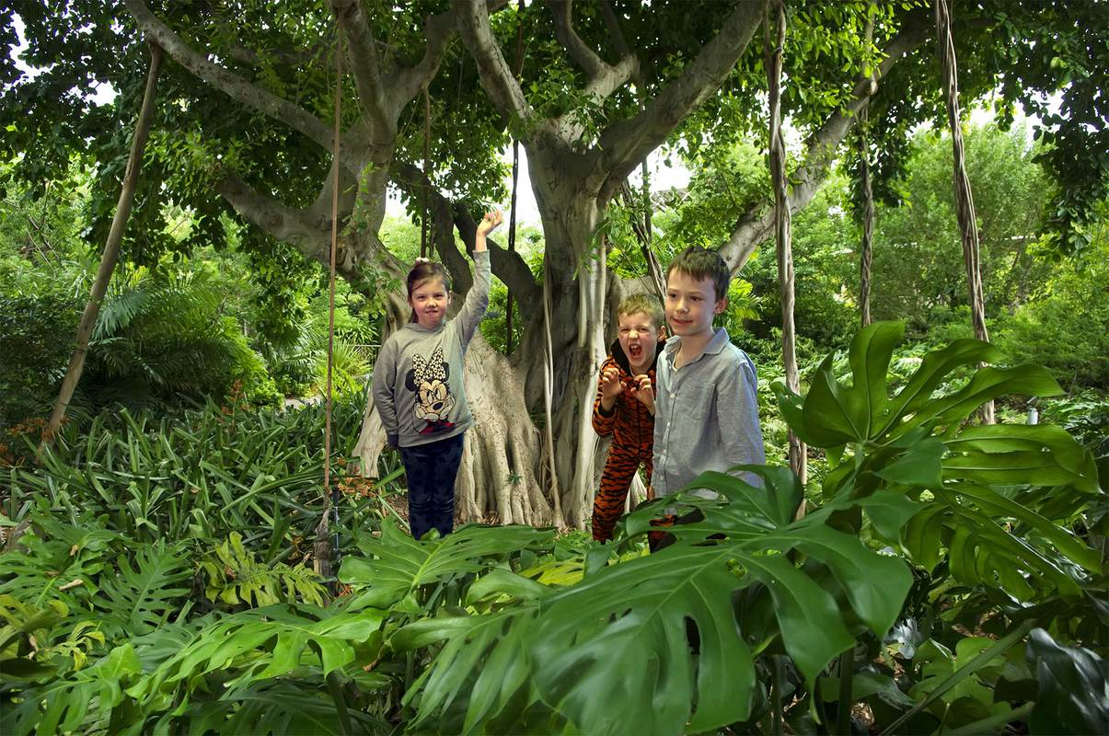

**Sentence challenge!**

Can you write a description of what it would be like to be in a jungle?

You could think about using your senses, for example, thinking about what sounds you might hear around you.

You could also describe how you might be feeling.

**Story starter!**

Moments earlier, she had been standing in her classroom holding the tiny port-key up in her hand, waiting for the magic to happen. With a flash and a puff of smoke they had vanished into thin air.

The port-key had taken them to some strange places before, but never to a jungle. The problem with port-keys is that you never quite know where you’re going to end up!

They gazed around them and took in their surroundings; the stifling heat and cacophony of jungle noises put the children on edge - they would have to be exceptionally brave on this particular adventure...

**Perfect picture!**

Can you draw a picture of the children travelling to the jungle using the port-key?

**Sick sentences!**

These sentences are ‘sick’ and need your help to get better. Can you help?  
  
The girl held the port-key. There was a bang and some smoke. The children landed in the jungle. It was hot. They were scared.

**Question Time**  
What do you think a port-key is?What does the port-key look like?Where might they have been on previous adventures?How do you think they return home after an adventure?Where did they get the port-key from?If you could go on an adventure somewhere, where would you like to go?Where would you least like to go on an adventure?Does their teacher know where they have gone?Do their classmates know?

