Home learning w/b: 1.6.20 Year: 3
Message from Mrs Roper and Mrs Davenport.
Hello Year 3!
We hope you had a lovely break over half term and are rested ready for some more fantastic home learning!
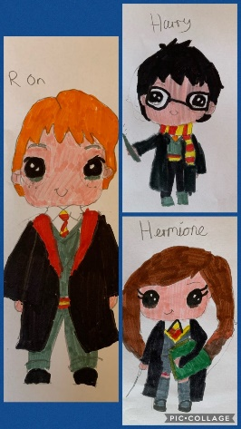
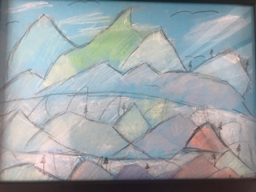
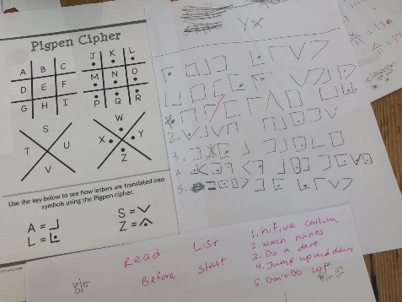
Don’t forget that you can send us pictures of the learning and activities that you are doing. There are some examples below. We can see that some of you have been keeping really busy! Florence created a frottage using colour and texture, Zara has been codebreaking and then creating her own code, Abigail made a torn mountain picture, and Riya has been drawing Harry Potter characters! 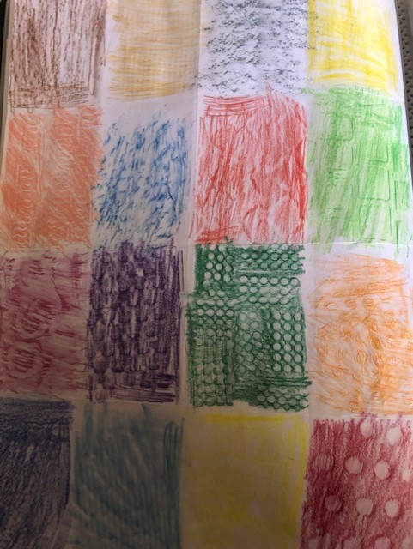 Keep sending them in as we love to see what you have been up to! The email address is
year3@lea-pri.herts.sch.uk.
Make sure you have plenty of time to have fun too!
Maths  This week, we need to finish the fractions unit that you have already started on Oak Academy. You will be looking at equivalent fractions, and how to add/subtract. Use the ‘subject’ tab to find all the maths lessons, and do lessons 11-15, one lesson per day.  Next week we will move on to a different maths topic.  https://www.thenational.academy/online-classroom/year-3/maths#  There is a related task on Education City if you want extra practice to help you practise add and subtract of fractions – there is space on the worksheet for you to make up your own questions once you have finished! Why don’t you be the teacher and set some questions for your family? Remember, you will have to work out the answers as well, so you know whether to mark their work as correct or not! | Writing  This week we are going to continue the Writing Challenge cards that we introduced before half term. Reflect on your work before half term – what could you do better? Choose one thing, and try and improve it when you are working this week!  As before, choose 2 or 3 to have a go at.  Whichever challenges you choose, try to remember our Every Time We Write rules:  - Say it, write it, read it  - Use our neatest handwriting  - Use capital letters and full stops  - Check spellings of our High Frequency Words  You can find all the High Frequency Words on the school website  https://lea-pri.herts.sch.uk/curriculum/english/
Grammar, punctuation & spelling  This week we are looking at the suffix – ous. Suffixes go on the END of words, and this one turns a noun into an adjective. It means ‘full of’  EG danger is a noun. To turn it into an adjective (a describing word) you need to add ous.  Danger + ous = dangerous! (full of danger)  Watch the education city learning screen that we have set for you, in the homework tab, then try the activity sheet.  Alternatively, if you prefer, turn these nouns into adjectives by adding -ous on the end, and write each one in a sentence.  fury (change the ‘y’ to’ i’ first!)  mountain  poison | Science – Plants  Our new topic for this half term is plants.  Go to Oak Academy using the link below, and do the first lesson with Miss Roberts. You will learn about what plants need to grow. Then you will learn about variables in order to set up a simple experiment to test the effect of water on the growth of a plant. https://www.thenational.academy/year-3/foundation/plants-what-conditions-could-we-change-to-investigate-the-growth-of-a-plant-year-3-wk1-3  Extra challenge (optional) – have a go at making the experiment at home, and keep a diary about your plant. Write in it every days to record the changes that you notice. Remember to put the date every time you write.
Topic  We are starting a new topic – you will be learning about the Mayan Civilisation over the rest of the half term! The Mayans lived in Mesoamerica (Central America) between 2000BCE and 900CE. They were a fascinating ancient civilisation, and each week we will look at something interesting about them.  This week I would like you to think about how we came to know about them in modern times. The ruins of this civilisation were discovered by Spanish explorers – called Conquistadors- about 500 years ago. Watch this introduction about the Mayans, https://www.bbc.co.uk/bitesize/topics/zq6svcw/articles/zqv6msg  After the introduction, watch this short video about how the Spanish came to discover the civilisation.  https://www.bbc.co.uk/bitesize/clips/zrrc87h  Then, write some questions you would like to find out the answers to around the pyramid picture attached. Keep the questions safe. There is some vocabulary attached to help you. | Physical activity  Joe Wicks is doing his workouts every morning at 9am. Join him for a fun mixture of exercise and quizzes to test your general knowledge!  Or go to the Fitter Futures website https://www.fitterfuture.com/ and log in using the details sent home.
RE Who decides what is right and wrong?

You have learnt in school the difference between right and wrong, but who decides what is right and what is wrong? Can you think of professions or jobs where people have to decide what is right and wrong? What about judges, police officers or teachers? Why is it important for them to consider the answer to this question? If you have a faith, how does that help you to know what is right and wrong? How do faith beliefs guide people with what is right and wrong?

When you have had time to think about the answers to these questions, draw a mind map about people who you think decide what is right and what is wrong? For each example that you give, explain what their job is and why it is important.
Art & Design  This week, as we are starting our Mayan topic, we thought it would be good to look at Mayan masks.  The Mayans worshipped many different Gods, and Mayan masks represented different Gods. They had a wide variety of uses, and the importance of the masks dictated how intricate (complicated) the designs on various masks were. The most sacred Mayan masks featured complex and delicate mosaics made out of jade (a greenish precious stone.)  An example of a Mayan mask is attached. Either colour this one in, or print one of your own choice off the internet and colour it in. Keep it with your work on the Maya. | PSHE  This week we would like you to think about one of our school values – ambition.  Ambition is a strong desire for success. Are you ambitious, and what do you want to be successful at? It could be a job or a career that you want to pursue, or it would be a personal target, such as am ambition to go somewhere or do something great.  Draw a picture of yourself and tell us what your ambitions are – and how you will achieve them!

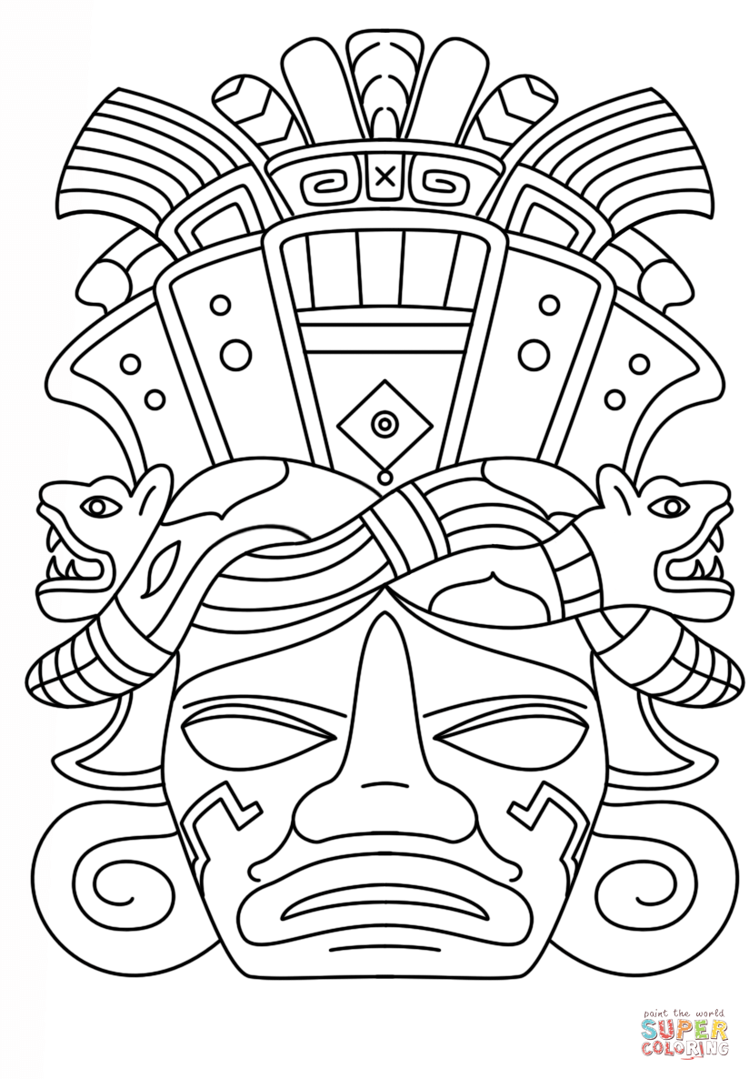
Write at least 3 questions that you would like to find the answer to about the mysterious ruins found in the rainforests of Mesoamerica by the Spanish Conquisadors in the fifteenth century. Write them around the picture of the ruins. You can draw more speech bubbles if you like.

