Home learning w/b: 4.5.20 Year: 4
Message from Mrs Hills and Mrs Stevenson
Hello Year 4!
How has your week been? Have you done anything exciting? We hope you’re keeping well and managing to stay active as well as getting some school work done. We also hope you’re having fun and enjoying the time with your family. Thank you so much to those of you who have sent us some pictures and messages. Keep sharing these with us. We miss you and it’s a great way to keep in contact. The email address to send it to is year4@lea-pri.herts.sch.uk. This week Eesaa made a chocolate birthday cake for his brother and used Lego to make a secret garden. Max made cookies and spent time with his dad learning Japanese! Like a lot of you, Asher has been busy making his Roman shield.
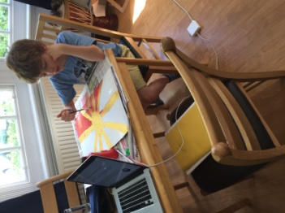
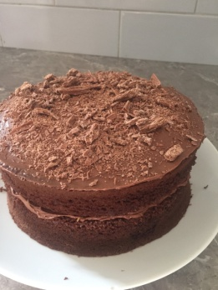
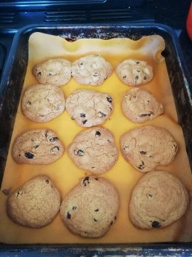

Here’s a message from Mrs Dada for you.
Dear year 4
It was lovely seeing you again on zoom on Thursday. I’m missing you all and can’t wait till we return to school.
I’m so impressed with all the work I hear you have been doing and looking forward to seeing it all. Remember to keep positive, it’s a very unusual way of life at the moment. Always find things to do to make you smile.
Q: Why was the math book sad?
A: Because it had too many problems.
Take care year 4
Mrs Dada
Remember to do some reading, writing and maths every day. You don’t have to do everything on the grid, so don’t feel under pressure to do it all, just do what you can manage.
Remember to check out the activities on educationcity in the year 4 folders.
We recommend that you watch the BBC iplayer daily lesson. https://www.bbc.co.uk/iplayer/episodes/p089g063/bitesize-79-year-olds?seriesId=p08b2wkg. You should be able to choose each day’s session from there.
Maths  Please follow the daily maths lessons on  https://whiterosemaths.com/homelearning/  Please join in on one a day. Over the next two weeks, it will cover multiplication and division and working out perimeter and area. It is now connected to the BBC Bitesize daily lessons with links going straight there for activities and further teaching. If you would like more maths then go to this website as well.  http://www.iseemaths.com/home-lessons/  Remember to keep practising your times tables – every day! Don’t forget to practise the division facts too.  I’ve also attached another maths mystery if you would like to have a go at it. | Writing  This week is a special week as we celebrate VE day on Friday. This is when we remember the day the Second World War ended in Europe 75 year ago. We’ve attached some activities for you to do and some information. You won’t need to print them all! Read the reading comprehension and answer the questions in full sentences.  Please watch the clip on BBC Bitesize about VE day  https://www.bbc.co.uk/teach/class-clips-video/history-ks2-ve-day/z7xtmfr  You might also enjoy the song on Horrible Histories  https://www.bbc.co.uk/cbbc/watch/horrible-histories-songs-ve-day-song  Now that you have some information, please write an information text about VE day. Don’t forget to use headings, subheadings and paragraphs and ETWW.  Enjoy the activities.  We also suggest you watch the daily English lessons on BBC bitesize this week.
Grammar, punctuation & spelling  What is a prefix? Which prefixes can you think of? This week, our new prefixes are ‘super’ and ‘sub’. How do they change the meaning of the words? Practise spelling these words. Can you think of any other words with the prefixes ‘super’ and ‘sub’. Word bank:  superman, superwoman, supermarket, supervise, superhero, superglue, superior, superpower, subtract, subway, subdue, subtitle, subside, submerge, submission, sublime  Now try using the words in sentences.  Keep practising using the apostrophe as well. | Science  https://www.bbc.co.uk/bitesize/topics/zkgg87h/articles/zydxmnb  Continuing on from last week when we were looking at changing liquids into solids (freezing) and back to liquids (melting), this week we will think about when liquids and gases turn from one state to another. This happens by heating or cooling.  Look at what happens to a wet tea towel when you place it in different places around the house. Try putting one on radiator that is turned on and another somewhere cooler. Which is dry faster?  The heat causes the water to evaporate and become a gas. This is evaporation. Can you think of any other examples of evaporation?  Record your ideas with photos, drawings or in notes.
Topic – The Romans  This week I’d like you to research these questions:  1. What was every day life like in Roman Britain?  2. What were their homes like?  3. What is a hypocaust and how did it work?  Here are some links to help you.  https://www.bbc.co.uk/bitesize/topics/zqtf34j/articles/ztqg4wx  http://www.primaryhomeworkhelp.co.uk/romans/various.htm  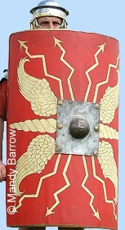  Continue to work on your Roman shield. If you’ve got some cardboard, that would be ideal. Here’s an example of what it looked like. It doesn’t have to be as fancy as this! Keep it, so that you can bring it in to school when we return. | Physical activity  Do something active every day. You could go for a run with your parents, ride a bike or do some skipping. You could also make up your own fitness routine. If you are able to, you can also do PE with Joe Wicks on Youtube or go to the Fitter Futures website and have a go at the workouts. Try to mix up the type of exercise you do, so you complete a balance of cardio and core strength activities.  Username: thelea2  Password: 3ffzx Please ask an adult to log on for you, as we must not change the password.  Why not keep a fitness diary so you can track your exercise.  Music  Try out beatboxing on here  https://www.thenational.academy/year-4/foundation/to-beatbox-using-rhythmic-patterns-year-4-wk2-5  Or try out a song a day with Out of the Ark on  https://www.outoftheark.co.uk/ootam-at-home/?utm_source=homepage&utm_campaign=ootamathome2&utm_medium=banner
RE
The 5 Pillars of Islam. You may already know the 5 pillars of Islam, they might be an important part of your faith or you might recall learning about them at school. The Five Pillars are: declaring your faith in God, prayer, charity, fasting during Ramadan and going on pilgrimage to Mecca (also known as Makkah), here is a video you can watch about them https://www.bbc.co.uk/teach/class-clips-video/religious-studies-ks1-the-five-pillars-of-islam/zv84jhv.
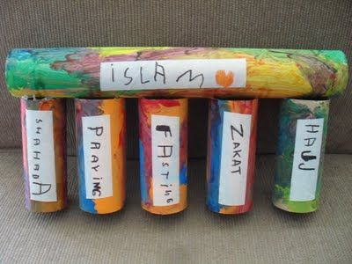
Can you think of a creative way of recording the 5 pillars of Islam
You could draw around your hand instead of using paint.

For each pillar think about how the instruction guides and supports Muslims in their daily lives. Eg:
The pillar to declare their faith guides a Muslim by instructing them to be confident to dress according the instructions of their holy book and the customs of their faith. It supports them in feeling confident to say that they believe in Allah and to show the world that they are a follower of Islam.
Can you use this sentence starter to explain how each pillar guides and supports Muslims:
The pillar ____________ helps to guide and support Muslims by instructing them to ________________________.

Daily basic skills and online learning
- Practise your spellings as handwriting, using the LetterJoin information and login sent home to help you. 15 minutes 3 times per week. See links below.
- Practice your times tables on https://ttrockstars.com/ using the logins that were sent home. Focus on the times tables that you are less confident with.
- Practice your number bonds to 10, 20 and 100. How quick can you get at matching them?To those who are confident with whole numbers, make decimal numbers, ie 45.67 + 54.33.
- Read for at least 20 minutes a day. Also get adults to read books and stories to you.
- Listen to David Walliams reading extracts from his books at 11am every day on https://www.worldofdavidwalliams.com/elevenses/
- Practice reading and spelling all the high frequency words.
- Practice reading and spelling words from the year 3/4 spelling list. Write sentences using the words.
- Do some daily writing. See the grid above first. You may also want to keep a diary of the activities you do every day. You could also write a story of your own, create a comic strip for a story that you know well, or create some non-fiction fact-files for topics that interest you.
Do not forget to use our every time we write rules:
- Say it, write it, read it
- Use our neatest handwriting
- Use capital letters and full stops
- Check spellings of our High Frequency Words

Websites:
Email address for queries about logins:
year4@lea-pri.herts.sch.uk - Please do let us know if you are having trouble with logins.
- Links to spelling lists are on our school website on https://lea-pri.herts.sch.uk/curriculum/english/
- Reading Eggspress – in addition to your own reading for enjoyment, there are comprehensions, spelling games and books to read on here. https://readingeggspress.co.uk
- Times Tables Rockstars on https://ttrockstars.com/
- Education City – there will be a selection of tasks set for Maths, English and Science
with Learn It sections to support some concepts if you need them. There are downloadable worksheets, too, to print out and try. There are lots of different games and activities on this site, so explore, learn and have fun! https://ec1.educationcity.com
- Fitter Futures subscription – https://app.fitterfuture.com/student/auth/login
- LetterJoin https://www.letterjoin.co.uk/ Use this to practise writing spellings using your neat joined handwriting.

- Twinkl – parents can use this free from home for a month to support learning at home.

- If you would like more, there are also the daily lessons on BBC bitesize. They are very good if you are happy to have extra screen time. https://www.bbc.co.uk/bitesize/dailylessons

