Home learning w/b: 11.5.20 Year: 4
Message from Mrs Hills and Mrs Stevenson
Hello Year 4!
How was your long weekend? Did you do anything special to commemorate VE day? Are you still enjoying being at home or are you getting a bit fed up and missing your friends? Remember whatever you are feeling is ok and it’s normal to have lots of different feelings at this time. If you are feeling a bit down and fed up, remember to talk to your parents about it. Getting up and doing something active is a good way to make you feel better. Perhaps you can find some good jokes to make your family laugh or do some drawing to relax!
Thank you so much to those of you who have sent us some pictures and messages. Keep sharing these with us. We miss you and it’s a great way to keep in contact. The email address to send it to is year4@lea-pri.herts.sch.uk. Sofia has made an amazing cat raincow, Sarah is now ready to protect herself against the Romans, Timothy was a meticulous cashier at the Cafe Cullis and Ibi made a fab poster about the different states of matter. Eesaa really thought about why we should remember VE day and Wilbur did some great maths whilst looking very comfortable on the sofa!
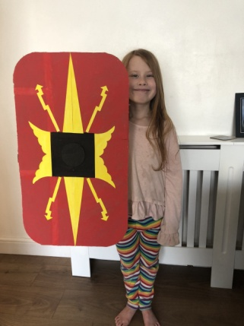
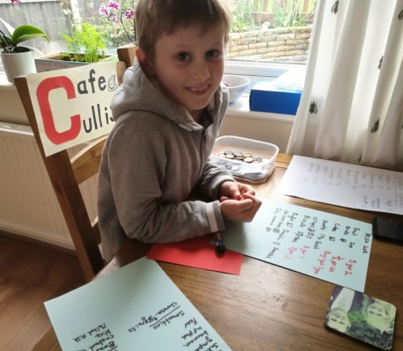
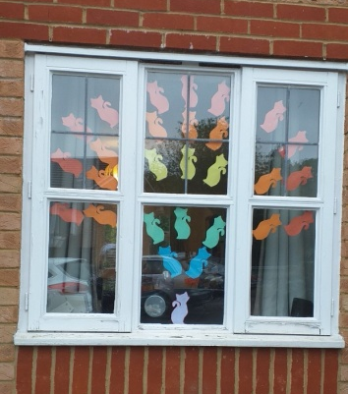

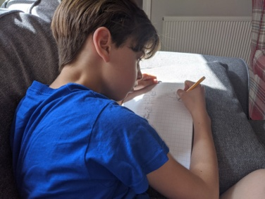
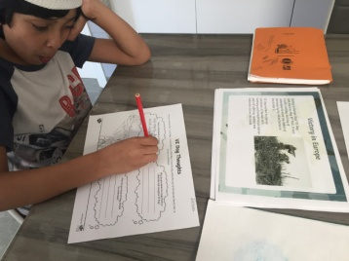
Here’s a message from Mrs Dada for you.
Dear Y4,
I’m still missing you all and wondering when we will be back at school. I know it must be really challenging being at home all the time with really nowhere to go, but you are doing a great job and doing some really fab work.
I thought I would set you a challenge this week. I would like you to perform an act of kindness towards a sibling or your parents. Do something to make someone smile. Here’s a joke to make you smile:
Why did the teddy bear say no to dessert?
Because he was stuffed.
Take care Y4
Love from Mrs Dada
Remember to do some reading, writing and maths every day. You don’t have to do everything on the grid, so don’t feel under pressure to do it all, just do what you can manage.
Remember to check out the activities on educationcity in the year 4 folders. Also make sure you are going on Times Tables Rockstars and Readingeggs. Email us if you are having trouble logging in.
We recommend that you watch the BBC iplayer daily lesson. https://www.bbc.co.uk/iplayer/episodes/p089g063/bitesize-79-year-olds?seriesId=p08b2wn1 and choose week 4. You should be able to choose each day’s session from there.
Maths  Please follow the daily maths lessons on  https://whiterosemaths.com/homelearning/  Please join in on one a day. This week continues with multiplication and division and working out perimeter and area. It is connected to the BBC Bitesize daily lessons with links going straight there for activities and further teaching. If you would like more maths then go to this website as well.  http://www.iseemaths.com/home-lessons/  Remember to keep practising your times tables – every day! Don’t forget to practise the division facts too. | Writing  This week we would like you to use the picture at the end of this document. There are some activities for you to do as well. You can spread them out over the week. It is taken from https://www.pobble365.com/the-artist but you do not need to click on it as it is all at the end of this document.  Don’t forget to use ETWW.  We also suggest you watch the daily English lessons on BBC bitesize this week. They are only short lessons and will help to continue to develop your writing.
Grammar, punctuation & spelling  This week’s spelling patterns are words beginning with ‘ass’, ‘att’ and ‘aff’. Here are some examples:  assemble assembly  assist assistant  assort assortment  attract attractive  attend attendance  affix affirm  afflict affliction  affection affectionate  Practise spelling them and use them in sentences. Can you find other words with those that start with the same letters? | RE  Who decides what is right and wrong? You have learnt the difference between right and wrong, but who decides what is right and what is wrong? Can you think of professions or jobs where people have to decide what is right and wrong? What about judges, police officers or teachers? Why is it important for them to consider the answer to this question? If you have a faith, how does that help you to know what is right and wrong? How do faith beliefs guide people with what is right and wrong? Can you draw a mind map about people who you think decide what is right and what is wrong? Explain what their job is and why it is important.
PSHE  If we were at school, we would have been looking at environmental issues and our shared responsibility to help protect the environment. Perhaps you can discuss this as a family or you can think back to our Rainforest topic and some of the recycling issues we have discussed. Here are a couple of questions to help you.  How does the environment provide the resources humans need?  Is this spread out fairly all over the Earth?  What are some of the issues we need to be aware of?  What can we do to help change things?  How can we take pride in the environment around us? | Physical activity  Do something active every day. You could go for a run with your parents, ride a bike or do some skipping. You could also make up your own fitness routine. If you are able to, you can also do PE with Joe Wicks on Youtube or go to the Fitter Futures website and have a go at the workouts. Try to mix up the type of exercise you do, so you complete a balance of cardio and core strength activities.  Username: thelea2  Password: 3ffzx Please ask an adult to log on for you, as we must not change the password.  Why not keep a fitness diary so you can track your exercise.
French  Rather than give you new French to learn, I’ve attached a French Vocabulary mat with some of the French you have already been taught. Over the next few weeks please use this to revise your French. | Music and Art  This week you can combine music and art by doing week 3 of the BBC Ten Pieces at Home. Listen to the music and follow the guidance. You can make someone feel really special.  https://www.bbc.co.uk/teach/ten-pieces/watch-this-do-this-weekly-activities/zjy3382
Science
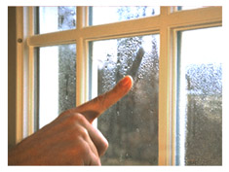
Below are some pictures. Cut them out and sort them into two groups - ones which show condensation and ones which are examples of evaporation. Then stick them down and write and explain how they show condensation or evaporation next to each one.
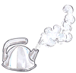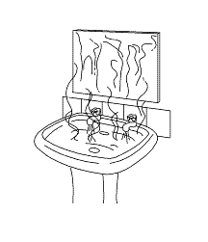

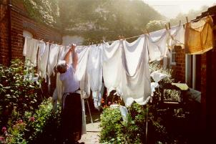

Topic – The Romans
The last couple of weeks we have asked you to do a lot of research. This week is going to be more creative. The Romans are famous for their mosaics. Mosaics are pictures and patterns made up of lots of tiny coloured stones. There are some amazing mosaics on display at Verulamium Museum in St Albans. They are worth a visit when they open up again! Have a look at some of these mosaics
http://www.primaryhomeworkhelp.co.uk/romans/mosaics.html

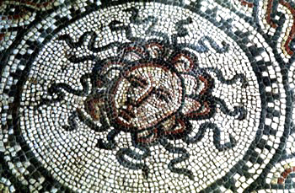
Wealthy Romans had mosaics covering the floors in their main rooms. They could be anything from simple patterns to scenes from history, Roman gods or every day Roman life.

Can you create a mosaic? You don’t have to use hundreds of stones. You could create a Lego mosaic, use beads, cut up coloured paper or you can use the patterned sheet at the end of this document and draw a mosaic by colouring each little tile a separate colour.

You can also make a mosaic online on
http://www.gwydir.demon.co.uk/jo/mosaic/mkmosaic.htm

Daily basic skills and online learning
- Practise your spellings as handwriting, using the LetterJoin information and login sent home to help you. 15 minutes 3 times per week. See links below.
- Practice your times tables on https://ttrockstars.com/ using the logins that were sent home. Focus on the times tables that you are less confident with.
- Practice your number bonds to 10, 20 and 100. How quick can you get at matching them?To those who are confident with whole numbers, make decimal numbers, ie 45.67 + 54.33.
- Read for at least 20 minutes a day. Also get adults to read books and stories to you.
- Listen to David Walliams reading extracts from his books at 11am every day on https://www.worldofdavidwalliams.com/elevenses/
- Practice reading and spelling all the high frequency words.
- Practice reading and spelling words from the year 3/4 spelling list. Write sentences using the words.
- Do some daily writing. See the grid above first. You may also want to keep a diary of the activities you do every day. You could also write a story of your own, create a comic strip for a story that you know well, or create some non-fiction fact-files for topics that interest you.
Do not forget to use our every time we write rules:
- Say it, write it, read it
- Use our neatest handwriting
- Use capital letters and full stops
- Check spellings of our High Frequency Words
Websites:
Email address for queries about logins:
year4@lea-pri.herts.sch.uk - Please do let us know if you are having trouble with logins.
- Links to spelling lists are on our school website on https://lea-pri.herts.sch.uk/curriculum/english/
- Reading Eggspress – in addition to your own reading for enjoyment, there are comprehensions, spelling games and books to read on here. https://readingeggspress.co.uk
- Times Tables Rockstars on https://ttrockstars.com/
- Education City – there will be a selection of tasks set for Maths, English and Science
with Learn It sections to support some concepts if you need them. There are downloadable worksheets, too, to print out and try. There are lots of different games and activities on this site, so explore, learn and have fun! https://ec1.educationcity.com
- Fitter Futures subscription – https://app.fitterfuture.com/student/auth/login
- LetterJoin https://www.letterjoin.co.uk/ Use this to practise writing spellings using your neat joined handwriting.

- Twinkl – parents can use this free from home for a month to support learning at home.
- If you would like more, there are also the daily lessons on BBC bitesize. They are very good if you are happy to have extra screen time. https://www.bbc.co.uk/bitesize/dailylessons

English – The Artist

Story starter!
He had been working on the drawing for hours, locked away in complete silence in his study, letting his imagination run wild. The only sound that could be heard was the soothing scratching of his pencil on the textured paper.
When he had finished, George stood up and took a step back, proud of the work he had done. He was an extraordinary artist, more extraordinary than any other artist in the entire world!
As George spoke the magic word, the ship’s sails started to flutter as if a strong breeze blew through the room. He loved this moment, seeing his creations come to life...

Question time!
Can you continue the story of George’s ship coming to life?
What will he do with the ship now that it has magically appeared?
‘He loved this moment, seeing his creations come to life’. The story starter refers to George’s creations in the plural. What does this tell you?
What other drawings might George have done in the past? Where are they now?
If you could draw anything (knowing it would come to life) what would you draw?
What was George’s magic word?

Sentence challenge!
‘The soothing scratching of his pencil’ is an example of alliteration. Can you use some alliteration to improve this sentence?
The ship went across the sea.

Sick sentences!
These sentences are ‘sick’ and need help to get better. Can you help?
George drew a picture. It was a ship. It sailed across the seas.

Perfect picture!
Imagine you have George’s powers. Can you draw something that you’d like to come to life? Can you write a story about it?

