Home learning w/b: 18.05.20 Year: 5
Messages from Mrs Cross
Hello, Year 5!
I hope you have had another good week – it seems strange not to have ‘Zoomed’ with you! I am sure you will have lots to tell us next week though, and we look forward to seeing you then.
Thank you for all the great work sent in this week! As you can see below, the class displays are coming on really well. Martina – your piano video was fantastic! Well done! We also have Phoebe with her recycling project, an amazing looking chocolate cheesecake from Imogen and fab work from Emily on ‘Home Sweet Home’ – I hope you enjoyed that film. I have had some more self-portraits come through, too – can you guess who it is?
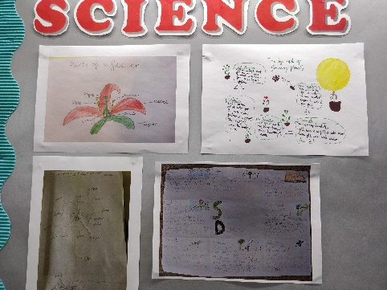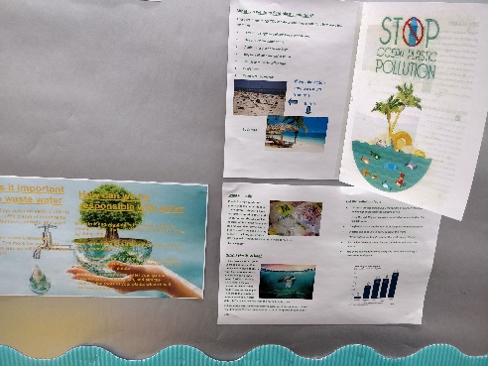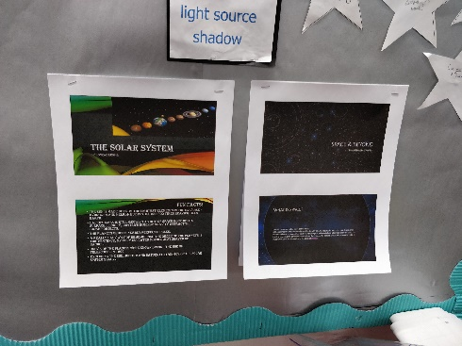

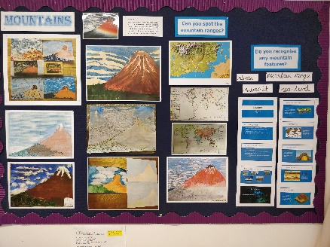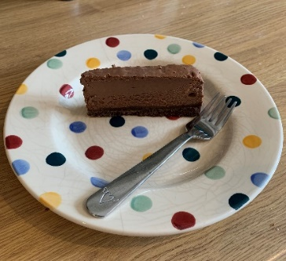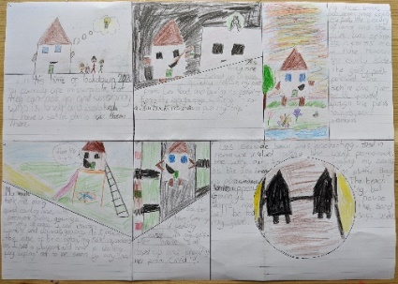

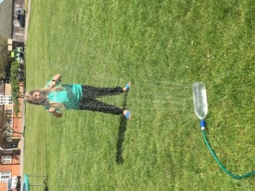
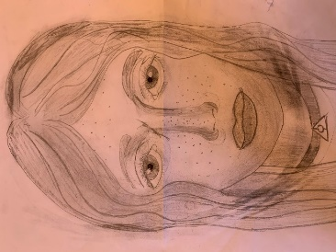

We hope you enjoy another week of our Home-Learning grid. Send in examples of work, or pictures of fun activities you have taken part in, to year5@lea-pri.herts.sch.uk so we can celebrate your efforts.

Maths  Online Maths lessons for this topic can be found on Week 4, Summer Term:  https://whiterosemaths.com/homelearning/year-5/  If you used this last week, I hope you found the links and activities on BBC Bitesize helpful!  If you used The Oak Academy, you still have another 5 lessons on ‘transformations’ for this week.  .https://www.thenational.academy/online-classroom/year-5/maths#subjects  Topic – Ancient Greece  We have finished our Mountains topic now – I hope you enjoyed it!  On a piece of paper, draw a KWL grid.  K I already know W What would I like to know? L I have learned  Write down what you already Know about the Ancient Greeks, and What you would like to know. Leave the L part of the grid – you will come back to it later in the topic.  You should have some questions to research for yourself from the W part of the grid, but can you find out and answer these for me, too?  - Who were the Ancient Greeks?  - What was daily life like for women, men and children?  - What religion did they follow?  http://www.primaryhomeworkhelp.co.uk/Greece.html  https://www.bbc.co.uk/bitesize/topics/z87tn39 | Writing  Tasks for ‘Home Sweet Home’  - Write a diary entry as the main character for one part of his journey. This could be about his decision to move;  - Using the setting descriptions from last week, write the story of the film. You can write your story from any of the character’s points of view (1st person) or in 3rd person, as a narrator.  https://www.youtube.com/watch?v=bpfiP7hn7YM  Grammar, punctuation & spelling  Try to use all of the punctuation you have practised over the last few weeks – can you use parenthesis in your writing?  Last week of spelling tests until the next spellings. Ask an adult to test you again on a mix of the spellings (max. 20), including ones you found tricky from last week. I have added some new spellings at the bottom for you to begin working on.
Science
Have a look at the Life Cycles work on Education City. Animals and insects have different life cycles and stages of development. Create your own life cycle for an animal or insect of your choice – it could be one that you are already interested in, or like.
Here are some links that could help you get started.
https://www.bbc.co.uk/bitesize/topics/zgssgk7
https://www.theschoolrun.com/homework-help/insects
https://www.bbc.co.uk/teach/class-clips-video/life-cycle-of-an-ant/zfttscw
https://www.outstandingscience.co.uk/index.php?action=view_page&page=view_unit&unit=5a

Physical activity
Use the Fitter Futures website and have a go at the workouts. Remember to mix up the type of exercise you do, so you complete a balance of cardio and core strength activities. Get out and about for your daily exercise. Enjoy your family walk or run, and keep up all those activities in your garden.
Other learning  French – practise your key vocabulary (numbers, colours and the alphabet). Can you describe the weather? Keep an eye on the weather next week and create a weather map. Label each day’s weather in French!  https://www.bbc.co.uk/bitesize/topics/zyr76sg  You decide!  Your own art project, science investigation or PE skills – your choice – how will you present it to me? | PSHE – money matters  So what did you decide? Should chores be paid for or freely completed? Why is it important to save?  What is the difference between ‘need’ and ‘want’?  We often say we ‘need’ something when we are talking about spending money, when we really mean that we want it instead. Ask your parents what they think is the difference. What do you think your family needs to buy or pay for, before spending money on other things?  Imagine you have £20 for the food shopping for the family. Have a look (don’t click and buy!) at an online shop and work out how you would spend the money on food for a week. What do you need? What tempts you?  Question: What is a budget? Find out.  When the lockdown is finally over, you plan to have a party with the class. Make a list of everything that you would want to eat and drink, and anything else to make the party fun (e.g. balloons, party poppers).  Now create a budget for the party. You have £20 to buy everything you need – you cannot borrow any more money, or use something you already have in the house!

Daily basic skills and online learning
- Practise times tables regularly, and as divisions. Use TT Rockstars for 10 minutes a day.
- Practise your spellings as handwriting, using the LetterJoin information and login sent home in the Autumn Term to help you. 10 - 15 minutes daily
- Reading – independent, or with an adult, 30 minutes daily.
- Reading Eggspress – up to 30 minutes, 4x weekly
- Practise spellings from Y5/6 words list and high frequency words. 10 - 15 mins.

leisure | queue | yacht | twelfth
lightning | muscle | opportunity | parliament
persuade | persuasion | stomach | sincerely

Keep a diary of the activities you do every day.
- Do not forget to use our ETW rules – Every time we write we:
- take pride in our presentation
- say it, write it, read it
- punctuate each sentence correctly
- check that High Frequency Words are spelled accurately.

Websites.
email address for queries about logins, and to send examples of your work to:
year5@lea-pri.herts.sch.uk

- Reading Eggspress https://readingeggspress.co.uk

- Mathematics https://whiterosemaths.com/homelearning/

- TT Rockstars https://play.ttrockstars.com

- Education City https://ec1.educationcity.com

- Fitter Futures https://app.fitterfuture.com/student/auth/login

- LetterJoin https://www.letterjoin.co.uk/

