Home learning w/b: 04.05.20 Year: 5
Messages from Mrs Cross and Mrs Light
Hello, Year 5! May the 4th be with you!
Your toilet roll challenge video on Twitter was fab! So clever – and a great choice of music to go with it. Britain’s Got Talent has nothing on you guys! Thank you to those who have sent a photograph of your Hokusai work – I have been printing them out and am going to put them up on display next week. I will add a photograph here when it is finished.
I have enjoyed seeing what you have been up to at home. Thank you to Phoebe, who has sent me lots of her work this week, including a really clear map of mountain ranges around the world, Emily for her art project and Konrad, for his fact-packed PowerPoint about the Solar System.
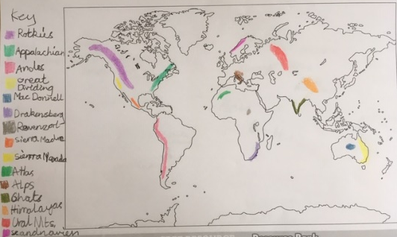

We hope you enjoy another week of our Home-Learning grid. Send in examples of work, or pictures of fun activities you have taken part in, to year5@lea-pri.herts.sch.uk so we can celebrate your efforts.

Hi everyone!
I hope you are all keeping safe and well at home with your families. I am really missing seeing you all every day, but really enjoyed your Twitter video, and am looking forward to our zoom call to see your lovely faces! Take care and keep smiling. Mrs Light.

Maths  Online Maths lessons for this topic can be found on Week 2, Summer Term:  https://whiterosemaths.com/homelearning/year-5  If you are finding these too tricky to work on independently, a good idea is to look at and do the Year 4 lessons – they still practise our skills and are a great support for revision.  From Monday, the White Rose site is linking to additional videos on BBC Bitesize, where there will be different worksheets to download if you would like. Remember – you don’t have to print them out – you can work into a book. The White Rose worksheets we have been using will not be published to us any more. So, let’s have a look – I hope it will be fab – and see what will be offered instead.  Topic – final task.  What would it be like to live on or near a mountain? Over the next 2 weeks, I would like you to investigate the mountain environment as a home project. Use these areas to focus your work: climate, plants and trees (what does fauna and flora mean?), wildlife, land use and tourism. Take the time to find out as much as you can – how you present your learning is your choice. As an example, you could make a booklet or pamphlet, create posters, even video yourself teaching the topic back to me or a mixture of all of these. I look forward to seeing the finished project, and hopefully, it is something you will be able to bring back into school to share with everyone when we return.  Starting points  How does the temperature change as you climb a mountain? What does this mean for plant growth and wildlife?  Why do humans settle near mountains and how do they use them? You might like to look at the contrasts between the Cambrian mountains in Wales and the Alps. What impact does tourism have? Positives and negatives? This links into your PSHE theme. Here are some links to get you started.  http://primaryhomeworkhelp.co.uk/mountains/climate.htm https://www.wwf.org.uk/where-we-work/mountainous-environments  https://www.3dgeography-pictures.co.uk/mountain-pictures  https://www.3dgeography.co.uk/mountain-animals  https://www.bbc.co.uk/bitesize/topics/z849q6f/articles/z4g3qp3 | Writing  This week, I would like you to try these five lessons for English. You can find them on:  https://www.thenational.academy/online-classroom/year-5/english#subjects  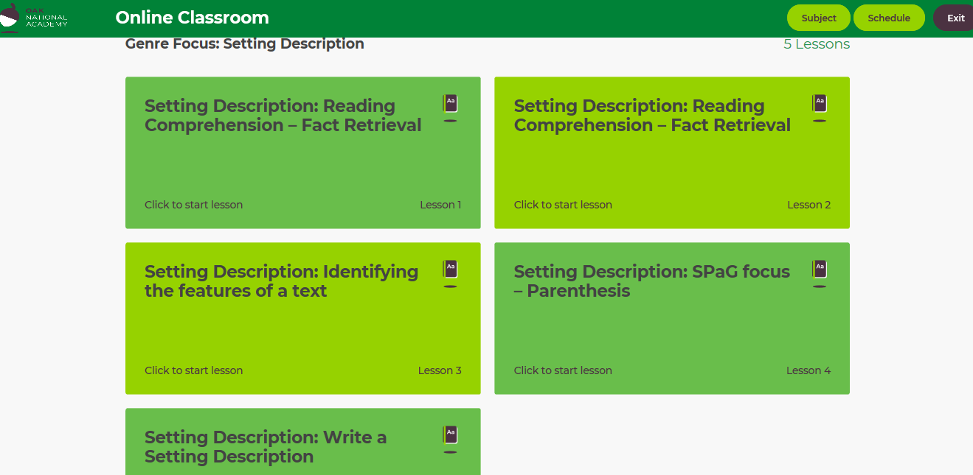  Next week, we will use a short film clip to write setting descriptions, so you can use the skills you have practised from these lessons.  Grammar, punctuation & spelling  The lessons above include a grammar and punctuation focus on parenthesis. We had started to look at this in more depth before the lockdown, so do have a go. I have added some parenthesis activities on Education City, too, to help. It would be worth trying the Safari So Good and Jungle Dash learn screens in the punctuation folder first. Can you find how many times I have used parenthesis in this learning grid? You should be able to find at least ten.  How have you got on with your Y5 spellings? I have not included new ones for you to practice this week – ask an adult to test you on a mix of spellings (max. 20) from the past 3 weeks – are there any you need to go back and work on again?
Physical activity
Use the Fitter Futures website and have a go at the workouts. Remember to mix up the type of exercise you do, so you complete a balance of cardio and core strength activities.
You can also use Joe Wicks if you want to, to get your morning started, although you can watch his sessions at any time of the day.

Science
Investigate the plant life cycle. Watch the link and try the activity. Draw your own plant life cycle.
https://www.bbc.co.uk/bitesize/topics/zgssgk7/articles/zyv3jty
How do plants spread their seeds? Watch the link and try the activity. Create a poster explaining the different types of seed dispersal.
https://www.bbc.co.uk/bitesize/topics/zxfrwmn/articles/z28dpbk
There is still some time to do the activity in the Science folder on Education City. Well done to those who have already tried it!
RE  Why is it important to have personal heroes? Do you have a personal hero? Are you a Ben Stokes fan? Do you want to be a ‘triple threat’ like Ariana Grande? Perhaps your hero is a member of your very own family. Who do you admire and why? Tell me about your hero, why they are important to you, how your interest in them shapes your life and how would your life be different if you did not know about them.  Think of a hero that a person of faith might have. Our focus has been Judaism and Christianity, but you are very welcome to explore other religions for this task if you would like to. How does this hero shape their life, why is this person important to them and how would their life be different if they did not know about them? Present your learning in your own way; this could be in written paragraphs, a mind map, a PowerPoint presentation, a poster or something else. | Other learning  Self-portrait  Look in the mirror – how have you changed this year? Sketch your face shape, ‘zoom in’ on one of your eyes and your smile, practising little sketches of yourself before trying to draw your whole face. Use the side of the pencil lead lightly for shadows around your nose area rather than drawing a solid outline for it. Noses are tricky! You may find this link as a quick tutorial on proportions helpful.  https://www.youtube.com/watch?v=1kHzAh9sCH4  Recreating Famous Paintings  An idea from Anais that looks quite fun!  https://www.boredpanda.com/my-kids-and-friends-in-famous-paintings-impersonations

Daily basic skills and online learning
- Practise times tables regularly, and as divisions. Use TT Rockstars for 10 minutes a day.
- Practise your spellings as handwriting, using the LetterJoin information and login sent home in the Autumn Term to help you. 10 - 15 minutes daily
- Reading – independent, or with an adult, 30 minutes daily.
- Reading Eggspress – up to 30 minutes, 4x weekly
- Practise spellings from Y5/6 words list and high frequency words. 10 - 15 mins.

Keep a diary of the activities you do every day.
- Do not forget to use our ETW rules – Every time we write we:
- take pride in our presentation
- say it, write it, read it
- punctuate each sentence correctly
- check that High Frequency Words are spelled accurately.

Websites.
email address for queries about logins, and to send examples of your work to:
year5@lea-pri.herts.sch.uk

- Reading Eggspress https://readingeggspress.co.uk

- Mathematics https://whiterosemaths.com/homelearning/

- TT Rockstars https://play.ttrockstars.com

- Education City https://ec1.educationcity.com

- Fitter Futures https://app.fitterfuture.com/student/auth/login

- LetterJoin https://www.letterjoin.co.uk/

