Home learning w/b: 4.05.20 Year: 6
Message from Miss Weston
Hello, Year 6!
I hope you are all well? I really enjoyed our Zoom session the other day, was so lovely to see so many of you and hear what you have all been up to! Please try to keep the effort up with school work – I know it can be difficult but it will really help to keep things ticking over.
We are all missing you here, so please remember to keep sending in any examples of work or pictures of fun activities to year6@lea-pri.herts.sch.uk so we can celebrate your efforts. I have really enjoyed all the emails, photos and videos that have been coming in – keep them coming please!
And from Mrs Akehurst…well done for all that you are doing at home, fantastic efforts in the pictures below! Keep going guys, you are all amazing
Celebrate learning
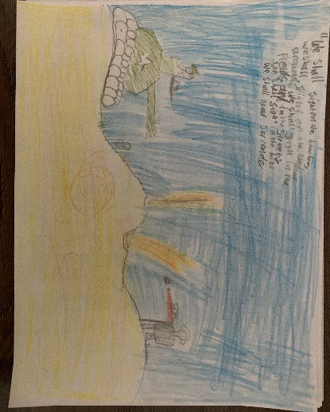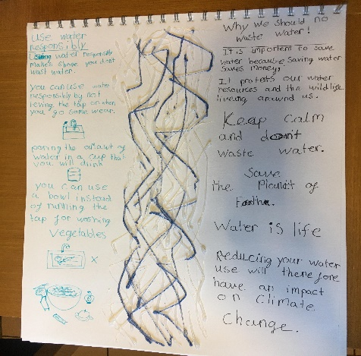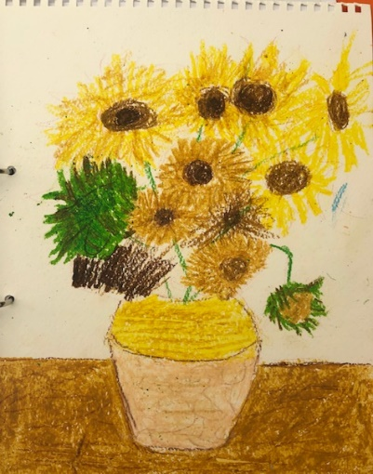
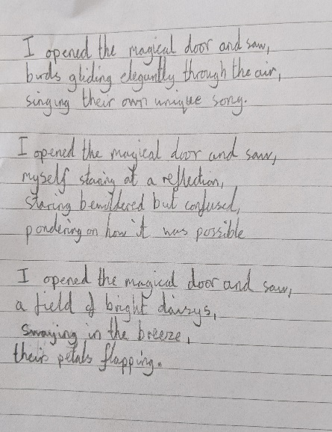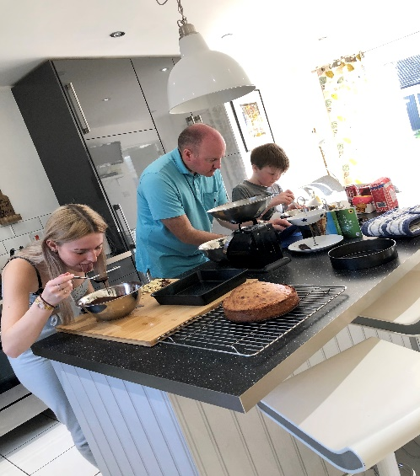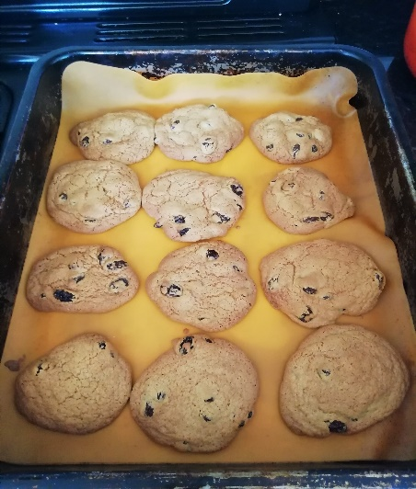
Matthew has been busy revisiting our WW2 topic and produced this fantastic picture using a famous quote from Churchill. Lia has produced an informative poster all about the importance of conserving water and used hot glue to make the river going through the middle. Amy has been extremely busy by beating her Mum at scrabble with some high levelled language plus creating a fantastic version of sunflowers. Charles has been extremely busy and completed so impressive neat work over the past week ranging from a detailed diagram of the heart, finding out cities from North and South America and completing some impressive work around the Magical door! Charlie has been keeping himself very busy by playing table tennis with his parents, baking and cooking some delicious food and playing scrabble. Frankie made some raisin cookies with no adult help! He has also been riding his bike a lot, completing white rose maths and playing on his trampoline.

Maths  There are set maths tasks ready in the My Homework section of Education City for you to practice past learning of long multiplication and look at our topic of shape. https://ec1.educationcity.com  https://whiterosemaths.com/homelearning/ Summer term week 3 is based around 2D and 3D shapes.  2D and 3D shapes:  https://www.bbc.co.uk/bitesize/guides/zj76fg8/revision/1  https://www.theschoolrun.com/what-are-the-names-of-2d-and-3d-shapes  https://www.theschoolrun.com/what-are-the-properties-of-2d-and-3d-shapes  Try these SATs style questions:  Arithmetic: https://goieoiw.exampro.net/  Reasoning: https://zirorap.exampro.net/  SPAG and Reading  SATs questions:  SPAG: https://yujipiw.exampro.net/  Spelling: https://sopeeyi.exampro.net/  (will need someone to read the words to you!)  Reading: https://buperif.exampro.net/ | Writing  https://www.talk4writing.co.uk/wp-content/uploads/2020/04/Y6-James.pdf  Activity 1: Make a list of place.  Activity 2: Make a list of abstract nouns.  Activity 3: Making your first combinations!  Activity 4: Try some alliteration.  Activity 5: Judging your ideas.  Remember to keep in mind Y6 expectations and every time we write when completing these activities.  Activities 6-10 will be for next week.
Science
Watch the following animation film about the journey of a red blood cell: : https://www.youtube.com/watch?v=-s5iCoCaofc
Can you create a comic strip or poster or powerpoint presentation about what you have found out about the red blood cell and its function? Use the following key words: red blood cell, oxygenated blood, deoxygenated blood, heart, chamber, valve, pump, lungs, arteries, veins.
Topic  What is the difference between weather and climate?  https://www.bbc.co.uk/bitesize/topics/z849q6f/articles/z7dkhbk  Why are there vast differences in climate zones around the world?  https://climatekids.nasa.gov/weather-climate/  https://www.metoffice.gov.uk/weather/climate/climate-zones  Read about the Koppen climate classification system:  https://kids.kiddle.co/Köppen_climate_classification  Can you find out latitude, type of climate and type of Biome for the following locations: Las Vegas (Nevada, USA), Havana (Cuba), Churchill (Canada), Buenos Aires (Argentina) and Barrow (Alaska, USA)  https://kids.kiddle.co/North_America  https://kids.kiddle.co/South_America  Example and to use for comparison:  Sheffield (North Yorkshire, UK)  Latitude: 53°22’58”  Type of climate: Temperate – 4 seasons, no major extremes in temperature, rainfall all year round.  Type of Biomes: Deciduous forest.  Use google as a search engine to help you find this information out. An atlas will also give you give information. | Physical activity  Complete Joe Wicks PE every morning (via You tube).  Go to the Fitter Futures website and have a go at the workouts. Try to mix up the type of exercise you do, so you complete a balance of cardio and core strength activities.  Username: thelea2  Password: 3ffzx  (please do not change the password)  Use a stopwatch (most iphones/ipads have these) to time yourself doing 15 star jumps. Have 5 attempts and record the times. What was the fastest time? What was the difference between your fastest time and slowest time?
Art and design
Explore an area of your choice (This could be your garden, a park, a field etc) and choose some interesting views or features to sketch using a viewfinder. https://www.youtube.com/watch?v=NeXvgRsjDGA (how to make a viewfinder)
When using your viewfinder, think about relative proportions, lines and shapes within the area selected.
https://www.tate.org.uk/kids/make/cut-paste/frame-view
https://www.teachkidsart.net/find-your-best-composition-with-a-viewfinder/
Can you choose a variety of views, e.g. natural, man-made, different textures, different uses of light/shadow, etc
Try and complete 2 or 3 small rough pencil sketches using your viewfinder. (only use 1 piece of A4 paper for all of them)
https://www.youtube.com/watch?v=Gon2Y3mq1rE
Reflection questions:
What did you sketch? Where is it? Why did you choose to sketch this? Look closely at the sketches they have produced. Do you think that you recorded the views accurately? Were you able to get the proportions right? Did you make the objects and patterns the correct sizes? Were you able to create a sense of distance?
RE  One world, one love.’ How can people with different beliefs live in harmony together? Can you remember the  school values, let me remind you if you need some help: respect, kindness, ambition and pride. How can we use  these values to ensure that we get along with others in harmony and how will this help you in your life as you get  older? Think about what you have learnt about different faiths, how do different religions teach their believers to live alongside others? Present your feelings and learning in your own way, this could be in paragraphs, a mind map, a  powerpoint presentation, a poster or something else.  You could use this sheet to record your learning  https://www.twinkl.co.uk/resource/t2-lf-480-pshe-andcitizenship-y6-one-world-home-learning-tasks | Other learning  Continue reading through our school play. What character(s) would you like to audition for? Try reading through various scenes with that character/those characters in – focus on clarity, expression, use of humour or sarcasm or evil hint to the lines. Ask your parents or siblings to help or go onto zoom and run through lines with fellow class mates. Auditions will happen end of May.  Become a ‘happy reporter’ and send me a video about something that’s made you happy during lockdown. You could report about something you have made that you’re proud of, a skill you have been practicing, a new skill that you have taken up, you could interview a family member, report about your pet, report while out doing your daily exercise or doing a cooking show while baking …….. etc
Daily basic skills and online learning
- Practise times tables regularly, and as divisions. Use TT Rockstars for 10 minutes a day – try a variety of tasks, e.g. garage/gig, not just one type.
- Practise your spellings as handwriting, using the LetterJoin information and login sent home in the Autumn Term to help you. 10 - 15 minutes daily
- Reading – independent, or with an adult, 30 minutes daily.
- Practise these homophones words 10 - 15 mins. (make sure you know what they mean to!)

course | stationary | heard | passed
coarse | stationery | herd | past
advice | guessed | morning | principle
advise | guest | mourning | principal
device | license | precede
devise | licence | proceed

Keep a diary of the activities you do every day.
- Do not forget to use our ETW rules – Every time we write we:
- take pride in our presentation
- say it, write it, read it
- punctuate each sentence correctly
- check that High Frequency Words are spelled accurately.

Websites.
email address for queries about logins, and to send examples of your work to:
year6@lea-pri.herts.sch.uk

- Reading Eggspress – in addition to your own reading for enjoyment, there are comprehensions, spelling games and books to read on here. https://readingeggspress.co.uk

- TT Rockstars – keep rocking those times tables! https://play.ttrockstars.com

- Education City – there are a selection of tasks set for Maths, English, Science and Computing with Learn It sections to support some concepts if you need them. There are downloadable worksheets, too, to print out and try. Well done to those who have had a go already! Just try your best and have fun! https://ec1.educationcity.com

- LetterJoin https://www.letterjoin.co.uk/ Username: eg55687 password: home

- Daily reading:
https://www.worldofdavidwalliams.com/elevenses/ Daily audio books from David Walliams
https://www.bbc.co.uk/newsround
https://www.firstnews.co.uk/
https://www.audible.co.uk/cat/Children-Audiobooks/535836031 Free audio books from Audible

