Home learning w/b: 11.05.20 Year: 5
Messages from Mrs Cross and Mrs Housley
Hello, Year 5!
I hope you have all had a good week and are keeping safe and well. I am SO glad that you could think of targets for Mrs Light and Mrs Housley, too, and I know they have been working on them when they can. I am sorry I could not join this week’s Zoom meeting, but at least it gives me some extra time to work on my juggling!
I have really loved seeing what you have been up to at home this week. Thank you to all who have sent me work! Some highlights include the “GOALclaimers” video; Laoura’s recipe for Greek ‘not cheese’ Pies and her Lighthouse written work; Ziya’s amazing collage self-portrait and Ramadan PowerPoint, and Matilde’s Hokusai painting.

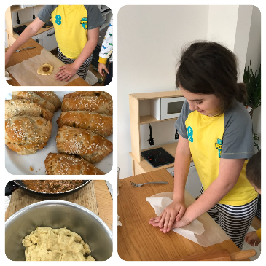
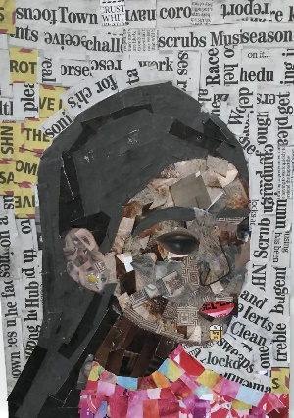

We hope you enjoy another week of our Home-Learning grid. Send in examples of work, or pictures of fun activities you have taken part in, to year5@lea-pri.herts.sch.uk so we can celebrate your efforts.

Hello everyone!
It was lovely to see you last week on Zoom! I am glad you are all keeping busy and I was really impressed with your Science work. Well done! Keep smiling and I hope to see you again soon. Mrs Housley

Maths  Online Maths lessons for this topic can be found on Week 3, Summer Term:  https://whiterosemaths.com/homelearning/year-5/ If you are finding these too tricky to work on independently, a good idea is to look at and do the Year 4 lessons – they still practise our skills and are a great support for revision. As I said last week, the way of working in White Rose is changing, and they are linking to BBC Bitesize (from 11th May) instead of offering worksheets. Our week 3 is still under the old format, but the worksheets may not be accessible. Record work in your books or on paper. We do not expect any parents to pay for worksheets and we have not decided to buy further into White Rose at this time as a school.  If you want a break from White Rose, you could use The Oak Academy – there are ten lessons here on translation – moving shapes around a co-ordinates grid.https://www.thenational.academy/online-classroom/year-5/maths#subjects  Topic – final task. Continue with your mountain project.  Physical activity  Use the Fitter Futures website and have a go at the workouts. Remember to mix up the type of exercise you do, so you complete a balance of cardio and core strength activities.  You can also use Joe Wicks if you want to, to get your morning started, although you can watch his sessions at any time of the day. | Writing  This week, I would like you to write some setting descriptions for me. We are going to use a new short film for this, about ten minutes long, and it might be a nice one to watch with a parent. It has some warm moments – and many scenes made me giggle a bit – but there is also a moment of sadness that you may want to discuss your reaction to with mum or dad. Activities for this week are attached with this grid and will also be on the school website. I have included a link through both YouTube and Vimeo for the short film, so your parents can choose which one to watch it from.  https://www.youtube.com/watch?v=bpfiP7hn7YM  https://vimeo.com/113868429  Sky audio description advert https://www.youtube.com/watch?v=IgSnrRjOG7Q  Grammar, punctuation & spelling  https://www.bbc.co.uk/bitesize/articles/zbkwqp3  Support your settings work with these clips. They remind you about noun phrases, and using prepositions in your writing.  How did you get on with your spelling test? Did you have any you needed to practise again? Ask an adult to test you again on a mix of the spellings (max. 20), including ones you found tricky from last week.
Science
How did you get on with your plant life cycles and seed dispersal work from last week? If you haven’t had a chance to finish them, continue this week! If you have, I have put some Life Cycles work on Education City for you, as we will be moving onto the different life cycles of the animal kingdom.
PSHE – money matters  Look after the pennies, and the pounds will look after themselves.  What do you think this means? Is it good advice? Do you think it is true? Our new topic for PSHE is Money Matters. Think of a time when you have really wanted to buy something, but you had to save up for it. What did you do? How long did it take you? How did you feel when you finally had enough money, or, if you haven’t got there yet, how do you think you will feel?  The Big Question: Why is it important to save?  https://www.valuesmoneyandme.co.uk/teachers/i-want-it-ks2  There are some nice activities for you, and lesson plans for your parents to have a look at on this site.  Something to think about – who do you agree with?  We should just do chores to be helpful at home.  We should always be paid for chores –it is like work! | Other learning  Music  BBC Ten Pieces at home has a really lovely activity this week, as is part of their BBC Music and Dementia Initiative. It is based on Elgar’s Enigma Variations with a creative activity.  https://www.bbc.co.uk/teach/ten-pieces/watch-this-do-this-weekly-activities/zjy3382  Plastic Pollution  Samira sent me an AMAZING pamphlet about plastic this week and one of her suggestions was to upcycle plastic rather than throw it away. What useful thing can you make from an old bottle or plastic container, instead of throwing it away? What about making an old t-shirt bag for shopping instead of using plastic bags?  VE Day  On Friday 8th May, there is a bank holiday to mark the 75th anniversary of the end of the Second World War in Europe. Have a look at these links for some activities and videos to commemorate the anniversary of VE day.  https://www.bbc.co.uk/teach/class-clips-video/history-ks2-ve-day/z7xtmfr  https://www.britishlegion.org.uk/get-involved/remembrance/teaching-remembrance

Daily basic skills and online learning
- Practise times tables regularly, and as divisions. Use TT Rockstars for 10 minutes a day.
- Practise your spellings as handwriting, using the LetterJoin information and login sent home in the Autumn Term to help you. 10 - 15 minutes daily
- Reading – independent, or with an adult, 30 minutes daily.
- Reading Eggspress – up to 30 minutes, 4x weekly
- Practise spellings from Y5/6 words list and high frequency words. 10 - 15 mins.

Keep a diary of the activities you do every day.
- Do not forget to use our ETW rules – Every time we write we:
- take pride in our presentation
- say it, write it, read it
- punctuate each sentence correctly
- check that High Frequency Words are spelled accurately.

Websites.
email address for queries about logins, and to send examples of your work to:
year5@lea-pri.herts.sch.uk

- Reading Eggspress https://readingeggspress.co.uk

- Mathematics https://whiterosemaths.com/homelearning/

- TT Rockstars https://play.ttrockstars.com

- Education City https://ec1.educationcity.com

- Fitter Futures https://app.fitterfuture.com/student/auth/login

- LetterJoin https://www.letterjoin.co.uk/

