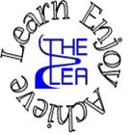
Home learning w/b: 22-06-20 Year: Reception
Message from Mrs Gallagher
Hello Reception
This week’s topic is ‘Pets’ and whether you have a pet at home or not, there are lots of activities that you can have fun doing! We are all missing you very much and know that you are doing a great job at home. We have had some strange weather this week but I hope you have still had lots of fun and even enjoyed the rain! The children that are in school are talking about all of you at home. We would all love to see what you get up to at home so please send us photos to look at - reception@lea-pri.herts.sch.uk - so that we can celebrate your achievements and see how you are getting on.
Thank you
Personal Social and Emotional Development  Discuss the question: How can we look after our outdoor environment? Go for a walk and look at different areas and whether they are being looked after and what would be the best way to look after it – no rubbish, water plants, keep areas tidy, don’t pick flowers etc. | Literacy  Phonics  These activities will depend on your child’s ability as to which sounds you focus on. However, recapping ones that they know will just consolidate learning.  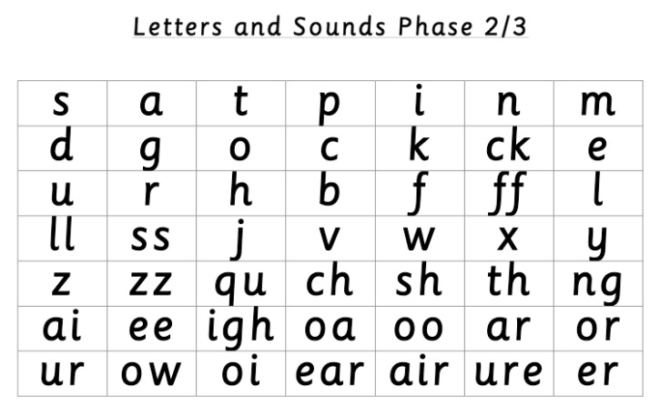  Use these sounds to have a go at some of the ideas for activities below:  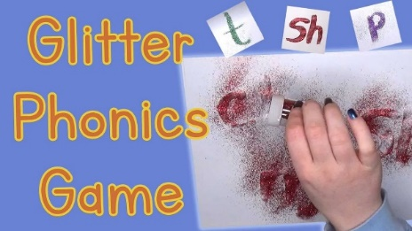  Use some glue to write the sounds on a piece of paper, then sprinkle some glitter on top and shake – your sounds should now be clear to read! Parents – if you do the gluing part and then your child will have to guess what the sound is!  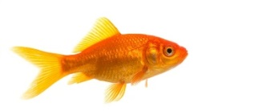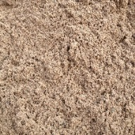  Use these pictures (or think of your own!) and have a go at saying the words and sounding them out. What sounds are in them? Have a go at writing each sound and count how many each word has – do all of the words have the same number of sounds? Can you think of other words with 3 or 4 sounds in?  Note to parents - if you are unsure of how to say the individual sounds correctly, revisit the link on the school website:  https://lea-pri.herts.sch.uk/curriculum/phonics/  Reading  Read the story that we will be reading this week at school together  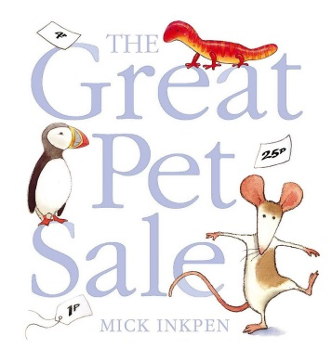  As you are reading it, think about how the rat is feeling during it. Talk about the different pets – do we normally have all of these animals as pets? Do you know anyone with these pets?  Print some pictures of pets, or use cuddly/plastic toys at home. Parents – write the name of each animal and get your child to read the word and match it up to the correct animal. For a challenge, also write some a description for them to read and match – has a long tail, 4 legs, is a big animal, has a beak etc.  Writing  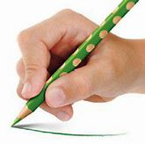  Whilst you are drawing, painting or writing, remember to hold your pencil or paintbrush correctly.  Parents – please make sure that you provide lines for your child to write on as this is how we have learnt to form our letters correctly.  Find these templates on Twinkl or make your own – have a go at writing a pet for sale poster – think about how to describe the pet you are selling and what would make someone want to buy it. You could also try writing a missing poster by describing what your pet looks like.  Physical Development  Continue practising your letter formation – https://www.letterjoin.co.uk  This can also be done without a pencil in sugar, salt, flour, glitter, rice using your finger – just make sure you follow the correct formation.  Make an obstacle course at home – use chairs, cushions, tables, a sheet etc and decide how to use each part, for example over a chair, around each of the cushions, under the table, under the sheet. Try some different ways and have a go at timing yourself, can you beat your quickest time?
Communication and Language
Talk about your pet/what animal you would like to have a pet and explain why you like it or why it is your favourite. Parents – model and encourage the use of full sentences, my favourite animal is…because it looks/likes to/can/is…
Ask family members and friends what their favourite pet is and why – encourage conversations.
Maths
Have a go at making a tally chart this week of either the pets people you know have or the pets they wish they had:
Here is an example:
Discuss the results – which is the most/least popular? How do you know?

Cut out some tag shapes and write some prices on them (like in the story of this week – The Great Pet Sale). Attach them to your cuddly/plastic toys and set up a pet shop. Use coins and with your family to buy and sell the pets and see if you can recognise the different coins needed to buy the pets.

Expressive Arts and Design
Have a go at drawing your pet/the pet you wish you had – make sure you use the correct colours for their fur, legs, ears, nose etc.

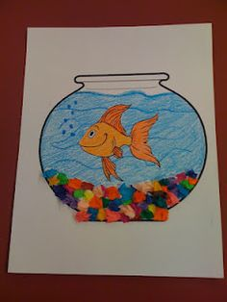
Try making a home for your pet/the pet that you would like – what would it look like? Use some junk modelling if you have some at home and try making a bed for them and even a toy! I would love to see what you come up with.

Find a big stone outside and have a go at designing your own pet – even an animal that you wouldn’t normally have as a pet – and make your stone into your very own pebble pet!

Understanding the World  Look at these animals and have a go at sorting them into groups – what is the same and different about them?  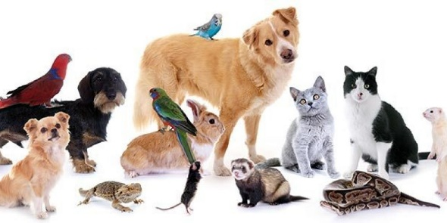  Think of your pet (or the pet you would like to have), how do you look after it? What do they need? Draw a picture of all of the different things a pet needs to survive. | Online Learning  Boogie Beebies https://www.bbc.co.uk/programmes/b006mvsc  There are lots of different routines to learn!  https://www.phonicsplay.co.uk/resources/phase/3  Phonics play –  A game the children have enjoyed at school is ‘Make a Match’ – you can access this game and all of the resources on this website at the moment:  Username: march20  Password: home  https://www.bbc.co.uk/iplayer/episodes/b08wb00s/the-pets-factor watch The Pets Factor and find out what happens to each of the animals – have a go at writing a sentence about what was wrong with the animal/how they got better.
Daily basic skills
Write or trace the tricky words – the, to, I, no, go, into, you, they, all, are, my, her, he, she we, me, be, was
You could use pencils, pens, chalk, paint, paintbrush and water, glitter, salt etc. Please only focus on a couple of words a day/week and ensure the formation is correct before moving on to a new word – provide your child with a line to write on to support correct formation. Have a go at writing a sentence from a story that you have read that day/week and make sure you are writing on a line and using the best letter formation you can do!

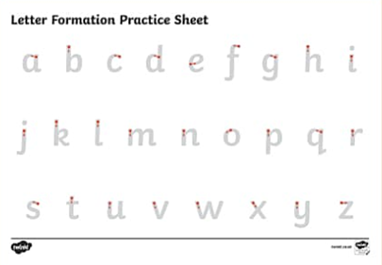
You could have a go at practising the letter formation on this sheet like we used to do at school – the children would sit at a table and we would have relaxing music on to help them to concentrate: https://www.youtube.com/watch?v=WUXEeAXywCY

Counting – have a go at listening to some number songs this week which encourage counting. Get your child to join in with the song or lay some number cards out on a surface in a random order and get them to listen to the song and find the correct number at the right time in the song. Some good number songs: ten green bottles, ten in a bed, Alice the camel, one two buckle my shoe, this old man – you will be able to find these on YouTube.

Reading – this can be a book, flashcards, hide words around the house to find and read, read packets, read words in newspapers or magazines, read signs on your daily walk – expose your child to lots of different things to read. Have a go at reading some sentences together – count how many words are in each sentence. Can you read a longer sentence as a challenge?

