Home learning w/b: 08.06.20 Year: 2
Message from Miss Tyler
I hope you are all well and doing lots of good work. Me and Mrs Wright have been in school this week and it is strange without you all here (although slightly quieter!) I look forward to hearing from Mrs Housley about all the great work you have sent her. Take care x
Message from Mrs Housley
Hi! I hope you are all well and working hard! As Miss Tyler is in school full time now, I will be taking over setting and looking at your home learning. I look forward to seeing all of the amazing work you do.
Celebrating your learning
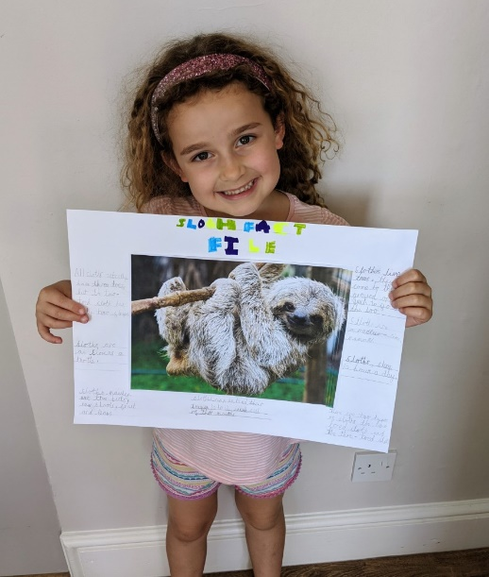
Remember to send me any examples of work or pictures of fun activities to year2@lea-pri.herts.sch.uk so that we can celebrate your efforts and learning at home.

Remember to complete your reading daily and your basic maths skills practice.
Here are this week's tasks:
Maths  In maths this week I would like you to work on 2D shapes. We will be learning about different 2D shapes and their properties.  Watch this clip about 2D shapes. There are also some activities you can complete:  https://www.bbc.co.uk/bitesize/topics/zjv39j6/articles/ztpwdmn  Can you find examples of each of the 2D shapes around your house or garden or out on a walk? Try to record them. Then write down their names and how many sides and vertices (corners) each shape has. | Writing  Write me a story. It can be about anything you like. If you are unsure, you could try retelling one of your favourite stories, or make up your own story about one of the animals you researched last week.  Your challenge is to try and include some speech to let the reader know what the characters are saying.  Try to remember to say who said it:  The big, bad wolf knocked at the door.  Little pig, little pig, let me in! shouted the wolf.  Not on the hair of my chinny chin chin! said the first pig.  So the wolf huffed and puffed and blew the house down.  Reading  In class we used to do quick reads to help with our reading fluency. Attached at the bottom of your home learning is a quick read about kangaroos. Just like in class, give yourself 60 seconds and see how far you read up to. Repeat each day, can you get further?
Grammar, punctuation & spelling  We would be learning about adding adjectives and adverbs to our writing to give essential information, for example – “plain flour” rather than “flour” or “white, fluffy flour”  Can you write a shopping list, including an adjective for each item to make it clear what someone should buy?  For example –  Rather than jam or sticky jam, you would write strawberry jam, or seedless, blackcurrant jam | Physical activity  Go to the Fitter Futures website and have a go at the workouts. These are between 6 and 9 minutes long and can be done at any time of the day. Try to mix up the type you choose of exercise you do, so you complete a balance of cardio and core strength activities. The new password for KS1 is 4aebp – this had to be reset so please ask an adult to log on for you, as we must not change the password.
Science  In science this term we would have been looking at the changes that humans and animals make as they grow and what they need to survive.  Can you find out the names of the young of some different animals? | Other learning  Can you find out why bridges are made and the different ways this can be done?
Topic
This term our topic will be Kings and Queens.
Have a look at these links and find out what the role of the monarch is.
https://www.royal.uk/her-majesty-the-queen
http://projectbritain.com/royal/role.htm
Record what you have found out.
You could even make a crown and write on it the things that a monarch does!

Daily basic skills and online learning
Recommended daily activity and timings to support basic skills
Practise handwriting, using the LetterJoin information and login sent home to help you. 10 - 15 minutes daily.
- Practice your number skills by going on numbots using the logins that were sent home.
- Practice counting in 2, 5, 10. This week can you verbally say them to someone else. Challenge- can you say them forwards and backwards?
- Practice your 2, 3, 5 and 10 times table. This week choose one and write it in order e.g 2x0=0, 2x1=2, 2x2=4 etc.
Can you draw the array to go with each one?
- Practice your number bonds to 10, 20 and 100. How quick can you get at matching them? Draw cherry model to represent them.
- Continue to read books from school and ones that you enjoy. Also get adults to read books and stories to you. Try to read 15 minutes a day.
- Practice reading and spelling the 100 high frequency words. https://www.highfrequencywords.org/
- Practice reading and spelling the Year 2 common exception words.
These can be found on Twinkl. You can find flashcards, posters, tick sheets etc.
- Do some daily writing-You may want to keep a diary of the activities you do every day. You could also write a story of your own, create a comic strip for a story that you know well, or create some non-fiction fact-files for topics that interest you.
Do not forget to use our every time we write rules:
-Say it before you write it
- Use capital letters and full stops
- Use finger spaces
- Spell the 100 high frequency words correctly

Websites:
email address for queries about logins and to send examples:
year2@lea-pri.herts.sch.uk

- Reading Eggspress – in addition to your own reading for enjoyment, there are comprehensions, spelling games and books to read on here. https://readingeggspress.co.uk

- Numbots- https://play.numbots.com/#/intro

- Education City – there will be a selection of tasks set for Maths and English, with Learn It sections to support some concepts if you need them. I have set some revision work and new learning in the homework section.
There are downloadable worksheets, too, to print out and try. There are lots of different games and activities on this site, so explore, learn and have fun! https://ec1.educationcity.com

- Fitter Futures subscription – we have a short-term access to a fitness website aimed at schoolchildren. This has workouts you can do at home and mental health and well-being activities you can try. https://app.fitterfuture.com/student/auth/login

- LetterJoin https://www.letterjoin.co.uk/

- Twinkl – parents can use this free from home for a month to support learning at home. A login offer code will be shared with your parents as soon as possible.
- If using Twinkl, these activities look useful.

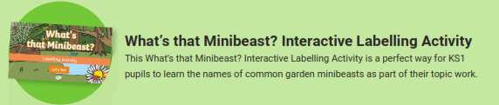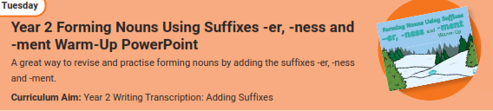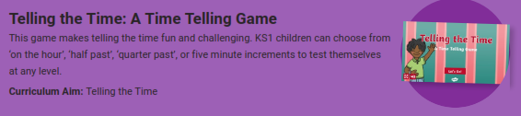
Phonics Play – https://new.phonicsplay.co.uk
While schools are closed, you will be able to access all the phonics games and resources on this website. Use the following to log in:
Username: march20
Password: home
When you have logged on, click on ‘Resources’ and then phase3, 4, 5 or 6.

