Home learning w/b: 8.6.20 Year: 3
Message from Mrs Roper and Mrs Davenport.
Hello Year 3! We hope you had a good half term break.
As you may know, some of the youngest and oldest children started back at the Lea this week. We are sad that it is not yet the turn of Year 3, but we are happy to know you are working hard at home and finding time to be very creative. Thanks to Noah D, Lucian and Saul, who sent in photos of some great artwork they have produced. Keep sending pictures in as we love to see what you have been up to! The email address is
year3@lea-pri.herts.sch.uk.
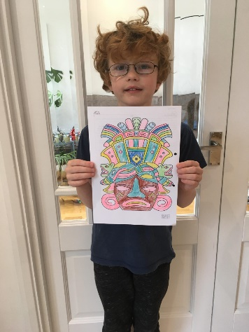
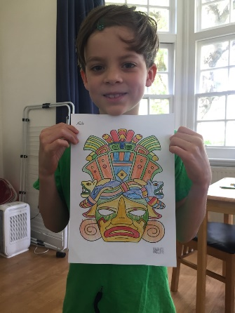
Make sure you have plenty of time to have fun too!

Maths  This week, we will look at a new topic in maths – Measure. (Stay with Oak Academy to do this, as White Rose maths are still doing fractions). The lessons you need are for Week 7, lessons 1-5. You will revise how to multiply and divide by 10, 100 and 1000, and then start to learn about mass (how heavy things are).  https://www.thenational.academy/online-classroom/year-3/maths#  If you want to extra practise, there is an Education City activity that we have set you called Mrs Cow’s Milk – don’t try it until after you have done lesson 2 though! | Writing  This week, we are going to write one paragraph about ‘A Light in the Forest’.  There is a story card attached. It has a photo, suggested vocabulary and some questions underneath it to think about, so you can use the ideas in your writing. There are no right or wrong answers – it is up to your imagination!  Write the starter ‘ As I trudged up the uneven path, I ‘, then continue the paragraph. Challenge – can you use at least two suggested openers? Extra Challenge – finish the story!  Try to remember our Every Time We Write rules:  - Say it, write it, read it  - Use our neatest handwriting  - Use capital letters and full stops  - Check spellings of our High Frequency Words  You can find all the High Frequency Words on the school website  https://lea-pri.herts.sch.uk/curriculum/english/
Grammar, punctuation & spelling  This week we are revising homophones and near homophones. Homophones are words that sound the same but are spelt differently (for example, sea and sea).  Find a homophone for the words on the list attached, then put six of the words into a separate sentence to show the different meanings. Alternatively, find the homophone for the words and then make a card matching game to help you practise writing and spelling them.  Extra challenge – look on Twinkl for lots of fun activities and worksheets to try! | Science – Plants  Continue your learning about plants by taking part in the second Oak Academy lesson – you will learn about the five basic parts and functions of a plant, and write a conclusion for the practical experiment from the last lesson.  https://www.thenational.academy/year-3/foundation/parts-and-function-of-a-plant-year-3-wk2-3
Topic  This week, we want you to imagine what life was like for the ancient Maya.  Watch the bbc bitesize clip below, and do the activity. Then make a comparison of what life was like then – and how it is different from your life today. You can make a list, write sentences or draw, it is up to you.  Challenge – can you do some more research, to find more information about what life was like? Include this extra information in your comparison.  https://www.bbc.co.uk/bitesize/topics/zq6svcw/articles/zg2htv4 | Physical activity  Joe Wicks is doing his workouts every morning at 9am. Join him for a fun mixture of exercise and quizzes to test your general knowledge! Are you doing the extra abs workout?  Or go to the Fitter Futures website https://www.fitterfuture.com/ and log in using the details sent home.
Art & Design
Have you ever tried making a miniature book? 200 years ago, tiny books (57mm high and 47 mm wide) were made for children to read to their dolls! Now the British Library needs your help – they are looking for children to write miniature books during lockdown. If you want to join in, or just to see some of the amazing miniature books, go to https://www.bl.uk/childrens-books/activities/make-a-miniature-book
PSHE  This term we are Aiming High! Think about everything you have achieved in the past year. What are you proud of? Write your ideas down on a piece of paper using coloured pens and pencils. Then think – what did I do to get there? There will always be an action (something you did) or behaviour (something about the way you behaved) that helped you achieve the thing you are proud of.  Write it down.  Choose your favourite achievement and celebrate it with your family | Other learning  Life skills - You already know about making your bed! This week, help an adult by folding some clean laundry and putting it away in the right place in your house. Can you fold it really neatly? Let us know how you get on!  French- Try learning the months of the year using this link. Copy the words onto a piece of paper first. It is very catchy! https://video.search.yahoo.com/search/video?fr=mcafee&p=french+months+of+year+for+ks2+youtube+video#id=2&vid=8cbf04420f75644906c9fcba7a5aa852&action=click

Homophone and near homophone word list
bawl
grate
here
brake
grown
witch
wear
Challenge – can you find two homophones for rain?

Daily basic skills and online learning
Recommended daily activity and timings to support basic skills
- Handwriting – try to practise for 10 minutes a day. The Letter-join website can help you - click on ‘Easy letters’, ‘Harder letters’, ‘Easy words’ and ‘Harder words’ to practice. There are lots of other activities in the ‘Resources’ section that you can explore.
- Practise spelling High Frequency Words and words on the Y3/4 word list. Little and often is best. You can see the lists of words on the school website:
https://lea-pri.herts.sch.uk/curriculum/english/
This website is a good one to use to help you practise them:
https://www.ictgames.com/mobilePage/lcwc/index.html (Click on Y2 Tricky Words and Y3&4 Tricky Words)
- Practise your Times Tables for 10 minutes a day. Remember, you need to know your 2, 3, 4, 5, 8 and 10 times tables by the end of Year 3 as a minimum. Once you know them in order, practise them out of order, and then practise using them to answer division questions. Times Tables Rockstars is a good website to use. See our separate note to parents for advice on using this website effectively
- Continue to read every day for 15-20 minutes. You could read independently some days, but to an adult on other days. Also ask an adult or older sibling to read to you. Log onto Reading Eggspress as well.
- Log onto Education City – we have carefully selected learning activities for English, Maths, Science and Computing. We would like you to complete these. Look in the ‘Homework’ section to find them.
- Do not forget to use our Every Time We Write rules:
- Say it, write it, read it
- Use our neatest handwriting
- Use capital letters and full stops
- Check spellings of our High Frequency Words (you can find these on the school website https://lea-pri.herts.sch.uk/curriculum/english/)

Websites:
- email address for queries about logins and to show us any fantastic work:
year3@lea-pri.herts.sch.uk

- Reading Eggspress – in addition to your own reading for enjoyment, there are comprehensions, spelling games and books to read on here. https://readingeggspress.co.uk

- Times Tables Rockstars- https://ttrockstars.com/

- Education City – there will be a selection of tasks set for Maths, English, Science and Computing with Learn It sections to support some concepts if you need them. There are downloadable worksheets, too, to print out and try. There are lots of different games and activities on this site, so explore, learn and have fun! https://ec1.educationcity.com

- Fitter Futures subscription – we have a short-term access to a fitness website aimed at schoolchildren. This has workouts you can do at home and mental health and well-being activities you can try. https://app.fitterfuture.com/student/auth/login

- LetterJoin https://www.letterjoin.co.uk/

- Twinkl – parents can use this free from home to support learning at home while schools are closed.

- Phonics Play https//new.phonicsplay.co.uk – while schools are closed you will be able to access all the phonics games and resources on this website. It will be really good for everyone to revise some phonics, and if any of you are unsure of some sounds, it will be a good chance to practise! Use the following to log in. Username -march20 Password - home. When you have logged in, click on ‘Resources’ and then ‘Phase 3’, ‘Phase 5’ or ‘Phase 6’.

