Home learning w/b: 15.6.20 Year: 4
Message from Mrs Hills and Mrs Stevenson
Hello Year 4!

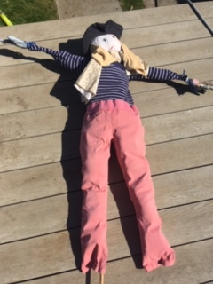
Hope you’ve all managed to keep busy and smiling despite the change in weather.
Mrs Stevenson has been a little bit pleased to have some rain for the fruit and vegetables they are growing on their allotment. They spent some time this week making a scarecrow to try and scare away the birds. They were pleased with how she turned out but then it was really windy and she blew down! Have you decided to grow anything during lockdown? We’d love to hear about it if you have!

Thank you to those who have sent their lovely letters for Mrs Stevenson. She’s going to be very surprised and delighted with them! If you’ve not written yours yet, please can you do it over the next week and send to me on the year4 address below. It would be lovely to have a letter from everyone in the class. Thank you also to those of you who have sent us some pictures and messages. We’ve had some great work in and it’s so lovely to see what you are doing. Naomi has made an amazing power point about the Romans and we’ve had the fantastic work below from Timothy, Eesaa, Naomi, Max, Jaya, Sarah, Eesha and Sofia. Keep sharing your work with us. The email address to send it to is year4@lea-pri.herts.sch.uk.
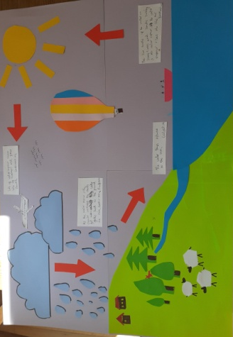
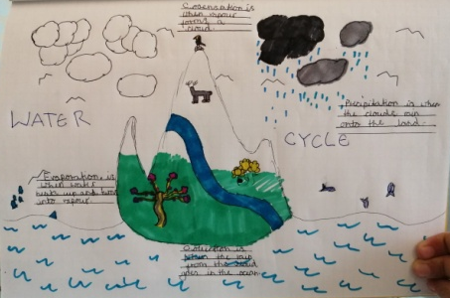
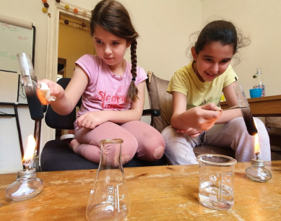

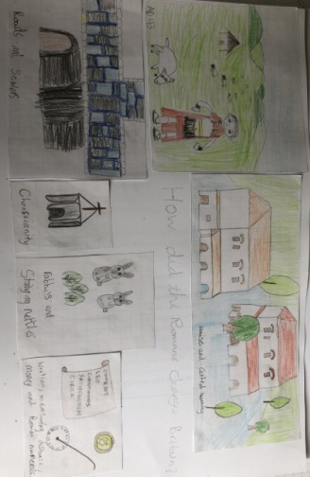
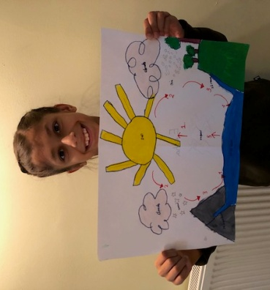
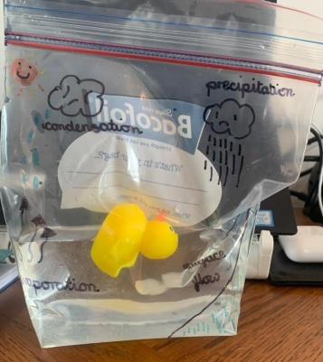

Dear year 4,
I hope this finds you all still safe and well and I hope you have had a positive and happy week, during what should be the start of the last term of the school year. I’m missing you all so much. It’s been lovely seeing some of you on zoom and in school over the weeks. I can’t wait till we get together again and see each other. Me and Mrs Hills talk about you all the time remembering all the times you have made us smile and there’s so many of them. I’m so, so, proud of you all and how you have stayed positive through such a challenging time. I hope my jokes keep you all smiling. Take care year 4
From Mrs Dada x
Why is Cinderella bad at soccer?
Because she’s always running away from the ball!
Why did the picture get sent to prison?
Because it was framed! Hahaha

Remember to do some reading, writing and maths every day. You don’t have to do everything on the grid, so don’t feel under pressure to do it all, just do what you can manage.
Remember to check out the activities on educationcity in the year 4 folders.
Maths  Please follow the daily maths lessons on  https://whiterosemaths.com/homelearning/  Please join in on one a day. This week is the final week of decimals! This is a great way to make sure you are totally secure with decimals before we move on to a different topic next week.  It is connected to the BBC Bitesize daily lessons with links going straight there for activities and further teaching. If you are fed up with this website, then try one of these websites and follow their lessons doing one each day.  http://www.iseemaths.com/home-lessons/ or  https://www.thenational.academy/online-classroom/year-4/maths#subjects  Remember to keep practising your times tables – every day! Don’t forget to practise the division facts too. We’ve also attached a maths mystery if you enjoy doing them, otherwise just leave it. | Writing  Last week you watched the Rhythm of the Rain on youtube: https://www.youtube.com/watch?v=VNB7WGEUur4  Watch it again to refresh your memory and look at the notes that you made. Listen out for the beautiful language Grahame Baker-Smith (the author) uses - ‘he raced the laughing streams down the mountainside’.  This week we’d like you to imagine you are Isaac writing a postcard, a letter or an email to Cassi. Tell Cassi all about the journey the water goes on to get from you to her.  Try to make your writing as descriptive as you can. Can you use metaphors and similes to help Cassi imagine a world where water isn’t in short supply?  You can watch this clip to remind you what about metaphors and similes: https://www.youtube.com/watch?v=yDOf299VYdU  We also recommend you continue to watch the daily English lessons on BBC bitesize https://www.bbc.co.uk/bitesize/tags/z63tt39/year-4-and-p5-lessons/1 . They are only short and will continue to help to develop your writing.
Grammar, punctuation & spelling  Look at the Y3/4 High frequency words and pick out the ones you are still finding tricky. Can you make a wordsearch with them? Or a crossword? Have some fun creating a puzzle for someone in your house to solve.  If you are secure in the High frequency words, please continue to revise the spellings from the y3/4 spelling list. Try writing the words in sentences to make it a bit harder.  Both lists are on the school website and in the front of your home learning books  https://lea-pri.herts.sch.uk/curriculum/english/ | PSHE  This term we are Aiming High! Q. What kind of behaviour and attitude helps us learn new things? A. A positive attitude! We have done lots of work on having a growth mindset, which includes a positive attitude. Use as many of the following words as you can to make a display of positive learning comments somewhere in your house (make sure you check with an adult first…….)  Positive, learning, attitude, develop, learn, improve, strength, build, strengthen, resilience
Topic – The Romans  A few weeks ago, you found out that the Roman Army was very strong. This week we’d like you to research what it was like to be in the Roman Army.  https://www.bbc.co.uk/bitesize/topics/zwmpfg8/articles/zqbnfg8 and watch https://www.bbc.co.uk/bitesize/clips/zbns34j and  https://www.bbc.co.uk/bitesize/clips/zn2mhyc  One of the fascinating things about the Roman Army is the different battle formations they did.  http://www.primaryhomeworkhelp.co.uk/romans/formation.html  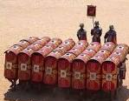  You can present your learning in any way that you like. Perhaps you can practise some of the formations with your Roman shields. | Physical activity  Try to do something active every day. You could go for a run with your parents, ride a bike or do some skipping. You could also make up your own fitness routine. If you are able to, you can also do PE with Joe Wicks on Youtube or go to the Fitter Futures website and have a go at the workouts. Try to mix up the type of exercise you do, so you complete a balance of cardio and core strength activities.  Username: thelea2  Password: 3ffzx Please ask an adult to log on for you, as we must not change the password.
Art  Father’s day is approaching, this week we’d like you to make a card for someone special in your life. It might be your dad or it could be an uncle, a grandad, your mum or anyone that who you’d like to make smile.  This is a lovely, easy and effective card to make  https://www.youtube.com/watch?v=YhHMTcn4kGY  You can get creative with it – you could put real buttons on and a bow tie instead of a tie (you could use some bow pasta for this!) or you could use patterned paper, colour in plain paper or use stickers to jazz up the shirt!  We’d love to see pictures of your finished designs. | Music  https://www.bbc.co.uk/teach/ten-pieces/ten-pieces-at-home/zjy3382 Choose week 8.  This week the BBC Ten Pieces at home activity is inspired by Bernstein’s Mambo from West Side Story. Learn Cuban rhythms and create kitchen percussion to play along to the music.  RE  This week we’re looking at the RE themes of fairness and justice. Watch this faith story about a man named Zacchaeus, then think about how it shows these themes. Retell it, explaining this, to someone you know.  https://www.bbc.co.uk/bitesize/clips/zq9jxnb  Life skills  This is a good time to learn some life skills. I wonder what you have already been learning and helping with at home. I know lots of you have been doing baking and cooking. Have any of you learnt how to put bedding on or how to fold the washing? This week, we challenge you to learn a new life skill at home. Ask your parents what would be good for you to learn to do and helpful to them and then have a go at it. Let us know how you get on.
Science
Now that you are familiar with the water cycle, we would like you to have some fun learning or making up a song about it.
If you have access to a computer - visit the web address below: https://www.youtube.com/watch?v=TWb4KlM2vts

Can you add in actions? You could ask an adult to record your performance and email it to the Year 4 address.

If you don’t have access to a computer or if you’d like a further activity to do - can you make up your own song, rap or poem about the water cycle? We’d love to hear or read them when you have!

Use the notes below to help you:

EVAPORATION – WATER EVAPORATES INTO THE AIR
The sun heats up water on land, in rivers, lakes and seas and turning it into water vapour.
The water vapour rises into the air.
CONDENSATION – WATER VAPOUR CONDENSES INTO CLOUDS
As water vapour in the air cools down it turns back into tiny drops of water. These tiny drops of water form clouds.
PRECIPITATION – WATER FALLS AS RAIN
As the amount of water vapour in the clouds increases the clouds get heavier and heavier. Water falls back to the ground as rain or if it’s cold enough, sleet or snow.
WATER RETURNS TO THE SEA
As rain water runs over the land back to rivers and the sea some is taken up by and used by plants, some returns back to the air through transpiration. Most of the rain water though collects in lakes or rivers and flows back to the sea for the water cycle to start again.
Daily basic skills and online learning
- Practise your spellings as handwriting, using the LetterJoin information and login sent home to help you. 15 minutes 3 times per week. See links below.
- Practice your times tables on https://ttrockstars.com/ using the logins that were sent home. Focus on the times tables that you are less confident with.
- Practice your number bonds to 10, 20 and 100. How quick can you get at matching them?To those who are confident with whole numbers, make decimal numbers, ie 45.67 + 54.33.
- Read for at least 20 minutes a day. Also get adults to read books and stories to you.
- Listen to David Walliams reading extracts from his books at 11am every day on https://www.worldofdavidwalliams.com/elevenses/
- Practice reading and spelling all the high frequency words.
- Practice reading and spelling words from the year 3/4 spelling list. Write sentences using the words.
- Do some daily writing. See the grid above first. You may also want to keep a diary of the activities you do every day. You could also write a story of your own, create a comic strip for a story that you know well, or create some non-fiction fact-files for topics that interest you.
Do not forget to use our every time we write rules:
- Say it, write it, read it
- Use our neatest handwriting
- Use capital letters and full stops
- Check spellings of our High Frequency Words

Websites:
Email address for queries about logins:
year4@lea-pri.herts.sch.uk - Please do let us know if you are having trouble with logins.
- Links to spelling lists are on our school website on https://lea-pri.herts.sch.uk/curriculum/english/
- Reading Eggspress – in addition to your own reading for enjoyment, there are comprehensions, spelling games and books to read on here. https://readingeggspress.co.uk
- Times Tables Rockstars on https://ttrockstars.com/
- Education City – there will be a selection of tasks set for Maths, English and Science
with Learn It sections to support some concepts if you need them. There are downloadable worksheets, too, to print out and try. There are lots of different games and activities on this site, so explore, learn and have fun! https://ec1.educationcity.com
- Fitter Futures subscription – https://app.fitterfuture.com/student/auth/login
- LetterJoin https://www.letterjoin.co.uk/ Use this to practise writing spellings using your neat joined handwriting.

- Twinkl – parents can use this free from home for a month to support learning at home.

- If you would like more, there are also the daily lessons on BBC bitesize. They are very good if you are happy to have extra screen time. https://www.bbc.co.uk/bitesize/dailylessons

