**Home learning w/b:** 29.6.20 **Year: 4**

**Message from Mrs Hills and Mrs Stevenson**

Hello Year 4!

It’s been a hot week and we hope you have enjoyed the lovely weather! I’m really looking forward to seeing most of you back at school. It’s been such a long time since we last saw each other. It will be very different as it won’t be the whole class because we need to come back in smaller groups. I’m very lucky though, as I’ll be seeing both groups. Some of you will stay in the Key Worker group, who have been in during most of this period. Some of you will wait to come back to school until after the summer. Whether you’re coming back in to school or not, we want you to know that we have missed you very much and thought about you every day and we’ll continue to do so. As you will still have most of your week at home, we are continuing the home learning grid. Remember, just do what you can. I’m going to try to link the English to what we’ll be doing at school so that those who are not in school can still take part in some of it.

Dear y4,

Hope you are all well. Wow the weather has been so hot this week, hope you have enjoyed it. I’m looking forward to seeing some of you back at school next week, it really has been quite some time now. I know Mrs Hills is really excited to see you too. I really am so proud of you all and I just want you to know you are all amazing.

I haven’t forgotten,

Q: What did the ground say to the earthquake?   
A: You crack me up!

Q: How do football players stay cool during the game?  
A: They stand close to the fans?

Have a good weekend y4, take care.

Mrs Dada x

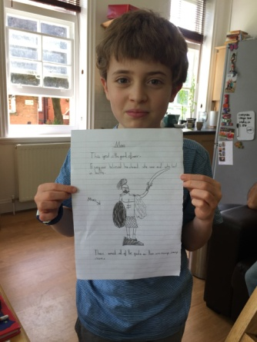Thank you to those of you who have sent us pictures and messages. It’s good to know that you are keeping yourselves busy. We’re also impressed with the life skills you have been learning. Keep sharing your work with us. The email address to send it to is [year4@lea-pri.herts.sch.uk](mailto:year4@lea-pri.herts.sch.uk). This week, Florence made a particularly impressive presentation including visual and sound effects and her speaking and presenting it! We’ve also had some fantastic examples of your drawings of the Colosseum as well as your research. The picture included is Sarah’s.

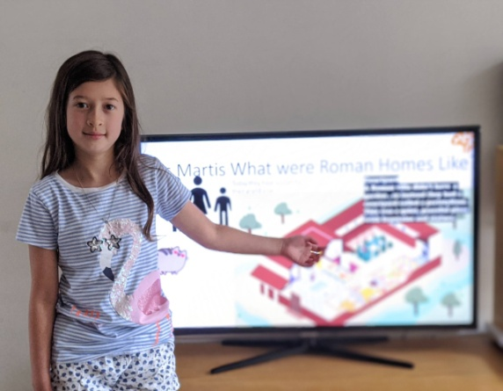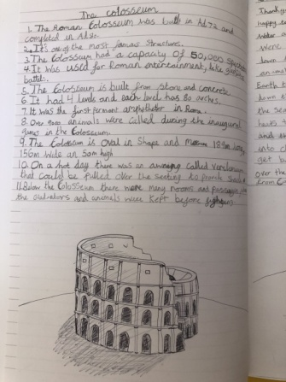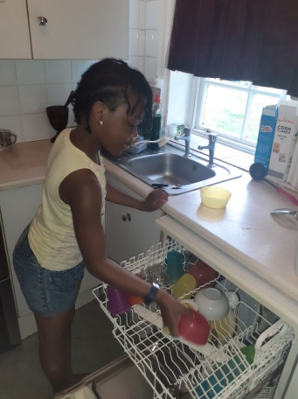

**Remember to check out the activities on educationcity in the year 4 folders.**

**BBC Iplayer has put some more daily lessons up. These are the 20 minutes lessons covering a range of topics. They can be found on** [**https://www.bbc.co.uk/iplayer/episodes/p089g063/bitesize-79-year-olds?seriesId=p08b2x25**](https://www.bbc.co.uk/iplayer/episodes/p089g063/bitesize-79-year-olds?seriesId=p08b2x25)

|  |  |  |
| --- | --- | --- |
| **Maths**  It’s the last week of money and statistics on <https://whiterosemaths.com/homelearning/>.  We know some of you are getting fed up with this now. How about making a café or a pretend shop for your family to buy things from in stead. You can then price up the things using decimals and work out how much they have spent.  We’ve also attached another Maths puzzle covering different areas of the curriculum for you to do. The answers are at the back.  Remember to keep practising your times tables – every day! Don’t forget to practise the division facts too. | **Writing**  This week those of us at school will be working on the book ‘Leon and The Place Between’ by Angela McAllister and Grahame Baker-Smith. You can listen to it being read by a teacher here:  <https://www.youtube.com/watch?v=ZIepFjnn0fM>.  Write a description of the place between. Which words would you use? (Eg magical, amazing, unique) You can imagine you are Leon telling his family about it later on.  Pretend you are Leon and you are being interviewed about your experience. Think about these questions and write the answers in full sentences.  What were you thinking about as you waited for the show to begin?  Which sights and sounds most grabbed your attention?  What was your reaction when Abdul Kazam appeared?  How did you feel as you stepped through the box?  What was your favourite sight as you travelled on the carpet?  Why did you hold onto the rabbit as your name was called?  Where did you think the Place between is?  What do your siblings think of your adventure now?  Try to do some writing every day and don’t forget to use our every time we write rules:   * Say it, write it, read it * Use our neatest handwriting * Use capital letters and full stops * Check spellings of our High Frequency Words   Daily English lessons are still available on BBC bitesize <https://www.bbc.co.uk/bitesize/tags/z63tt39/year-4-and-p5-lessons/1> . | |
| **Spelling**  How many words can you make using some or all of the letters below? |
| **download.jpgTopic – The Romans**  Chariot racing was a very popular sport in the Roman era. The charioteers (drivers) were usually slaves. If they were really good and won a lot of races, they could earn enough money to buy their freedom. This week we’d like you to make or draw a Roman chariot. You can either use the template at the end of this grid or you can make your own version of a chariot. The picture is an example of what you could do.  Or  You could try to build the Colosseum out of biscuits. We did it at school last year and we had a lot of fun. Warning: It will get messy! | **Physical activity**  This week we recommend you watch one of these BBC Celebrity Supply Teacher clips.  If you’d like to do some dancing with Darcy Bussell click here:  <https://www.bbc.co.uk/iplayer/episode/m000kcml/celebrity-supply-teacher-series-1-11-darcey-bussell-dance>  If you’d like to learn some great warm up techniques with Marcus Rashford click here:  <https://www.bbc.co.uk/iplayer/episode/m000jycy/celebrity-supply-teacher-series-1-3-marcus-rashford-pe> | |
| **Art & PSHE**  Teacher's Pet på Twitter: "I LOVE this idea for a KS2 self ...James Tansey School on Twitter: "Grade 5 #selfportrait using ...Classroom Inspiration | Elementary art, 4th grade art, School art ...Self-Portrait Collage | Knutselen, Selfies, Projecten  As we are coming to the end of the year, we thought it would be nice for you to create some art that would help your new teacher get to know you!  Have a look at the portraits above. Two of the examples use descriptive words to make the facial features and the other two use pictures to fill in the profiles. Pick which you like best and have a go at creating your own. You can use whatever you like – collage, pen, pencil, crayon or even paint. Just try to make it all about you! | | |
| **Science**  There are two activities below. Have a go at one or both of them. Try to write a few sentences about what you did and what happened afterwards. Can you explain in your own words what happens?  See next page! | |
| **Daily basic skills and online learning**   * Practise your spellings, handwriting and times tables at least 3 times per week. Read every day.   **Websites:**  Email address for queries about logins - [year4@lea-pri.herts.sch.uk](mailto:year4@lea-pri.herts.sch.uk)   * Spellings - [**https://lea-pri.herts.sch.uk/curriculum/english/**](https://lea-pri.herts.sch.uk/curriculum/english/) * Reading Eggspress –[https://readingeggspress.co.uk](https://readingeggspress.co.uk/) * Times Tables Rockstars on <https://ttrockstars.com/> * Education City –<https://ec1.educationcity.com> * Fitter Futures subscription – <https://app.fitterfuture.com/student/auth/login> * LetterJoin <https://www.letterjoin.co.uk/> | |

