Home learning w/b: 8.6.20 Year: 4
Message from Mrs Hills and Mrs Stevenson
Hello Year 4!
How are you all getting on? Mrs Hills has been enjoying being back in school this week (she’s been doing some work on meerkats with her group and realized how fascinating they are!) Mrs Stevenson has been at home keeping busy with her girls. They’ve been enjoying some lovely walks and even ventured further out to walk around the gardens at Knebworth House this week. The dinosaurs there are fabulous. Her girls were most impressed with the ice cream van though! Have you all been having lots of ice cream to stay cool in the hot weather? Hope you are all staying happy and safe.

Thank you to those who have sent their letter for Mrs Stevenson. If you’ve not written yours yet, please can you do it over the next week and send to me on the year4 address below. It would be lovely to have a letter from everyone in the class. Thank you so much to those of you who have sent us some pictures and messages. Keep sharing these with us. We miss you and it’s a great way to keep in contact. Just let me know if you don’t want it shared in the learning grid. The email address to send it to is year4@lea-pri.herts.sch.uk.

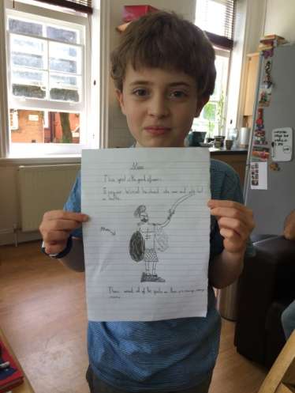
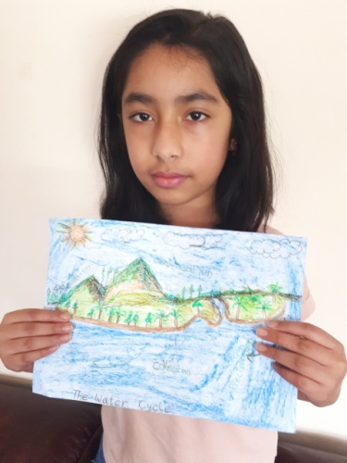
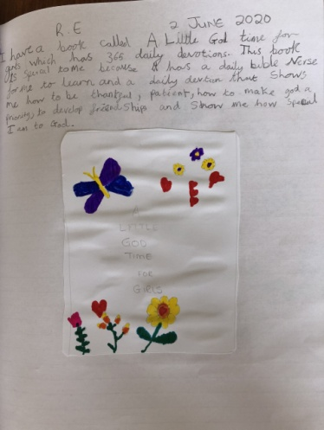
Here’s a message from Mrs Dada for you.
Dear y4,
Hope you are all doing well. It’s been a busy week back at The Lea. It’s been lovely seeing some of the other classes return to school. I have enjoyed hearing and seeing all your fabulous work and I read an amazing story which James had written. I’m so proud of you all, for persevering through such a challenging time. You’re all superstars! I miss you all very much, keep smiling and stay safe year 4.
Mrs Dada x
Oh, by the way,
Q: What did the triangle say to the circle?
A: You’re pointless!
Q: What do you call a funny mountain?
A: Hill-arious

Remember to do some reading, writing and maths every day. You don’t have to do everything on the grid, so don’t feel under pressure to do it all, just do what you can manage.
Remember to check out the activities on educationcity in the year 4 folders.
Maths  Please follow the daily maths lessons on  https://whiterosemaths.com/homelearning/  Please join in on one a day. This week it is going back to decimals. You might have had enough of decimals, but it is an area that is really important to be secure in, so it will help you in year 5 and beyond. It is connected to the BBC Bitesize daily lessons with links going straight there for activities and further teaching. If you are fed up with this website, then try one of these websites and follow their lessons doing one each day.  http://www.iseemaths.com/home-lessons/ or  https://www.thenational.academy/online-classroom/year-4/maths#subjects  Remember to keep practising your times tables – every day! Don’t forget to practise the division facts too. | Writing  This week we would like you to watch someone telling the story ‘The Rhythm of The Rain’ on Youtube.  https://www.youtube.com/watch?v=VNB7WGEUur4  This is a beautiful story about the journey water goes on and it ties in really well with the work we have done on the Water Cycle in Science.  Watch it a second time and make some notes on the journey that the water takes, e.g. streams down mountainside > joins river > goes down waterfall  Keep these notes for next week when we will do some more work on the story!  We also recommend you continue to watch the daily English lessons on BBC bitesize https://www.bbc.co.uk/bitesize/tags/z63tt39/year-4-and-p5-lessons/1 . They are only short and will continue to help to develop your writing.
Grammar, punctuation & spelling  Continue to revise all the High frequency words and practise spelling them if you are not secure in them  If you are secure in the High frequency words, please continue to revise the spellings from the y3/4 spelling list. Try writing the words in sentences to make it a bit harder.  Both lists are on the school website and in the front of your home learning books  https://lea-pri.herts.sch.uk/curriculum/english/ | PSHE  This term we are Aiming High! Think about everything you have achieved in the past year. What are you proud of? Write your ideas down on a piece of paper using coloured pens and pencils. Then think – what did I do to get there? There will always be an action (something you did) or behaviour (something about the way you behaved) that helped you achieve the thing you are proud of.  Write it down.  Choose your favourite achievement and celebrate it with your family
Topic – The Romans  How did the Romans change Britain?  Use the link to find out how the Romans changed Britain and what they left behind.  https://www.bbc.co.uk/bitesize/topics/zqtf34j/articles/z2dr4wx  You can choose how you want to present your learning, ie a power point presentation, an information leaflet, write a play about it and perform it to your family, create a comic strip about it or choose any other way to present your findings. | Physical activity  Try to do something active every day. You could go for a run with your parents, ride a bike or do some skipping. You could also make up your own fitness routine. If you are able to, you can also do PE with Joe Wicks on Youtube or go to the Fitter Futures website and have a go at the workouts. Try to mix up the type of exercise you do, so you complete a balance of cardio and core strength activities.  Username: thelea2  Password: 3ffzx Please ask an adult to log on for you, as we must not change the password.
Art  Thinking about the story we have looked at in English, ‘The Rhythm of the Rain' - imagine you are either Isaac or Cassi.  Look at the illustrations in the book and think about how different their lives must be.  Now draw a landscape picture that either Cassi would send to Isaac or Isaac would send to Cassi to show the other where they live.  Remember when you are drawing a landscape to have your paper ‘landscape’ way round and not portrait.  Try experimenting by mixing two different ways of adding colour to your picture e.g. pen and crayon or pencil and pen. | Music  This week we’d like you to listen to Stravinsky’s ‘The firebird’ on BBC Ten Pieces at home https://www.bbc.co.uk/teach/ten-pieces/ten-pieces-at-home/zjy3382 . If you do the activity and draw to the music, make sure you send in a picture of it as we’d love to see it.  You can still access the Out of the Ark sing at home every week. Keeper of my heart is one of the new songs in the wellbeing section. I think you’ll enjoy it  https://www.outoftheark.co.uk/ootam-at-home/?utm_medium=email&utm_campaign=OOTA%20%20HOME%20Week%2011%20AB&utm_content=OOTA%20%20HOME%20Week%2011%20AB+Version+A+CID_a0a77db994ac4d6f709f83d089fe19d5&utm_source=Email%20newsletter&utm_term=Keeper%20Of%20My%20Heart#new-and-featured
Science
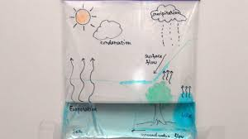
Last week you made a water cycle poster. This week we would like you to make a water cycle in a bag.

Draw a picture of the water cycle on a freezer bag and then fill about a third of it with water. Tape it to a window that catches the sun and watch what happens.
Can you write a short paragraph to explain what is happening within the bag? What is the process that makes the water rise to the top of the bag? Why does it fall back to the bottom? Why did the window need to be in the sun?

Daily basic skills and online learning
- Practise your spellings as handwriting, using the LetterJoin information and login sent home to help you. 15 minutes 3 times per week. See links below.
- Practice your times tables on https://ttrockstars.com/ using the logins that were sent home. Focus on the times tables that you are less confident with.
- Practice your number bonds to 10, 20 and 100. How quick can you get at matching them?To those who are confident with whole numbers, make decimal numbers, ie 45.67 + 54.33.
- Read for at least 20 minutes a day. Also get adults to read books and stories to you.
- Listen to David Walliams reading extracts from his books at 11am every day on https://www.worldofdavidwalliams.com/elevenses/
- Practice reading and spelling all the high frequency words.
- Practice reading and spelling words from the year 3/4 spelling list. Write sentences using the words.
- Do some daily writing. See the grid above first. You may also want to keep a diary of the activities you do every day. You could also write a story of your own, create a comic strip for a story that you know well, or create some non-fiction fact-files for topics that interest you.
Do not forget to use our every time we write rules:
- Say it, write it, read it
- Use our neatest handwriting
- Use capital letters and full stops
- Check spellings of our High Frequency Words

Websites:
Email address for queries about logins:
year4@lea-pri.herts.sch.uk - Please do let us know if you are having trouble with logins.
- Links to spelling lists are on our school website on https://lea-pri.herts.sch.uk/curriculum/english/
- Reading Eggspress – in addition to your own reading for enjoyment, there are comprehensions, spelling games and books to read on here. https://readingeggspress.co.uk
- Times Tables Rockstars on https://ttrockstars.com/
- Education City – there will be a selection of tasks set for Maths, English and Science
with Learn It sections to support some concepts if you need them. There are downloadable worksheets, too, to print out and try. There are lots of different games and activities on this site, so explore, learn and have fun! https://ec1.educationcity.com
- Fitter Futures subscription – https://app.fitterfuture.com/student/auth/login
- LetterJoin https://www.letterjoin.co.uk/ Use this to practise writing spellings using your neat joined handwriting.

- Twinkl – parents can use this free from home for a month to support learning at home.

- If you would like more, there are also the daily lessons on BBC bitesize. They are very good if you are happy to have extra screen time. https://www.bbc.co.uk/bitesize/dailylessons

