Home learning w/b: 22.06.20 Year: 5
Message from Mrs Cross
Hello, Year 5!
The weather has not been quite so glorious this week, but I hope you have still been able to get out and about for some fresh air and fun. Thank you so much for the examples of your hard work! We have topic and art-to-music; French and Science; and I was really pleased to see so much fantastic writing. You should all be really proud of yourselves! I enjoyed reading the start to Juliette and Chloe’s story, too – War, Sirens and Scales – and watching Chloe’s baking video of Anzac slices!

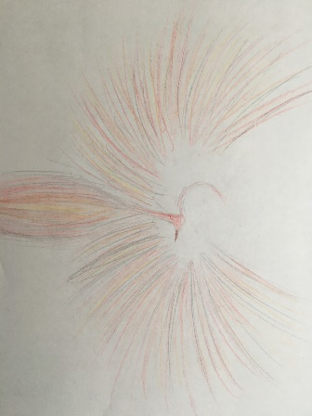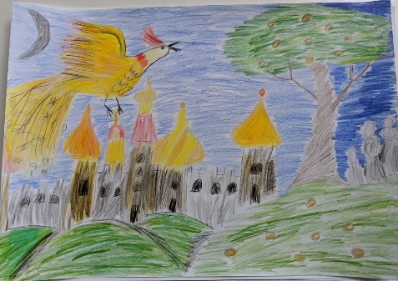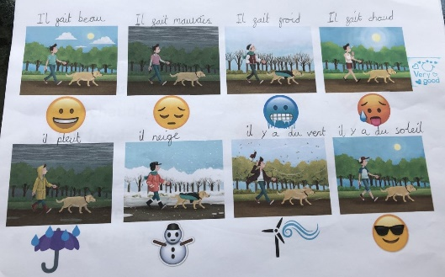

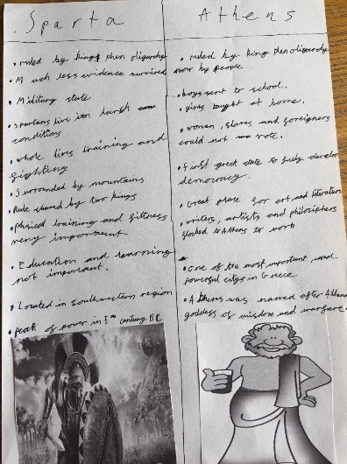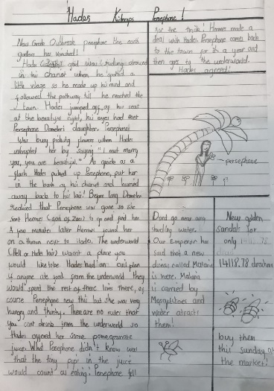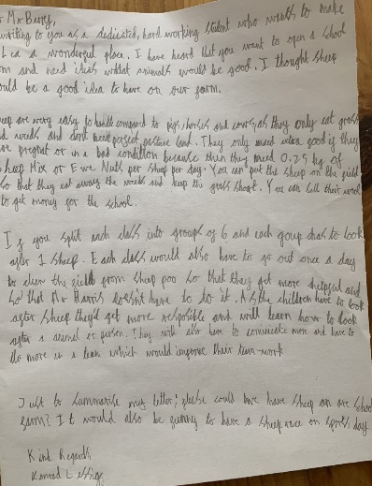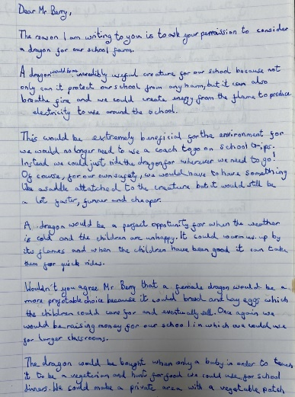
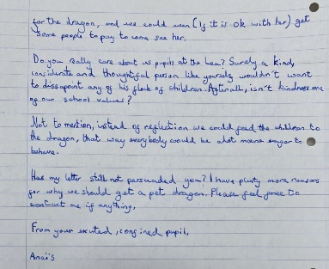
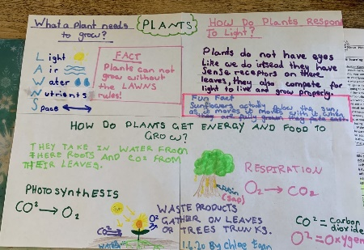
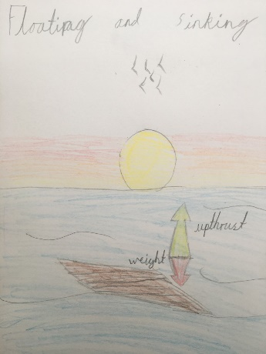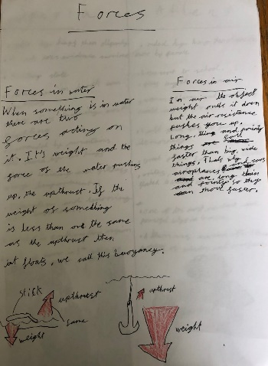

Keep up the good work, Year 5 – you keep impressing us!

Message from Mrs Housley

Hi! Was lovely to see some of you on Zoom last week and I’ve really enjoyed looking at the work you have shared with us. Hope you’re all managing to get outside when it’s not raining! I’m really looking forward to seeing the science work you do this week – I know it is tricky, but remember to try your best and have a go! Take care!
Message from Mrs Light

Hope you’ve all enjoyed your week! We’ve had a lovely week at school but it’s very different without all your smiley, happy faces and we miss you. For our art project, we went on a nature walk at school and took some photos at the outdoor area; the water lilies in the pond, and the poppies some of the children planted at the beginning of lockdown, look great! Keep working hard and challenging yourselves and hopefully we will see you soon!

Maths  Online Maths lessons can be found on Week 7, Summer Term, adding and subtracting fractions:  https://whiterosemaths.com/homelearning/year-5/  Something different? Look at these 4 lessons from NCETM https://www.ncetm.org.uk/resources/54454 - Upper Key Stage 2 (Number, Addition and Subtraction) This is a good series of lessons to help keep your deeper maths understanding in tip-top condition.  Keep practising your times tables regularly, and as divisions. These help you in so many different areas of mathematics – a speedy and accurate recall of these facts help you to focus on the learning in those different areas.  Topic – Ancient Greece  So, would you rather have been an Athenian or a Spartan? Why? What would someone who disagreed with you say? Write a letter to me, explaining which state would be the best to be a part of – you could try to persuade me to follow your choice, or you might encourage me to consider the benefits and problems with both cultures, then make up my own mind. I have included some language and sentence starters for you at the bottom of the grid.  Something different? You could try filming a stop motion animation of this as a debate, recording a voice over for the arguing characters (you will still need to use the language at the end of the grid), or can you think of another way to present your ideas to me?  Other learning – pupil ideas  PowerPoint Power!  If you like making slideshows, you could try this challenge, suggested by Martina.  Create a slide show about your favourite country or a country you would like to visit one day. You could include information from the following list (or from all of it if you are feeling particularly adventurous!), which has some great ideas to get you started.  1. Cultural facts  2. National food /recipe  3. Historical facts  4. Myths and legends  5. Geographical features, e.g. rivers/mountains  6. Famous scientists/inventors  7. A famous piece of art or monument  8. National animal  9. National anthem or a famous song that you like  10. Words/phrases/numbers in the language of the country  11. Religion | Writing  We are going to try something different this week, using a home-learning booklet that you can work through independently and at your own pace. We are not able to publish it on our website, so you can download it and print, or work into a lined book from the pdf. Follow this link to the Pie Corbett Talk for Writing site, then filter the page for Key Stage 2 resources.  https://www.talk4writing.com/home-school-units  Choose which booklet you find most interesting from these two Year 5 options – ‘One Chance’ or ‘The Game’ – and work through this thoughtfully and with care. There are a lot of activities, so this should last you TWO weeks!  Grammar, punctuation & spelling  Remember to use ETW for your written work and check that you have used punctuation accurately throughout your work. The booklets explore spellings through looking at rich vocabulary and give specific punctuation and grammar to practise (The Game – relative clauses; One Chance – inverted commas and dialogue). I look forward to hearing how you got on!
Physical activity
Use the Fitter Futures website and have a go at the workouts. Remember to mix up the type of exercise you do, so you complete a balance of cardio and core strength activities. Get out and about for your daily exercise. Enjoy your family walk or run and keep up all those activities in your garden.

Science
Forces revision
Mrs Housley says that an area of Forces you did not get to focus on was levers, gears and pulleys. These are tricky concepts to understand! We have put some learn screens and glossaries (Teacher Notes) on Ed City for you. Here are some clips to help you learn about levers, pulleys and gears:
https://www.bbc.co.uk/bitesize/clips/zrp6n39
https://www.bbc.co.uk/teach/class-clips-video/science-physics-ks2-ks3-will-pulleys-let-9-year-olds-beat-Britain%E2%80%99s-strongest-man/zvm4d6f
https://www.bbc.co.uk/teach/class-clips-video/science-physics-ks2-ks3-will-gears-let-children-pull-a-piano-uphill-with-their-bikes/zmcpy9q
What can you find out about these simple mechanisms? How do we use them in everyday life?

Other learning  Well-being  Sometimes we get tired or anxious, and then the little worries can overwhelm us. We may react in different ways when we feel like this; perhaps we might move angrily, cry, shout, or say something unkind when we don’t mean to. At the bottom of the grid, I have added a page for you to look at. When you feel like this, which activities help you to calm down and feel better? Are there some that you haven’t tried that you think might work? Make your own poster showing the ones you would choose to help you. Be creative with your decoration. | PSHE  Ambition  What did you find out from the person you interviewed? Were you surprised at how hard they had to work to achieve their goal, or the obstacles they had to overcome?  Now think of a goal you would like to achieve. It can be a big life goal, for many years in the future, or a shorter-term goal for next year. It could be about school, but it does not need to be.  This Photo by Unknown Author is licensed under CC BY-NC  Draw a ladder or some stairs.  What small steps do you think  that you will need to take to reach  your goal?

Daily basic skills and online learning

- Practise times tables regularly, and as divisions. Use TT Rockstars for 10 minutes a day.
- Practise your spellings as handwriting, using the LetterJoin information and login sent home in the Autumn Term to help you. 10 - 15 minutes daily
- Reading – independent, or with an adult, 30 minutes daily.
- Reading Eggspress – up to 30 minutes, 4x weekly
- Practise spellings from Y5/6 words list and high frequency words. 10 - 15 mins.

Keep a diary of the activities you do every day.

- Do not forget to use our ETW rules – Every time we write we:
- take pride in our presentation
- say it, write it, read it
- punctuate each sentence correctly
- check that High Frequency Words are spelled accurately.

Websites.
email address for queries about logins, and to send examples of your work to:
year5@lea-pri.herts.sch.uk

- Reading Eggspress https://readingeggspress.co.uk

- TT Rockstars https://play.ttrockstars.com

- Education City https://ec1.educationcity.com

- Fitter Futures https://app.fitterfuture.com/student/auth/login

- LetterJoin https://www.letterjoin.co.uk/

Topic support

Topic
Are you going to try to persuade me to agree with you, or encourage me to consider both Athenian and Spartan cultures before I make my own decision?

Sentence starters
Although not everyone would agree, I believe that ………
Firstly, there is strong evidence to suggest that………
The issue of…
In addition to…, you might consider…
Hard as it is to understand, some people believe…
The arguments against (the issue) are merely based on…
I must draw your attention to the final point that…
So, in conclusion, I claim that…
Devices used to persuade

1. Appeal to be like ‘everyone else’, or ‘the best people’.
Examples:
Everyone thinks that… All the best people…
It is well known that… It’s generally believed that…
It is universally accepted that… Those ‘in the know’ accept that…
Sometimes advertisers use Testimonials, using some person to testify the worth of the product. Example: endorsement by a movie star or sports hero.

2. Implication that to think the reverse is stupid or dangerous…
Examples:
No-one in their right mind would deny… No-one but a complete idiot would…
It cannot be denied that… Only those with an axe to grind would…
All right-thinking people would reject… Gullible or vulnerable people might…
It wouldn’t be very difficult… The real truth is…

3. Deliberate ambiguity
Examples:
Possibly the only way… Generally accepted as…
Probably the very best…in the world Widely known to be…
Known to cure all… The professional’s choice.

4. Rhetorical questions (don’t expect an answer)
Examples:
Can we possibly be expected to…? Have we not all heard it before...?
How could any normal person…? Why is there not a...?
Are we expected to…? Where will future audiences come from…?

5. Persuasive definitions
Examples:
Professionals agree that… All available evidence shows that…
Scientifically proven to… Rational argument leads us to believe…
Use of glowing, positive words such as ‘new’, ‘exciting’, and ‘wonderful’ are useful.

6. Emotive language
Example:
Imagine being cast out into the street, cold, lonely and frightened. The awful truth is…

7. Description and Imagery
Example using metaphor, simile and personification:
While we wait and do nothing, we must not forget that the fuse is already burning.

8. The ‘rule of three’
Examples:
I ask you, is this fair, is it right, is it just?
Education! Education! Education!

9. Sound patterns
Alliteration: Callous, calculating cruelty – is this what we must expect?
Assonance: A fine time we all had, too.

10. Pandering, condescension, concession
Example:
Naturally it takes time for local residents… Obviously we all agree that…

Connectives

however therefore because although

yet in addition nevertheless nonetheless

on the other hand consequently meanwhile

secondly not only…. but also on the contrary

as a result furthermore besides after all

moreover in other words thus since

firstly understandably finally also so

unbelievably clearly in conclusion as

when next obviously regardless

this shows in view of to begin with

but instead in contrast to summarise

looking at it another way alternatively

