Home learning w/b: 29.06.20 Year: 6
Message from Miss Weston
Hello, Year 6!
Welcome to phase 2! I know it might seem strange going down to 2 days of being in school after Please having 4 days but we have so much to look forward to – keep smiling! Here are some activities to keep you going while you’re not in school. Please remember to keep sending in any examples of work or pictures of fun activities to year6@lea-pri.herts.sch.uk so we can celebrate your efforts.

Maths  Let’s consolidate ‘fractions!’  Arithmetic skills using fractions:  https://nohibir.exampro.net/  Reasoning skills using fractions:  https://oapemes.exampro.net/  (use the ‘how to’ pack mentioned below to support you.)  Complete the consolidation reasoning and problem solving pack handed out in class – answers and a ‘how to’ packs are included! | Writing  https://www.talk4writing.com/wp-content/uploads/2020/06/Y6-Monsters.pdf  (ignore the first page and scroll down)  Read ‘swamp monsters’ and complete the following activities:  Activity 1: Match the vocabulary to its definition.  Activity 2: Underlying pattern of information texts.  Activity 3: Let’s look at the toolkit.  Activity 4: Formality.  Activity 5: Topic sentences.  (You will be working on the other activities over the next few weeks in your home learning)
Science
Can you find out about Stephen Hawking and why is he significant in the world of science?
Key questions:
Who was he?
What did he do in the world of science?
Why will he be remembered?
What did he think about black holes?
What health battles did Hawking endure?

You can create a fact file, PowerPoint, biography etc. about your findings.

https://www.bbc.co.uk/bitesize/topics/zd4dy9q/articles/zjkp8xs
https://www.bbc.co.uk/teach/a-brief-history-of-stephen-hawking/z43k382
Topic  Why were so many lives lost on the ‘unsinkable’ Titanic?  When the Titanic sank, the news spread across the world as a huge tragedy. People were looking for someone to blame for the massive loss of life. Survivors, both passengers and crew members alike, were brought in to be questioned about what had happened on the night the Titanic sank, revealing the actions of those in charge as well as the attitudes of everyone on board at the time.  Using the information on the slides, (attached) investigate the Titanic sinking, beginning with its owners and  construction, exploring how the rumour of it being unsinkable started and the consequences of this  rumour spreading. Look at the actions of the different people in charge on the night of the incident. What do you think? How do you feel about the sinking? Was it anyone’s fault?  Task:  Can you sort the Titanic Cards (below learning grid) into a diamond nine formation? Stating the greatest cause for loss of life at the top and the lowest cause for loss of life at the bottom. (this is your opinion!)  Challenge:  Can you write an argument saying who you think was to blame for the sinking of the Titanic? If you believe it was more than one person/factor, please explain all. Use the fact sheet 5A to help you (below learning grid) | Physical activity  Can you design your own ‘social distancing’ sports day?  You could film yourself completing the activities or take photos? You could draw pictures and write an explanation about the activities? You could get your family involved to!
Music  Learn the words for our school play songs. You will find these on the following link:  https://www.youtube.com/watch?v=2duyGFH0fGQ  Song lyrics are in your scripts. Please learn all songs; we will be singing them in school as well. | Other learning  Continue learning your lines for the school play. As we are not performing on a stage, the way you deliver your lines, facial expressions and gestures are vital to get across your character – please try and focus on these. You not only need to know your lines; you need to know what lines come before yours so you know when to come in.  Watch a sports event and try to add commentary to it or a section of it? You could either record yourself doing this or write a script? It could be a section of a football match? 100m Olympic final? Hockey penalties? Tennis match break point? Etc.
Daily basic skills and online learning
- Practise times tables regularly, and as divisions. Use TT Rockstars for 10 minutes a day – try a variety of tasks, e.g. garage/gig, not just one type.
- Reading – independent, or with an adult, 30 minutes daily.
- Word of the day! Here are some words from my word of the day list. Can you find out what they mean? Start using them in conversation and in your writing. 20 - 25 mins. (don’t worry about knowing how to spell these, although as an extra challenge you could try this!)

thrive | swift | pounced
mishap | iota | plunged
illegible | portrayed | carelessly
indignant | vulnerable | grime
impulsion | duplicate | debris
seldom | native | intensity

Keep a diary of the activities you do every day.
- Do not forget to use our ETW rules – Every time we write we:
- take pride in our presentation
- say it, write it, read it
- punctuate each sentence correctly
- check that High Frequency Words are spelled accurately.

- Reading Eggspress – in addition to your own reading for enjoyment, there are comprehensions, spelling games and books to read on here. https://readingeggspress.co.uk

- TT Rockstars – keep rocking those times tables! https://play.ttrockstars.com

- LetterJoin https://www.letterjoin.co.uk/ Username: eg55687 password: home

- Daily reading:
https://www.worldofdavidwalliams.com/elevenses/ Daily audio books from David Walliams
https://www.bbc.co.uk/newsround
https://www.firstnews.co.uk/
https://www.audible.co.uk/cat/Children-Audiobooks/535836031 Free audio books from Audible

Diamond 9 template
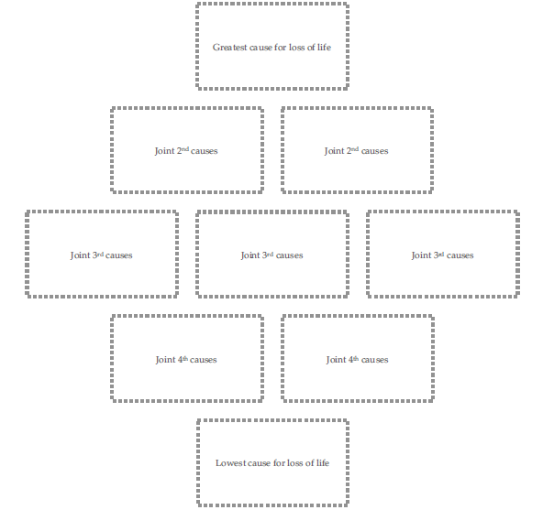

Titanic cards
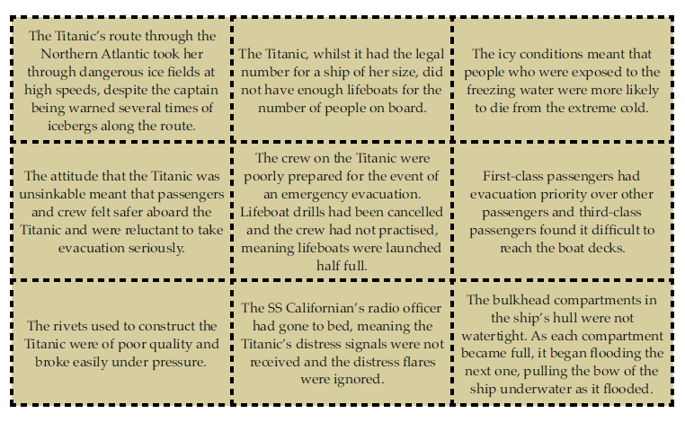
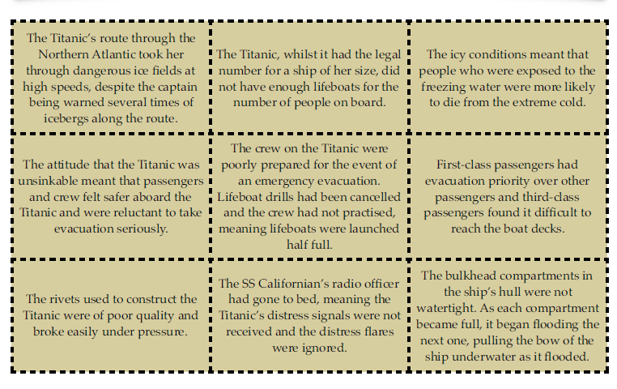

Fact sheet A
